**Learning Material**

**Text 1**

***Read the following text carefully and answer the questions in Task 1.***

**Soccer Clinics with Bambang Pamungkas**



Yesterday we had a great day. We had a football practice with a popular football player, Bambang Pamugkas. We called him “Bepe”. The name of the event was ‘Soccer Clinics with Bambang Pamungkas.

Early in the morning we arrived in a football field in Palmerah Jakarta. There were only 30 of us, including the only girl player, Fadia. First, Bepe taught us the theories of playing football. We listened to him carefully. After that, we had a football practice with him. It was great fun! He showed us many techniques and tricks to be a good football player. After two hours having practice with him, we had to stop and say goodbye to Bepe. Before saying goodbye, Bepe told us to dream big and to keep working hard and to keep struggling for gaining our dreams.

It was a very memorable day for me. I learned a lot of good things from Bepe. I would never ever forget that day.

*Adapted from:* [Bright:](http://ilmanzblog.blogspot.co.id/2013/04/unforgettable-experience.html) An English Course for Junior High School Students grade VIII

Orientation

Events

Reorientation

(optional)

***Here is a list of difficult words and phrases you may find in Text 1. Study them to make you understand with the text***

|  |  |  |
| --- | --- | --- |
| Word/phrase | Part of Speech | Meaning |
| great day | adjective (great)  noun (day) | hari yang menyenangkan |
| practice | verb | latihan |
| called | verb | panggil |
| event | noun | kejadian |
| early in the morning | adverb (early)  noun (morning) | pagi-pagi sekali |
| Including |  | termasuk |
| Taught | Verb | mengajari |
| Carefully | Adverb | dengan hati-hati |
| Showed | Verb | memperlihatkan |
| Told | Verb | mengatakan |
| Struggling | Verb | berjuang |
| Gaining | Verb | mencapai |
| memorable day | Adjective (memorable)  Noun (day) | hari yang sangat mengesankan |
| Learned | Verb | belajar |
| Forget | Verb | lupa |

 **Task 1**

***The following questions are based on Text 1. Answer the following questions with your partner.***

1. What is the text about?
2. What is the purpose of the text?
3. How is the generic structure of the text?
4. Who is “I” in the text?
5. Who are “we” in the text?
6. What is the type of the text?
7. What is the tense used in the text?

**Simple Past Tense**

The followings are the sentences taken from text 1.

1. Yesterday we **had** a great day. (paragraph 1, line 1)
2. Early in the morning we **arrived** in a football field in Palmerah Jakarta. (paragraph 2, line 1)
3. It **was** a very memorable day for me. (paragraph 3, line 1)

The bold words (*had*, *arrived, was*) are the verbs in the past form (simple past tense).

Simple past tense is tense that talk about something happened in the past and it now is finished.

When writing recount text, simple past tense is always used.

There are two ways for writing a sentence with simple past tense. The first way is using “verb” and the second way is using “to be”. Here is the pattern of simple past tense with “verb” and “to be”.

* **Simple past tense of to be**

Pattern:

*(Affirmative)*

**S + was/were + O**

Example:

1. There were 20 people.
2. We were very happy.
3. It was a very memorable day.

*(Negative)*

**S + wasn’t/weren’t + O**

Example:

1. There weren’t 20 people.
2. We weren’t happy.
3. It wasn’t a memorable day.

* **Simple past tense of verbs**

Pattern:

*(Affirmative)*

**S + V2 + O**

Example:

1. We played football with Bepe.
2. We went to Palmerah early in the morning.
3. I kicked the ball.

*(Negative)*

**S + didn’t + V1 + O**

Example:

1. We didn’t play football with Bepe.
2. We didn’t go to Palmerah early in the morning.
3. I didn’t kick the ball.
4. .

 **Task 2**

***In your book, write 10 sentences using simple past tense about what you did last week. See the following examples.***

1. Last week, I joined eating chip contest.
2. Yesterday, I went to market with my grandmother.
3. A week ago, I played badminton in school.

 **Task 3**

***Rearrange the following sentences into a good text.***

|  |  |
| --- | --- |
| **Monkey Rage** | |
| 1 | When I was in Elementary School, I played at my friend’s house every day when the school was over. |
|  | His house is closed to my school and there is a thick forest at the backyard. |
|  | For the moment, I thought it was gone, but it turned out that I was wrong. |
|  | After I threw a small guava, the monkey didn’t take it but turned back into the jungle instead. |
|  | We locked the door and the window because we were afraid that the monkeys would try to enter the house. |
|  | We helped each other to climb it since our body were still so small. |
|  | One day, when we were at his backyard, we decided to climb a guava tree because we saw so many guavas were hanging on the tree. |
|  | After a while, we decided to take a peek at the monkeys through the window and we saw all of them were sitting on the tree enjoying the guava. |
|  | The monkey returned with its group and they line like an army and start making noises as if they were angry. |
|  | We were just eating the guava on the tree when suddenly I saw monkey at the jungle walking on the land between the trees. |
|  | We were just eating the guava on the tree when suddenly I saw monkey at the jungle walking on the land between the trees. |
|  | It was so memorable that I never forget that moment. |
|  | We were so afraid that we decided to climb down the tree and ran out to my friend’s house. |

 **Task 4**

***Write a recount text about your experience that unforgettable. Work individually.***

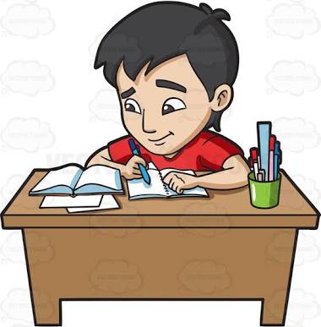

**Text 2**

***Read the following text carefully and answer the questions in Task 4.***

**How Could I Hide My Face?**

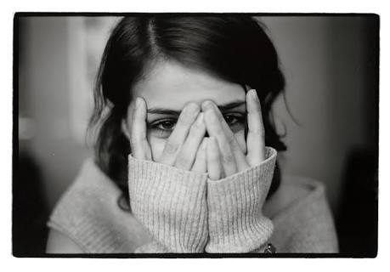

One afternoon a month ago, I was very hungry. As my mother didn’t cook anything for lunch, I decided to go to a café about a hundred meters from my house.

After came back from school, I changed my trousers and shirt then left for the café by myself. As soon as I got to the café, I ordered the meal with fresh vegetable soup that seemed very delicious in the hot day. I also ordered a glass of ice tea. When they were served, I eagerly ate up the meal and soup and drank the tea. I was satisfied with the food and it was the time for me to pay. I grabbed my trousers pocket and I was shocked. My hands didn’t feel any wallet there. I felt so embarrassed that I didn’t dare to see the faces of the customers. My body stayed still on the chair and began sweating. I tried to control myself. I collected my courage to come to the cashier to say something. I told her that I left my wallet in home and promised to take it and come back soon. She nodded and said it was nothing. Some customers looked at me. I thought I must hide myself.

Finally, I ran to the house and got back with the money. I gave it to her and came out of the café. What a relief! It should not happen again to me.

*Adapted from: Erlangga Fokus UN SMP/MTS 2012*

***Here is a list of difficult words and phrases you may find in Text 2. Study them to make you fully understand the text***

|  |  |  |
| --- | --- | --- |
| Word/phrase | Part of Speech | Meaning |
| hungry | adjective | lapar |
| decided | verb | memilih |
| came back | verb | kembali |
| changed | verb | mengganti |
| left | verb | meninggalkan |
| ordered | verb | memesan |
| delicious | adjective | enak |
| eagerly | adverb | Dengan lahap |
| satisfied | adjective | puas |
| pay | verb | membayar |
| grabbed | verb | mengambil |
| pocket | noun | kantong |
| wallet | noun | dompet |
| stayed still | verb | diam |
| sweating | adjective | berkeringat |
| courage | verb | berani |
| promised | verb | berjanji |
| nodded | verb | menggeleng |
| hide | verb | menyembunyikan |
| got back | verb | kembali |
| come out | verb | keluar |
| relief | noun | kelegaan |

 **Task 5**

***The following questions are based on Text 2. Answer the following questions with your partner.***

1. What is the text about?
2. What is the purpose of the text?
3. How is the generic structure of the text?
4. Who is “I” in the text?
5. What is the type of the text?
6. What is the tense used in the text?

**Regular & Irregular Verb**

The sentences belows are taken from the text entitled “How Could I Hide My Face?”.

1. I **decided** to go to a café about a hundred meters from my house. (paragraph 1, line 2)
2. I **ran** to the house and **got back** with the money. (paragraph 3, line 1)

What is the difference on the first and second sentence?

**The verb in the first sentence is irregular verb.**

**The verb in the second sentence is regular veb.**

Regular verbs are verbs which have one typical pattern in the second and third form, commonly by adding –ed at the end of verbs. Example:

decide – decided – decided

order – ordered – ordered

visit – visited – visited

play – played – played

Irregular verbs are verbs that have different pattern in the first, second, and third form. Example:

come – came – come

leave – left – left

feel – felt – felt

begin – began – begun

*Note: There are no many irregular verbs in English. Full list of irregular verbs can be found in the dictionary. Try to memorize them.*

When you learn about simple past tense, you need to know regular and irregular verbs. Remember that the pattern of simple past tense with verb is S+V2+O. Therefore, when you write a sentence using simple past tense, you need to change the verb from V1 to V2.

 **Task 6**

***Please find the regular and irregular verbs in the text entitled “How Could I Hide My Face?”.***

 **Task 7**

***Fill in the blanks with the appropriate verbs. The first sentence has been done for you.***

**Pull, Not Push**

A year ago, I ____*visited_____* (visit) my aunt in Jakarta. She __________ (show) me around and __________ (take) me shopping at some malls.

I was really awestruck by the glamorous malls. While window-shopping with her, the nature__________ (call). My aunt __________ (show) me the rest room. I __________ (enter) one of the cubicles and she __________ (wait) outside.

When I had finished, I _____________ (try) to open the cubicle door. I pushed, pushed and pushed again. Nothing __________ (happen). I ________ (start) to get panic. I _____________ (try) to push again. Zero.

I ____________ (cry) out my auntie’s name several times. I ________ (hear) her coming but she __________ (sound) panic too. I said I _______ (can’t) open the door. Abruptly, in one fling, the door was wide open. I heard people was burst into laugher. Not knowing to what happened, I __________ (step) out of the cubicle. Later, I __________ (find) out that I was supposed to pull, not to push the door. I ________ (feel) so embarrassed. I ____________ (want) the ground to swallow me up.

 **Task 8**

***Rearrange the following sentences into a good text.***

|  |  |
| --- | --- |
| **What a Shame!** | |
| 1 | I was on a tour bus with my classmates. |
|  | We felt very thirsty. |
|  | Everyone was enjoying his/her own drink. |
|  | It was sour. |
|  | I felt so shame and terrible at the same time because I knew that we were still thirsty. |
|  | Now everybody gave me a dark look. |
|  | We were on our trip going back to school after a long day visiting museums and an amusement park. |
|  | I found out later that the drinks tasted sour because they had a new lime flavor. |
|  | Then, I heard a voice shouting, “That’s May next year, not May this year!” |
|  | We gave a big hurrah when two of our friends distributed soft drinks. |
|  | May 20! Gosh… that was nearly two months ago. |
|  | I felt suspicious and quickly looked the expiry date printed on the back of the cartoon. |
|  | At once, almost everyone stopped drinking. |
|  | Everyone? Well, no… I found the taste of the soft drink some kind of funny. |
|  | Some of my friends even threw their half empty drinks into the garbage bins along the bus side aisle. |
|  | I stood up, cleared my throat and said, “Stop drinking! These soft drinks are already expired. The expiry date is last May.” |
|  | We were on our trip going back to school after a long day visiting museums and an amusement park. |

 **Task 9**

***Write a recount text about your experience that was so shamed. Work individually.***





**Text 3**

***Read the following text carefully and answer the questions in Task 10.***

**Trapped in an Elevator**

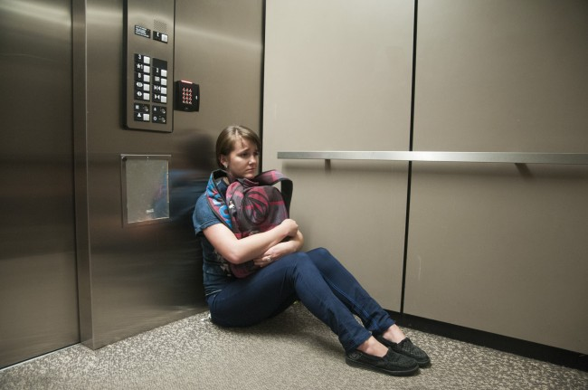

**Three years ago**, I experienced the most horrible thing for me. I was trapped in an elevator in my mother’s office. I still remember the event clearly although it had been three years.

That day was a special day because it was my mother’s birthday. **In the afternoon**, I went to the bakery to choose a birthday cake for her and then went to my mother’s office. My mother’s desk was on the fourth floor so I decided to take the elevator. I pressed the elevator button and waited the elevator as usual. **When** the elevator’s door opened, I entered the elevator. There was no one in the elevator. Suddenly, **when** the elevator was on the third floor, the light off and the elevator was stopped.

I was so afraid because I was stuck in it. I tried to calm down and thought how to escape. **After thinking for a while**, I pressed the emergency button to contact the security guard. **After forty minutes**, I heard some voice outside. **Not long after that**, the elevator door finally opened.

I thought I would probably die in the elevator if I was stuck in it for a long time because there were no food, water and air for me to survive. Luckily, I didn’t get any hurt and was still alive.

*Adapted from* <http://sites.pccu.edu.tw/i-say-you-say/144444/themosthorribleexperiencethatihaveeverhad>

***Here is a list of difficult words and phrases you may find in Text 3. Study them to make you fully understand the text***

|  |  |  |
| --- | --- | --- |
| Word/phrase | Part of Speech | Meaning |
| horrible | adjective | mengerikan |
| trapped | verb | terjebak |
| bakery | noun | Toko kue |
| desk | noun | meja |
| elevator | noun | lift |
| pressed | verb | menekan |
| button | noun | tombol |
| waited | verb | menunggu |
| As usual | adverb | Seperti biasa |
| entered | verb | masuk |
| Suddenly | adverb | Tiba-tiba |
| light | noun | lampu |
| afraid | adjective | takut |
| stuck | verb |  |
| Calm down | verb | tenang |
| thought | verb | berfikir |
| escape | verb | keluar |
| emergency | adjective | darurat |
| voice | noun | suara |
| probably | verb | kemungkinan |
| hurt | noun | Sakit/luka |
| alive | adjective | hidup |

**Task 10**

***Read the following text carefully and answer the questions in Text 3.***

1. What is the text about?
2. What is the purpose of the text?
3. How is the generic structure of the text?
4. Who is “I” in the text?
5. What is the type of the text?

**Time Connectives**

The sentences below are taken from the text.

1. **Three years ago**, I experienced the most horrible thing for me.
2. **In the afternoon**, I went to the bakery to choose a birthday cake.

The underline phrases refers to time connectives.

Time connectives is words or phrases used to tell someone when something is happened.

Time connectives is used to relate one sentence or clause to another sentence clause.

The following is the list of time connectives commonly appear in recount text.

Yesterday = kemarin Before = sebelum

A week ago = minggu lalu Next = selanjutnya

Last week = minggu lalu Then = lalu

A month ago = bulan lalu Afterwards = setelah itu

Last month = bulan lalu Later = selanjutnya

A year ago = tahun lalu Not long after that = tak lama setelah itu

Last year = tahun lalu When = ketika

In the afternoon = pada sore hari Finally = akhirnya

In the morning = pada pagi hari At the end = akhirnya

At first = pertama-tama After that = setelah itu

Firstly = pertama-tama

Time connectives can appear in the beginning of the sentence, in the middle of the sentence and in the begining of the paragraph.

**Task 11**

***Fill in the blanks with appropriate words below. The first has been done for you***.

two years ago before when

then after

*___Two years ago__* (1), I visited my grandparent’s house in Bandung for only two days and one night. I went there by bus and it took me 5 hours to get in there.

________________ (2) I arrived, I went to the bedroom to sleep. _______________ (3) I slept, I read a book. It wasn’t a horror book anyway. ________________(4) I read the book, I felt someone in the room looked at me. I looked around the room but there was no one there except me. _______________(5) I put my book down and tried to sleep. _______________(6) I closed my eyes, I heard someone whispered my name in my ear. I was so frightened until I couldn’t open my eyes.

It was the scariest moment I ever had. I wish it won’t happen again to me.

**Task 12**

***Rearrange the sentences below into a good recount text.***

|  |  |
| --- | --- |
| **My Horrible Experience** | |
| 1 | Let me remind you my experience during an earthquake last week. |
|  | There were rocks everywhere. |
|  | I was driving home from my vacation to Bali. |
|  | I knew it was an earthquake when I saw some telephone and electricity poles falling down to the ground, like matchsticks. |
|  | Although nothing was left, I thanked God that nobody was seriously injured. |
|  | I thought I got flat tire. |
|  | I was trapped by the rock. |
|  | When I reached my town, I was so surprised that there was almost nothing left. |
|  | Even I could not move my car at all. |
|  | I did not know that it was an earthquake. |
|  | When the earthquake happened, I was on my car. |
|  | Then I saw a lot of rocks tumbling across the road. |
|  | Suddenly, my car launched to one side, to the left. |
|  | The earthquake made a lot of damage to my town. |
|  | There was not I could do but left the car and walked along way to my house, in the town. |

**Task 13**

***Write your experience that made you felt scary. Work individually.***

