Development of Problem Solving Ability Test

On the Work-Energy Material

Wartono¹, Sutopo¹, Desella Inna Rahmatina¹, John Rafafy Batlolona²
¹Department of Physics, Faculty of Mathematics and Natural Sciences, Universitas Negeri Malang, Indonesia
²Department Primary Education, Teaching and Education Faculty, Pattimura University, Indonesia

Article Info |  | ABSTRACT (10 PT)
Article history:  Received Jun 12, 201x  Revised Aug 20, 201x  Accepted Aug 26, 201x |  | The purpose of this research is to develop test questions of problem solving ability on work-energy material for high school students class X. This type of research is research and development. The model used in this study is ADDIE with the stages of analyzing, planning, developing, implementing, and evaluating, but this study only up to the implementation stage. The test developed in this research consists of three items of problem solving ability description that is multi context. Validation of item was done by content validation and empirical validation. The results of content validation indicate that the average score of test items is 3,125 with good category. The results of empirical validation indicate that there are two valid questions and one invalid question. Two valid questions have a Cronbach Alpha coefficient of 0.807. The results of the implementation of the test showed that the average student problem solving abilities in Question 1 is 17.41 of a maximum score of 25, the lowest score is 10 and the highest is23. The results of students in the question number 2 by 16.60 of a maximum score of 25, with the lowest score is 10 and the highest is 22. These results indicate that the test instrument is feasible to use to assess students' problem solving abilities.
Keywords:
Test
Problem Solving Abilities Work-Energy

Keywords:  Test  Problem Solving Abilities Work-Energy |  | Copyright © 2019 Institute of Advanced Engineering and Science.  All rights reserved.
Corresponding Author:
John Rafafy Batlolona,
Department of Primary Education,
Pattimura University, Jl. Ir. M. Putuhena, Unpatti Campus Poka Ambon 97223, Indonesia
Email: johnrafafybatlolona@gmail.com

- INTRODUCTION
The ability to solve problems is one of the skills students need to face new challenges in the 21st century. Students as young scientists and scholars must have good problem solving skills in order to solve all the problems that exist in life. Problem solving skills are a series of actions to solve a problem (Mason & Singh, 2006). There is a difference between novice and expert in solving problems. If faced with a problem, beginners tend to determine the appropriate equations for solutions, whereas experts tend to conduct qualitative analysis of the problem then the results of the analysis provide the appropriate quantitative explanation for the solution [1].
There has been much research in physics education about problem solving abilities. They arethe identification of students' ability to solve a problem [2], learning strategies that can improve student problem solving skills [3], and even the development of rubrics to measure student problem solving skills [4]. The development of the problem solvingability test has also been done by Minnesota University whose first point results were published by Heller & Hollabaugh (1992) [5]. The problem developed by Minnesota University is context rich with setting the situation according to the conditions there. Students in Indonesia find it difficult to understand such problems, therefore it is necessary to develop a context rich problem that is appropriate to the situation around the students so that students can easily understand the problem and solve it.
The context rich problem is a short story that integrates the everyday phenomena presented in multi-context. The purpose of using context rich is so that students can be trained to solve problems that are real life or that they normally experience in life [6]. A context rich problems is complex and requires connection between concepts in solving it.
Student problem solving skills must be known early in order to know the ways and difficulties in solving problems, so that teachers can train students to solve problems as the experts do. Therefore, the development of an instrument to measure problem solving skills is context rich.
The test developed in this research & development is a problem solving test for high school students on work-energy materials. The selection of the description form is based on the need for information on how to solve students’ problems and the characteristics of work-energy materials that emphasizes the drawing of force diagrams in problem solving. In addition, many difficulties experienced by students in learning work-energy materials such as determining the system and environment, the concept of mechanical energy, the concept of energy transfer, and so forth. The purpose of this research is to develop problem solving test instrument for high school students class X on work-energy material. Another goal is to know the validity and reliability of the test developed.

- RESEARCH METHOD
This research includes a type of research & development that adapts from the step of the ADDIE model research (Branch, 2009). The research steps in this model are five (a) analyze (analyzing), (b) design (planning), (c) develop (development), (d) implement (implementation), and (e) evaluate (evaluation). Steps taken in this study only until the implementation stage. The total time required in this study is six months ie from December 2017 to May 2018.
The first stage in this research is analyze. This stage is done by reviewing various existing problem solving instruments. Heppner & Petersen (1982) [7] has developed a mechanical problem solving instrument but is aimed at students. Hidayat et al (2017) [8] has developed a special problem solving instrument for high school students on vibration, wave and sound materials. Mustofa (2017) [9] has developed problem solving instruments but still refers to the end book chapter question. Heller et al (1991) [5] developed a context rich problem solving instrument on mechanical materials, but it is too difficult to apply to high school students in Indonesia. The problem solving tools developed are short stories and not accompanied by drawings. This makes most high school students difficult to understand the problem. A context rich problem solving test instrument on work-energy material for senior high school students in Indonesia is not available yet, therefore the development of a context rich problem solving test instrument for high school students is performed.
The second stage in this research is design. This stage is done by selecting aspects of the problem solving ability of students to be measured. There are five aspects measured in this study that adopted from Doctor et al [10]. The five aspects are useful description, physics approach, specific application of physics, mathematical procedures, and logical progression. These five aspects become the basic benchmark for developing the problem solving test instrument.
The third stage in this research is develop (development). Problem solving tests are developed based on these five aspects. Three items on problem solving tests on work-energymaterial were developed. These three test questions refer to one indicator that solves the problem of motion of objects using work-energy concepts. One indicator is used because in context rich problems have applied many concepts in its completion [11].
After the development of the problem solvingtest is completed, proceed with validation. There are two validations were done namely content and empirical. Content validation was conducted on two lecturers of Faculty of Math and Science, State University of Malang that one lecturer was a physics subject and another lecturer of physics education. The aspects assessed in content validation are the suitability of the item with the Indicators of Competence Achievement, the difficulty level of the item, the item is easy to understand and does not give a double interpretation, and the correctness of the concept of the key answer. In addition to scoring by both validators, they also gave suggestions for the improvement of test instruments.
After the revision is done, proceed with empirical validation. Empirical validation was carried out in grade XI students of SMA An-Nur Malang, who had taken the work-energy material. Students who made the respondents amounted to 104 students. This empirical validation aims to determine the level of validity and reliability of test instruments that have been developed. The validity of each item can be known by comparing the value of r arithmetic with r table. If r_{hitung}> r_{tabel} item is valid, and vice versa. The degree of reliability of the instrument is known in the Cronbach Alpha coefficients.
The fourth stage is implementation. The items that are known to be valid and reliable are used to measure the problem solving ability of high school students. The number of respondents who were given the test is 68 students of science class X Senior High School An-Nur Malang.

- RESULTS AND ANALYSIS
This research was conducted with the aim to know the validity and reliability of test problem solving instruments that have been developed. After the development is completed, content and empirical validation is done on each item. The result of validation contents by both validators is shown in Table 1.
Based on Table 1, it is known that the average score of 3.125 indicates valid for use. This is also supported by research by Pradana et al (2017) who developed the test instrument with an average content validation result above 3 and is suitable for use. The suggestions given to content validation are only in items 2 and 3. Suggestions given in the form of orders to improve the order of words in the problem and clarify the picture. For the sake of refinement of the instrument, an improvement is made according to the suggestion of the two validators. Although the validation results of the content by both validators are said to be valid, but this instrument can not be concluded valid and reliable. Therefore, empirical validation is performed.

Table 1. Content Validation Results by Two Validators
No | Rated aspect | Item Question1 | Item Question 2 | Item Question 3 | Average
1 | Compliance of items with achievement indicators of competence | 3 | 3,5 | 3 | 3,167
2 | Problem can measure students’ problem solving abilities | 3,5 | 3 | 3,5 | 3,333
3 | The correctness of the key answer | 3 | 3 | 3 | 3
4 | The language used is easy to understand and does not give rise to double meaning | 3 | 3 | 3 | 3
Average |  | 3,125 | 3,125 | 3,125 | 3,125

Empirical validation was conducted with 104 respondents randomly selected. Students are given context rich problem solving question as much as 3 items about work-energy materials that must be done in 70 minutes. After the students did the test, the test results are corrected and analyzed. The results of the analysis show that from the three given questions, only two are valid and reliable i.e. at number 1 and 2. The question number 3 has level of difficulty 0.123 that is recommended to be discarded because it is too difficult for students. Empirical validation results of numbers 1 and 2 are shown in Table 2.

Table 2. Empirical Validation Results
No. Question | Level of Difficulty |  | Discrimination Power |  | Validation |  | Cronbach's Alpha
No. Question | P | Note | D | Note | r | Note | Cronbach's Alpha
1 | 0,302 | Medium | 0,367 | Good | 0,943 | Valid | 0,807
2 | 0,285 | Medium | 0,256 | Enough | 0,899 | Valid | 0,807

According to Table 2, it is known that all r_{hitung} is larger than r_{table} (0.1622). It can be said that the two items of context rich problem solving are valid. Having known that both items are valid, then tested the reliability to determine the level of constancy when used to measure students’problem solving ability. Based on the calculation, Cronbach Alpha value obtained is 0.807, which means the item have a high level of constancy [11]- [12].
There are factors that cause the item is valid and reliable. According to Isyanto et al (2014), the factors that influence a valid and reliable question are four. The four factors are the items developed in accordance with the development procedure, the items are developed from the appropriate reference, the item through the content validation stage, and the items tested empirically on the respondents who are serious in doing it.
Each item of problem solving test measures the following five aspects: useful description, physics approach, specific application of physics, mathematical procedures, and logical progression. Point 1 is shown in Figure 1. The case can be solved by using the mechanical energy of the system with people, springs, and earth as a single system. The next step is to determine the external force that works on the system. Since the system consists of people, springs, and Earth, there is no external force acting on the system (applied to the law of conservation of mechanical energy). The force diagram of the case is shown in Figure 2. The concepts used are mechanical energy conservation laws
$∆EM=∆EK+{∆EP}_{g}+{∆EP}_{p}$;$∆EK=\frac{1}{2}m{\left(∆v\right)}^{2}; ∆{EP}_{g}=mg\left(∆h\right);dan ∆{EP}_{p}=\frac{1}{2}k{\left(∆x\right)}^{2}$.
The calculation of bungee string elasticity constants is done with
$${EM}_{A}={EM}_{C}$$
$${EK}_{A}+{EPg}_{A}+{EPs}_{A}={EK}_{C}+{EPg}_{C}+{EPs}_{C}$$
because the child in position A and C aremotionless, then:
$$0+{mgh}_{A}+0=0+{mgh}_{C}+\frac{1}{2}k{\left(∆x\right)}^{2}$$
$$30.10.20=30.10.5+\frac{1}{2}k{\left(5\right)}^{2}$$
$$6000=1500+\frac{25}{2}k$$
$$k=\left(6000-1500\right)\frac{2}{25}$$
$$k=360 N/m$$
Thus, a bungee string elasticity constant of 360 N / m is required for the bungee strap to be stretched to 5 m and the child's head does not touch the surface of the pond water.

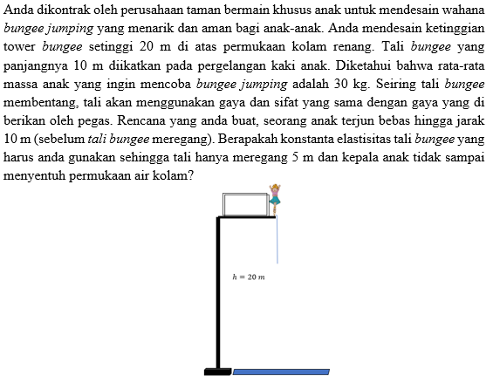

Figure 1. ItemQuestion Number 1

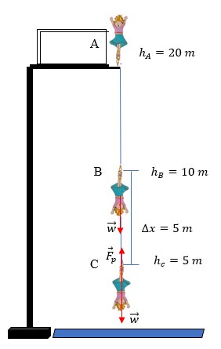

Figure 2. Diagram of Working Forces on the System

Item 2 is shown in Figure 3. In that case, the car is considered a system. Since the track is two (italics and plane), the review is divided into two namely the incline (Figure 4) and the flat plane (Figure 5). The forces acting on the system in the incline are i.e.
- NormalForce,
$$N=w\cos{α}=mg\cos{α}=1000.10\frac{40}{50}=8000 N$$
- Earth's gravitational force,
$$w=mg=1000\left(10\right)=10.000 N$$
- Kinetic frictionforce,
$$f_{k}=μ_{k}N=0,2 \left(8000\right)=1600 N$$

While the forces that work on the system in the plane ie
- Normal Force
$$N=mg=1000\left(10\right)=10.000 N$$

- Earth's gravitational force
$$w=mg=1000 \left(10\right)=10.000 N$$
- Kinetic friction style
$f_{k}=μ_{k}N=10.000μ_{k}$ N

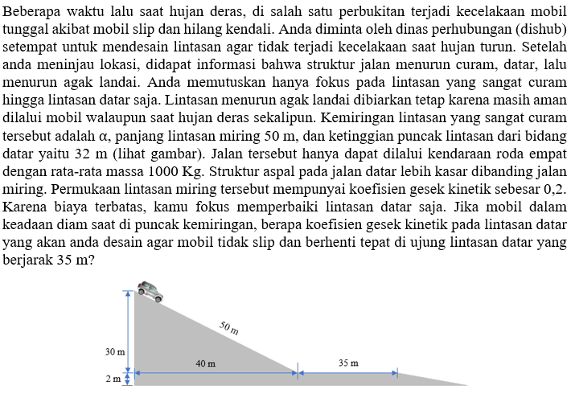

Figure 3. Item Question Number 2

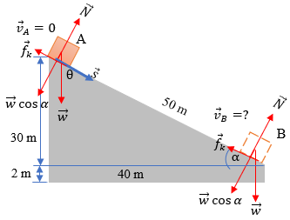

Figure 4. Forces Diagram in Incline

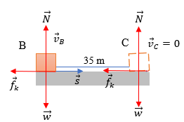

Figure 5. Forces Diagrams in the Flat Field

The case can be solved by kinetic work-energy theorem (W_total = ΔEK) and work is equal to the multiplication of dot product force with displacement (W = F ⃗.s ⃗ = cos⁡θ)
- Determine the speed of the object on B
$$W_{total}=∆EK$$
$$W_{w}+W_{N}+W_{f_{k}}={EK}_{B}-{EK}_{A}$$
$$ws\cos{θ}+Ns\cos{{90}^{0}}+f_{k}s\cos{{180}^{0}}=\frac{1}{2}mv_{B}^{2}-\frac{1}{2}mv_{A}^{2}$$
$$10000 (50)\frac{30}{50}+0-1600 (50)=\frac{1}{2}1000\left(v_{B}^{2}\right)-0$$
$$500\left(v_{B}^{2}\right)=300.000-80000$$
$$\left(v_{B}^{2}\right)=\frac{220.000}{500}=440$$
$$v_{B}=\sqrt{440}m/s$$
- Determine the kinetic friction coefficient on the plane
$$W_{total}=∆EK$$
$${W_{N}+W}_{g}+{W_{f}}_{k}={EK}_{2}-{EK}_{1}$$
$$0+0+f_{k}s\cos{180}=\frac{1}{2}mv_{2}^{2}-\frac{1}{2}mv_{1}^{2}$$
$$μ_{k}Ns\cos{180} =\frac{1}{2}mv_{2}^{2}-\frac{1}{2}mv_{1}^{2}$$
$$μ_{k}\left(1000.10\right)35\left(-1\right)=\frac{1}{2}1000\left(0^{2}\right)-\frac{1}{2}1000 (440)$$
$$-350.000μ_{k}=-220.000$$
$$μ_{k}=\frac{-300.000}{-350.000}=0,63$$

Thus, the flat surface kinetic friction coefficient required for the car does not slip and stops right at the end of a 35 m flat trajectory of 0.63.
Test that has been proven valid and reliable, then implemented in high school students X class of 68 students. The results of the implementation are shown in Table 3.

Table 3. Results of the Problem solving Test Instrument Implementation
No | Aspect | Value
No | Aspect | Question 1 | Question 2
1 | Average Value | 17,26 | 16,60
2 | Minimum Value | 10 | 10
3 | Maximum Value | 23 | 22

Based on Table 3, it is known that the average value of students in question number 1 is 17.26 and question number 2 is 16.02 with a score range of 0-25. The minimum score that students achieve on the number 1 and 2 the same is 10. The maximum value obtained by students on the matter number 1 is 23 and question number 2 is 22. This acquisition is quite good because all students can understand the problem and solve it. The test results also indicate that in question number 1 as much as 42.65% students still solve the problem by novice way, while 57.35% of students have been able to solve the problem by expert way. While on problem number 2 it is known that 47,06% student still do by novice way, while 52,94% student have done by expert way. The high percentage of students solve problems by expert way means that students' problem solving skills are good, but training is still needed to get closer to 100%.
The result of the student's answer on question 1 is shown in Figure 6. Based on Figure 6 it is known that the questions have been able to assess the problem solving ability of the students. In the useful description, students have been able to determine the system and draw a diagram of forces that work on the system. Students have been able to determine the physics approach as well as the specific application of physics used as well. Mathematical procedures written by students are appropriate and get the right solution. The logical progression that students demonstrate in solving this problem has been coherent, clear, focused, and logically connected solutions. Students who solve a problem coherently, clearly, and can correctly answer indicate that the conceptual understanding they have in the material is good (Wang & Buck, 2015).
The result of student's answer on question 2 is shown in Figure 7. Based on Figure 7, it is known that the problem solving ability of students has been assessed. Students have written useful description well. Students can define systems and environments, draw style diagrams although there is little inconsistency in vector writing. Students have mentioned physics approach correctly, but specifiec application of physics is lacking. The mathematical procedures presented by the students contain few errors, namely the writing of vector signs, and the writing of speeds that are not accompanied by units. Logical progression students have shown that the solutions displayed are clear and focused with little inconsistencies.

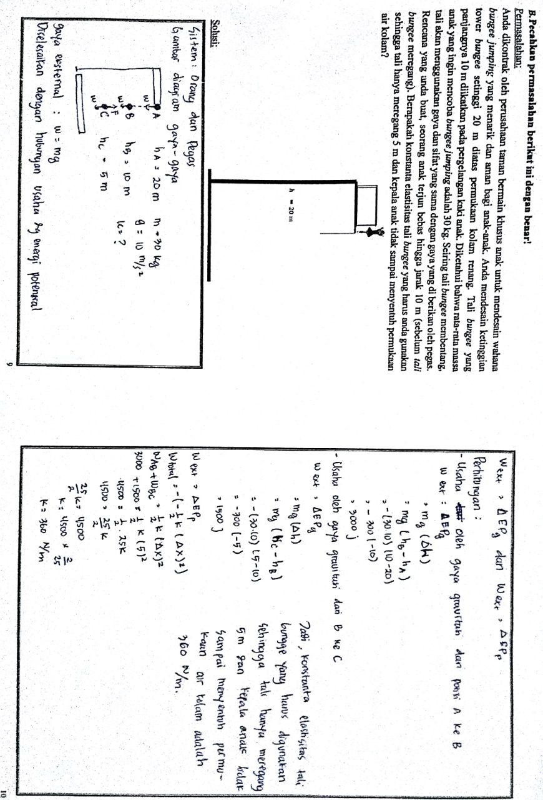

Figure 6. Results of Students’Answers to Question Number 1

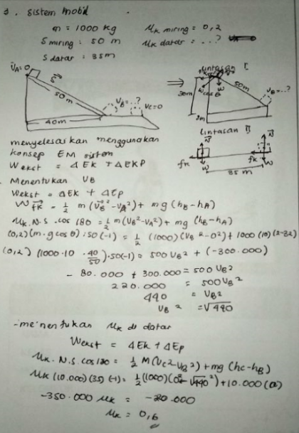

Figure 7. Results of Student Answers to Question Number 2

- CONCLUSION
Based on the results of research and data analysis, it is known that of the three questions that have been developed only two are classified as valid. The two validly stated questions have a reliability level of 0.807. This value indicates that the reliability level is high, so it can be used to measure students' validity and reliability problem solving abilities.
Test that has been valid and declared reliable, implemented to measure problem solving ability. The number of respondents used is 68 students of class X MIA SMA An Nur. The result is the average score of the students on item 1 is 17.41 with the lowest score of 10 and the highest 23. The average score on question 2 is 16.60 with the lowest score of 10 and the highest 22. These results indicate that the test instrument can already be used to assess students' problem solving abilities. The absence of students who get a perfect score of 25 and still there are students who get a score of 10 indicates that the problem solving ability of students is also not completely good, so it takes further research about the provision of learning that can train students’problem solving skills to fully achieve the expert way.

REFERENCES
- G. Zhu adn J. Wang, "Pseudolongitudinal investigation on chinese student’s of kinematics and mechanics problems, " Physics Education Research, vol. 13, pp. 1-9, 2017.
- W. Fakcharoenphol., J. W. Morphew and J. P. Mestre, "Judgement of physics problem difficulty among experts and novices, " Physics Education Research, vol. 11, pp. 1-14, 2015.
- B. A Bottge., E. Rueda., T. S. Grant., A.C. Stephens and P. T. & Laroque, "Anchoring problem solving and computation instruction in context rich learning environtments, " Council for Exceptional Children, vol. 76, pp. 417-437, 2010.
- J. L. Docktor and K. Heller, "Robust asessment instrument for student problem solving, " In Prociding of the NARST 2009 Annual Meeting Garden Grave. http://groups.physics.umn.edu/20physed/Talks/Docktor_NARST09_paper.pdf, 2009.
- P. Heller and M. Hollabaugh, "Teaching problem solving through cooperative groupingpart 2: designing problems and structuring groups, " American Journal of Physics, vol. 60, pp. 637-644, 1992.
- S. Glynn and T. R. Koballa, "The Contextual Teaching and Learning Instructional Approach. Exemplary Science: Best Practices in Professional Development, " vol. 53, pp. 75-84, 2005.
- P. P. Heppner and C. H. Petersen, "The development and implications of a personal problem solving inventory, " Journal of counseling psychology, vol. 29(1), pp. 66-75, 1982.
- S. R. Hidayat., A. H. Setyadin., Hermawan., I. Kurniawati., E. Suhendi., P. Siahaan and P. Samsudin, Pengembangan instrumen tes keterampilan pemecahan masalah pada materi getaran, gelombang, dan bunyi [Development of skills problem solving testing material on vibration, wave, and sound material]. Jurnal Penelitian & Pengembangan Pendidikan Fisika, vol. 3, pp. 157-166, 2017.
- Z. Mustofa, "Peningkatan Pemahaman Konsep dan Kemampuan Pemecahan Masalah pada Topik Usaha-Energi melalui Modeling Instruction [Improved Understanding Concepts and Problem solving Abilities on Business-Energy Topics through Modeling Instruction], " Unpublished Thesis. Universitas Negeri Malang, 2017.
- J. L. Docktor., J. Dornfeld., E. Frodermann., K. Heller., L. Hsu., K. A. Jackson.,
A. Mason., Q. X. Ryan adn J. Yang, "Assessing student written problem
solutions: A problem solving rubric with application to introductory physics, " Physics Review-Physics Educational Research, vol. 12, pp. 1-18, 2016.
- P. D. Antonenko., C. A. Ogilvie., D. S. Niederhauser., J. Jackman., P. Kumsaikaew., R. R. Marathe and S. M. Ryan, "Understanding student pathways in context-rich problems, " Education and Information Technologies, vol. 16, pp. 323-342, 2011.
- S. Arikunto, "Dasar-dasar evaluasipendidikan [Fundamentals of educational evaluation], " Jakarta: Bumi Aksara, 2012.
- I. Ghozali, "Aplikasi multivariate denganprogram SPSS [A multivariate application with SPSS program], " Semarang: BadanPenerbit Universitas Diponegoro, 2007.
- E. Istiyono., D. Mardapi and Suparno, "Pengembangan teskemampuan berpikir tingkat tinggiFisika (PysTHOTS) peserta didikSMA [Development of high-level thinking physics thinking test (PysTHOTS) high school students], " Jurnal Penelitian dan EvaluasiPendidikan, vol. 18, pp. 1-12, 2014.
BIOGRAPHIES OF AUTHORS

 | Dr. Wartono, M.Pd  A Senior Lecturer at physics education, Universitas Negeri Malang, Malang, Indonesia. Doctoral Studies completed at the Universitas Pendidikan Indonesia (1996), Department of Science Education.
 | Prof. Dr. Sutopo, M.Si  A Senior Lecturer at physics education, Universitas Negeri Malang, Malang, Indonesia. Doctoral Studies completed at the Universitas Pendidikan Indonesia (2013), Department of physics education .
 | Desella Inna Rahmatina, S.Pd., M.Pd  Desella Inna Rahmatina is a Master of Physics Education.  Master Studies completed at the Universitas Negeri Malang (2018), Department of physics education .
   | John Rafafy Batlolona, S.Pd., M.Pd  John Rafafy Batlolona is a Master of Physics Education.  Lecturer of Primary Teacher Education, Faculty of Teachers Training and Education, Pattimura University, Ambon-Indonesia. The office adress is Dr. Tamaela street on Kampus PGSD, Ambon-Maluku, Indonesia.  Email: johanbatlolona@gmail.com; johnrafafybatlolona@gmail.com  His major interests over physics education, science education, teaching and learning model, primary education.

