Interview Questions on Electrochemistry
- Select ONE of the following statements that correctly describes the anode of a standard galvanic cell in operation.
- The anode is electrons acceptor.
- There is a decrease in the mass of the anode.
- The concentration of the electrolyte in the anodic half-cell initially decreases.
- The positive terminal of the cell is represented by the anode.
The reason for your choice in the question above is _______________________.
- The below electrochemical cell contains two CARBON RODS as electrodes and a concentrated copper(II) chloride solution as electrolyte.
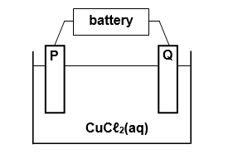
A gas will evolve at electrode P, whilst electrode Q will be coated with a reddish-brown layer when the cell is in full operation. Use this information to answer the question below:
What is the most likely gas formed near electrode 2? Explain your answer.
- H_{2(g)}
- Cu_{(g)}
- O_{2(g)}
- Cl_{2(g)}
- In a galvanic (voltaic) cell, electrons are transferred from the…
- Anode through the salt bridge to the cathode.
- Cathode through the salt bridge to the anode.
- Anode through the external circuit to the cathode.
- Cathode through the external circuit to anode.
What is the reason for your choice in the question above?
Use the information provided to respond to the questions 4.
Ga³⁺ _{(aq)} + Al_{(s)} → La³⁺ _{(aq)} + Ga_{(s)}
B³⁺ _{(aq)} + Ga_{(s)} → no reaction
B³⁺ _{(aq)} + Al_{(s)} → Al³⁺ _{(aq)} + B_{(s)}

- Which of the following statements applies to the equations above?
- The oxidizing agent loses electrons.
- The reducing agent undergoes reduction.
- The oxidation number increases in the species undergoing reduction.
- Electrons are transmitted from the reductant to the oxidant.
Use the information provided to respond to the questions 5 and 6.
- H_{2(g)} + Cl_{2(g)} → 2HCl_{(g)}
- SO_{3(g)} + H₂O_{(l)} → H₂SO_{4(aq)}
- NH_{3(g)} + H₂O_{(aq)} → NH₄⁺_{(aq)} + OH⁻_{(g)}
- 2NH_{3(g)} + ½O_{2(g)} → 2NO_{2(g)} + 3H₂O_{(g)}

- Which of the following statements about the oxidation state of an atom is correct?
- The oxidation number of oxygen in O_{2(g)} is O
- The oxidation number of chlorine in C1_{2(g)} is -1
- The oxidation number of nitrogen in NH₄⁺_{(aq)} is -2
- The oxidation number of sulphur in H₂SO_{4(aq)} is -2
- Which of the equations above represents redox reaction? Explain your answer.
- 3 only
- 4 only
- 1 and 4
- 2, 3 and 4
Use the information provided to respond to the question 7.
- The cell potential for the electrochemical cell in the diagram above is
- +1.10V
- +0.42V
- -0.42V
- -1.10V
Use the information provided to respond to the questions 8 and 9
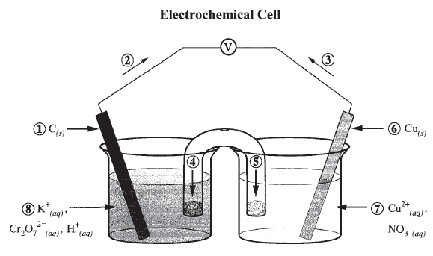
- Which of the following statements applies to the electrochemical cell above?
- The anode is labelled 1.
- Electron flow is labelled 2.
- Cation movement is labelled 4.
- The strongest reducing agent is Cr₂O₇²⁻_{(aq)} and H⁺_{(aq)}
- Which of the following statements applies to the electrochemical cell above?
- The negatively charged anode attracts positively charged protons.
- The positively charged cathode attracts negatively charged electrons.
- Cations move towards the cathode so that the cell remains electrically neutral.
- Cations are attracted to anions in the electrolyte which limits their movement toward the cathode.

Use the information provided to respond to the questions 10 and 11

The electrochemical cell represented below consists of a hydrogen half-cell and an unknown half-cell at standard conditions.
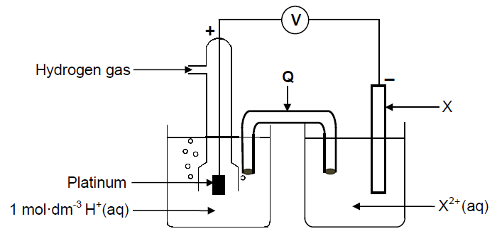
The reading on the voltmeter is 2.36 V.
- If the reading on the voltmeter is +2.36 V under standard conditions, then X_{(s)} is most likely ____________.
- Ag_{(s)}
- Al_{(s)}
- Mg_{(s)}
- O_{2(g)}+H₂O_{(l)}
- Select the statement that best describes the circuit in the electrochemical cell above.
- Electrons are provided by the salt bridge in order to complete the circuit.
- An operating circuit requires the movement of anions, cations and electrons.
- Electrons exit the electrolyte at the anode after entering and moving through the electrolyte at the cathode.
- The salt bridge allows the flow of electrons through it as positive ions in the bridge attract electrons from one half-cell to the other half cell.

Use the information provided to respond to the question 12
A thin layer of silver was used in electroplating a tin jewellery to improve its appearance as shown in the electrochemical cell below.
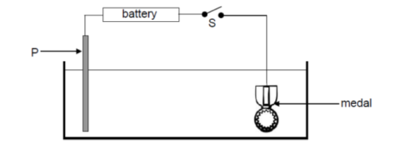
- The anode in the electrochemical cell above is __________.
- Identified by its location in the cell
- The species with the lowest oxidation potential
- The metal with the least ability to attract electrons
- The electrode with the highest concentration of electrons

Use the information provided to respond to the question 13
A learner set up the following electrochemical cell and allowed it to operate for a few minutes.
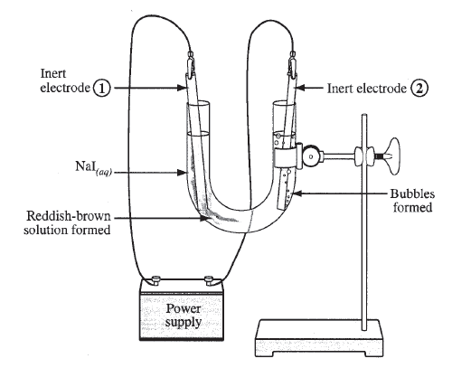
- Which of the following statement applies to the electrochemical cell in the diagram above?
- The same reaction occurs at each of the inert electrodes.
- The inert electrodes are oxidized and reduced in this cell.
- In the electrolysis of aqueous solutions, water is unreactive.
- The chemical reactions occur on the surface of the inert electrodes

