. (2017). The Role of Research-Based Learning to Enhance Students’ Research and Academic Writing Skills. Journal of Education and Learning. Vol. x(x), pp. x-y.

The Role of Research-Based Learning to Enhance Students’ Research and Academic Writing Skills

Abstract
This paper exposes the role of research-based learning to enhance students’ research and academic writing skills in mathematics education. A learning trajectory of research in mathematics education using research-based learning designed and developed for pre-service mathematics teachers. In this study, the research methodology used is a design research to develop research-based solutions and validate theories about learning processes. The subjects are 35 pre-service mathematics teachers from higher education institution in Tangerang, Indonesia. The contribution of this investigation to mathematics education research field is produced a local instruction theory to enhance preservice teachers’ skills in doing research and writing academic paper, which yet developed in Indonesia. This theory provides an explanation of the steps that preservice teachers’ must go through using research-based learning. The enhanced research skill is focused on the trend of mathematics education research, and the improved academic writing skill is focused on the articles published in a journal.

Keywords: Design research, research-based learning, local instruction theory on research in mathematics education, research skill, academic writing skill

Introduction
Numerous research has documented students’ difficulty in doing research and writing academic paper (Prahmana & Kusumah, 2016; Dowse & Howie, 2013; Arcavi, 2000; Singhal, 2004; Prahmana, Kusumah, & Darhim, 2016; Cryer, 2006). Students’ limited knowledge of research methodology, experience in doing research, make a real research problems to investigate, get the initial impetus of a research project, lack of research skills, and the role of thesis advisor were identified as factors behind students’ difficulties in doing research (Prahmana, Kusumah, & Darhim, 2016; Arcavi, 2000; Cryer, 2006). On the other hand, students are required to have academic writing skills to help them in finishing their academic paper (Dowse & Howie, 2013; Prahmana & Kusumah, 2016). Therefore, research and academic writing skills accepted as core competencies to doing research and writing academic paper.
Research is a systemic and objective activity to find the truth and solving or answering a problem (Siswono, 2010). Curiosity should support research about something or to figure something out, how it works, and what it does or will do (Willison & O’Regan, 2007). In consequence, a researcher should direct the activity in such a way so that it can answer or solve the research question.
A research consists of several components, namely: research background, procedure, collect data, research findings and discussion, and publication (Cryer, 2006). Each component gives important meaning which can be seen from different points of view. For example, formulating the research question, answering the question/ solving the problem, and communicating the result are believed to improve the quality of education in general, and the learning in specific (Arcavi, 2000). In addition, research-based learning is a kind of students’ activity under the lecturer’s guidance in order to help them constructing their knowledge and enhance their skills (Prahmana & Kusumah, 2016). Students should be able to conduct a research and publish a paper as a part of the learning outcomes in a university (Tim Penyusun KKNI Dikti, 2013). Therefore, research and academic writing skills become two indispensable skills that each student must have.
Research skills represent a set of abilities related to conducting a research, including the strategies and instruments to access and evaluate information which consists of observing, formulating research question, building a hypothesis, conducting experiment, analyzing data, and drawing a conclusion (Waris, 2009). In accordance to that, Majelis Profesor Riset Lembaga Ilmu Pengetahuan Indonesia (The Council of Research Professor of Indonesian Institute of Science) (2007) stated that research skills are the skills to conduct scientific study in attempt to find truth with the implementation of scientific methods which are based on tested scientific reasoning. Furthermore, these skills are important for preservice teachers since developing such skills would help them building a strong intellectual and practical connection between research and their own learning process (Webb, Smith, & Worsfold, 2011; GIHE, 2008). Thus, when students possess these skills, it would be easier for them to do a research.
On the other hands, several studies indicated that pre-service teacher has some problems in their research studies in mathematics education (López & Alsina, 2016; Santos & Lins, 2016; Miguel, 2016; Rios, 2016). The significant influence of pre-service teachers’ beliefs on their classroom practices and the solution is the mathematics learning of their students in the context of initial training, as part of didactic knowledge, beliefs that lead to negative professional identity (López & Alsina, 2016). Some characteristics about an aesthetic of research in Mathematics Education regard the process of theorization (Santos & Lins, 2016). The role of philosophy in the historiographical research in mathematics education is making the therapeutic grammatical philosophy of Austrian philosopher Ludwig Wittgenstein act with the deconstructionist view of French-Algerian philosopher Jacques Derrida (Miguel, 2016). The constitution of oral sources provides to emerge opportunities identified by formed students, offering contributions to those who traditionally served as a source for researches in History of Mathematics Education, studied, and enriches historical analysis about the process of modernization in mathematics teaching at Colégio de Aplicação da Universidade da Bahia (Rios, 2016). Therefore, research in mathematics education is an important topic in the study.
Prahmana and Kusumah (2016) has designed a learning trajectory for research in mathematics education course using research-based learning, and it has been limitedly implemented to 14 students of Mathematics Education Department of Surya College of Education, which were divided into 7 research groups. The students selected learning approach as their independent variable, such as Realistic Mathematics Education (RME) approach, which has become a trend in research of mathematics education. As a result, within 6 month of implementation, all research groups succeeded to publish their research report in the proceeding of Konferensi Nasional Matematika (National Conference of Mathematics) XVII (6 papers in total) and Jurnal Elemen (1 paper). As a matter of fact, Prahmana and Kusumah (2016) have developed a learning trajectory through the research conducted by Prahmana (2015) which enabled each researcher to publish their individual paper in a google scholar-indexed journal. These facts lead the author to assume that students’ learning trajectory for research in mathematics education course using research-based learning will be able to enhance students’ skill in research and writing academic paper.
Several limitations that students encountered in each phase were found to enhance students’ skills and academic writing skills through the learning trajectory which has been designed previously using research-based learning model. Those limitations are: appropriate methodology concept, how to design a lesson and research instruments, how to implement learning design, how to analyze the data, and lastly, how to write academic paper (Prahmana, 2015; Prahmana & Kusumah, 2016). This limitations make students research skills are still on level 1 and 2 based on the framework developed by Willison and O’Regan (2007).
This finding became the basis to revise students’ learning trajectory before taken into further implementation in the next step. In addition, a number of research have found that research-based learning was able to help enhancing students’ research skills, even though most of those research still focus on non-education department students (Widayati, et al. 2010; Waris, 2009; Webb, Smith, & Worsfold, 2011; University of Adelaide, 2009).
Willison and O'Regan (2007) developed six indicators of research skills that are classified into 5 levels of research. Furthermore, Dowse and Howie (2013), conducted within the framework of design research, sought to design and develop an academic research writing intervention. Therefore, this study aims to develop a learning trajectory in Prahmana and Kusumah (2016) research using design research methodology to enhance research and academic writing skills for pre-service mathematics teachers. Based on the problems mentioned, the success of the learning activities to improve pre-service teachers’ skills is investigated in a research question as follow, “To what extent do the learning trajectory on research in mathematics education by using research-based learning in assisting the students of mathematics education department to enhance their research and academic writing skills?”.

Method
The research methodology used is a design research. The systematic study of designing, developing and evaluating educational interventions encompassed by design research, such as programs, learning processes, learning environments, teaching-learning materials, products, and systems (Plomp, 2013). In this research, learning processes is focused on the most appropriate way to answer the research questions that start from preliminary design, teaching experiment, and retrospective analysis (Prahmana, Zulkardi, & Hartono, 2012).
Hypothetical Learning Trajectory (HLT) and Local Instruction Theory (LIT) are two important aspects related to design research as a cyclical process of thought and instruction experiments to implementation (Gravemeijer, 2004; Prahmana, 2017). Thirty-five pre-service mathematics teachers in a higher education institution in Tangerang - Indonesia were chosen as research subjects for six months period. Initial data analysis of 35 pre-service teachers’ research and academic writing skills conducted in six stages and the learning trajectories on this topic identified. Data collected from various sources, such as video and voice recording, photo, student worksheet, and fieldnote to get a visualization of the enhancing research and academic writing skills on the mathematics education of students. Lastly, Data were analyzed retrospectively together with HLT as a guide in this phase. The researcher performed data analysis and worked with counselors to ensure the accuracy of the data analysis from this study. There are three steps done repeatedly until the discovery of a new local instruction theory focused on mathematics education in this study (Figure 1).
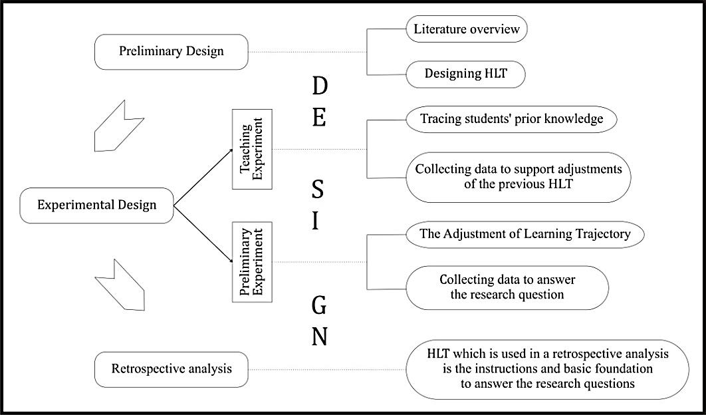
Figure 1. Phase of the design research (Prahmana, Zulkardi, & Hartono, 2012; Prahmana, 2017)

Results and Discussion
The results of this study indicate that research-based learning plays a critical role in developing learning trajectory of research in mathematics education to assisting pre-service mathematics teachers to enhance their research and academic writing skills. There are five main activities in learning path designed. First, 35 pre-service mathematics teachers divide into ten groups to do research independently, review some mathematics education articles, search and observe the current problem issue in mathematics education, and make the research question. Second, pre-service mathematics teachers design and do research based on observation results to answer the research question. Third, all subjects collect and analyze the research data and also draw a conclusion. Fourth, write a full paper based on the research result and publish that article in the journal as a part of dissemination stage. Lastly, students make a portfolio containing all research process and checklist research and academic writing skills questionnaire as an evaluation process in this learning activities.

This study found that students were able to do research, write a scientific paper, and publish it seen from the research results at the end of activities. In total, there are ten scientific papers published in journals. For more details, the researcher will discuss the results of the learning process on each of the three stages in research in mathematics education course as the phases of design research.

Preliminary Design
On this stage, researcher implemented the initial idea about the development of syntax for research-based learning model to enhance students’ research and academic writing skills based on the literature study as previously discussed. After that, researcher conducted observation to Surya College of Education (STKIP Surya) in Tangerang to obtain information about students’ prior knowledge, which further will be used as a basis to design the prototype of Hypothetical Learning Trajectory (HLT).
The development of HLT in every learning activity was the most important part in designing students’ learning activities. This design cannot be separated from the learning trajectory which contains the trajectory of learning material and the concept map which students will go through during the 6 month of learning (Figure 2).
Figure 2. Learning trajectory in research in mathematics education course

A number of activities to conduct research and academic writing have been designed based on the learning trajectory and students’ hypothetical learning process. These instructional activities have been divided into 6 groups of activities for 16 meetings. This study aims to enhance students’ research and academic writing skills through the16 meetings of learning.
The relationship between students’ learning pathways, learning activities, research skills, and academic writing represent the proposed hypothetical learning trajectory (Figure 2). Research-based learning activities which are contained in the Hypothetical Learning Trajectory (HLT) on Figure 2 will be explained in Figure 3.
Figure 3. The development of learning trajectory

Experimental Design
On this stage, researcher tried to do a trial of the developed learning trajectory of research in mathematics education course. The learning process will be explained as follows.
- The activity of “understanding the concept of research methodology”
This activity aimed to explore students’ prior knowledge about research methodology by showing language or students’ understanding about definition of research and its process. To show this, students were given initial tasks in groups (3 – 4 students in each group), that is constructing a mind map about all the things relevant to research methodology. Before going deeper into students’ generated mind maps, lecturer facilitated a class discussion by proposing relevant questions to students. All students looked so active during this discussion, as can be seen through the dialogue at the beginning of learning process below.

Lecturer : “According to you, what is a research?”
Student 1 : “A systematic attempt to obtain a reliable data.”
Lecturer : “Anyone else?”
Student 2 : “A careful and critical investigation to find facts”.
Lecturer : “Anyone wants to add?”
Student 3 : “A certain activity or procedure to solve a problem.”
Lecturer : “Anyone else?” Lecturer keep asking
Student 4 : “A process being conducted systematically which includes data collection and analysis. After being analyzed, certain phenomena will emerge from those data. Nah, those phenomena would attract our attention. Nah, that’s what we called research.”
Lecturer : “Anyone else?” Lecturer keep asking question
Student 5 : “An activity or procedure which is being conducted to solve a problem.”
Lecturer : “Ok. There are key words, aren’t they? What are they?”
Student : “To solve a problem”.

Each of student’s answer tends to use simple terms that suited with their understanding. This is affected by lecturer’s way in giving question which was relaxed and more personal, especially by using the words, “according to you”. Besides, every student seemed very enthusiastic to give their opinions, so that the atmosphere of class discussion was quite lively. All students agreed on one point about research based on their simple understanding. Finally, lecturer asked about the definition of research method and how it is different to research methodology. All students also had their own opinion about it, and through this kind of discussion, students’ understanding about those two points were formed in their own language.
The description of this process was started by dividing students into 10 groups. Each group consists of 3-4 students with heterogeneous skills. These groups were decided based on the result of prior knowledge test about things relevant to research methodology given at the beginning of the lesson.
Next, each group was given a task to construct a mind map about all the things relevant to research methodology (Figure 4). The map from each group were discussed in the class to help all students to grasp the same idea or understanding about the definition of research, various research methods, research variable, research instrument, and research data.
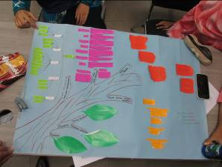
Figure 4. Students’ generated mind map about research methodology

When all students were considered to share the same idea or understanding about research methodology, lecturer distributed students’ worksheets and scientific articles from journal or proceeding. Each group was given 30 minutes to analyze the articles together using the guidance in worksheets (Figure 5).
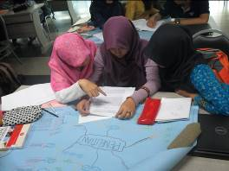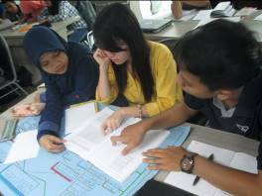
Figure 5. The atmosphere of group discussion while working on worksheet
During this session, students came up with different answers to the questions on the worksheet depends on the articles given to them. This indicates that each student already have understanding about how research is conducted based on their analysis on other researchers’ publication. From the evaluation, it turned out that the highest score was obtained by group 4 with 5.00 (Very Good) and the lowest by group 7 with 3.24 (Good). Overall, the average score for the class is 4.29 which belong to the category of Very Good.

- Class discussion as a stimulation and support for the understanding of research methodology concept
To clarify students’ answer on the worksheets, a class discussion was required. Therefore, lecturer gave an opportunity to any group who wants to present their work. During the discussion, all students seemed very enthusiastic in giving opinions and ideas about the publications, as can be seen in Figure 6. Due to the difference of research methods in each articles, each group provided various new knowledges about research in mathematics education to the class. At the end, lecturer guided the students so that they have the same general idea or understanding about research methodology that there is a relationship between research tittle, research question(s), method, variable(s), subject(s), and result in a single research activity.
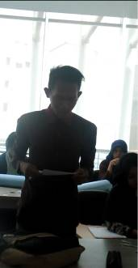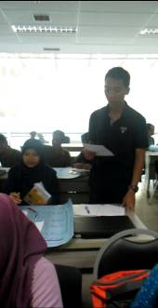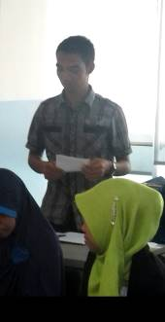
Figure 6. Presentation of the analysis of published articles

- The activity of research design
In this activity, students designed a research in group consists of 3-4 students. The research was designed using students’ worksheet which contained a number of questions about the process of designing a research. From the evaluation of students’ worksheet in this activity, the average score was 3.65 which belong to the category of Good. Group 5 obtained the highest score wit 4.07 (Very Good) and group 10 obtained the lowest score with 2.71 (Satisfactory).
There were two kinds of worksheets used in this activity. The first worksheet was related to research in mathematics education and should be done in group. The second worksheet was related to the research procedure and should be done individually. To work on the first worksheet, students have to use the analysis in the previous meeting as a basis, which include research title, research questions, answer/ solution for the questions, data and instrument for data collection, research method, and how to organize the data. The highest score of this group work indicated that the group was able to design a research so well.
The result of research design activity was then developed to be research proposals and submitted to the Students Creativity Program by Indonesian Directorate of Higher Education Institution (DIKTI). Afterward, the proposals were presented in class to get suggestions from other groups. There were several interesting suggestions came from the students. One is describe as follow.

Student 1: “Your research question, how did you use the LINCAH props to improve the learning achievement elementary school students on Fraction? As a matter of fact, you used experimental method. Nah, as far as I know, a research question started with “how” is supposed to be for qualitative research, which in turn provide explanation as an answer. However, an experimental research is a quantitative research. There are only two answers, yes or no. So, I would suggest this research question is revised to address whether the use of the LINCAH props could improve the learning achievement of elementary school students. Nah, you could only have either one out of two answers, yes or no.” As suggested by a female student.
Student 2: “Thank you for your suggestion.” A member of presenting group replied.

This activity was closed by an evaluation using the second worksheet about research procedure, construction of research instrument, and other important things to be noticed in designing and conducting a research in mathematics education. The evaluation was conducted individually to assess students’ ability in doing a research after a group activity. The result shows that students were able to finish all three questions given within the category of Good (49%), Very Good (34%), and Satisfactory (17%). One of students’ work in the category of Very Good shows that the student was able to make a procedure and construct a research instrument so well, including the data organization and analysis. Overall, the average score of class evaluation belongs to the category of Good.

- Class discussion as suggestion to research design
The class discussion was conducted to obtain suggestions from other groups and lecturer to improve the research design. The material for this discussion was focused on how to make a good instrument, started from constructing an instrument until the validation process. As a matter of fact, research procedure also became an interesting topic in this discussion. This is because all group used the same research method, which was experimental method. Each group had their own version in interpreting the procedure for experimental research. At last, the topic of discussion in this activity was about sampling techniques. As a closure to the discussion, lecturer guided the students to help them share the same ideas or understanding about the procedure to make a research instrument, experimental research, and sampling techniques.

- The activity of research data collection
Beyond the schedule for 16 meetings in class, students constructed research instruments and went to the school (research site) in group to collect data (Figure 7). The test instrument to collect data was validated in advance and then was measured for its reliability.
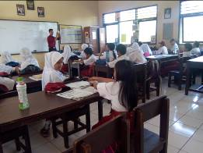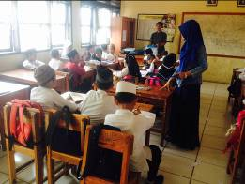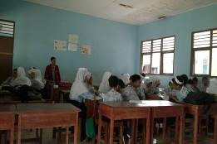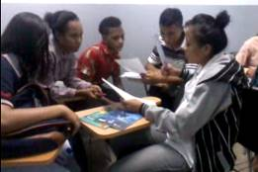
Figure 7. Data collection process in experiment class

The construction of test instrument was started with the making of cards for each question. Overall, each group used test instrument and observation sheet to collect their research data. However, some group constructed additional instruments such as questionnaire and interview protocol. Schools as the source for data were chosen with purposive sampling technique with or without school observation in advance. Half of the researcher groups did observation in advance and 60% of the groups did randomization. Data collection at school was conducted within one month, depends on the type of research chosen by each group (research title can be seen in Table 1). Learning process was documented along with photographs of teaching activities and research instruments, such as lesson plans, activity worksheets, and also pretest and posttest documents. When data collection process came to an end, all groups have to make sure that they have obtained sufficient data to answer their research questions. All data was then collected to be organized simultaneously in class.

Table 1. Research title of each group
No. | Research group | Research title
1 | Group 1 | Improving Students’ Mathematical Understanding through Student-Teams-Achievement Division (STAD) Learning Approach
2 | Group 2 | The Implementation of Talking Stick Learning Model on the Subject Matter of Trapezium and Rhombus Area for Fifth Grade Elementary School Students
3 | Group 3 | Improving Students’ Mathematical Understanding with GASING (Easy, Fun, and Enjoyable) Mathematical
4 | Group 4 | The use of Kobesi in GASING Mathematical Learning Method to Enhance Elementary School Students’ Understanding about Multiplication
5 | Group 5 | Improving Fifth Grade Elementary School Students’ Mathematical Problem Solving Ability on the Subject Matter of Cube’s and Cuboid’s Volume with Vokuba Props
6 | Group 6 | Improving Elementary School Students’ Mathematical Problem Solving Ability through the Implementation of Discovery Learning Model
7 | Group 7 | The Use of Brick Hunter Props to Enhance Students’ Learning Achievement on the Subject Matter of Two-Dimensional Shapes
8 | Group 8 | The Implementation of Numbered-Head Together (NHT) Learning Model on Fifth-grade Elementary School Students’ Mathematical Representation Skills
9 | Group 9 | The Effect of Numbered-Head Together (NHT) Learning Model on Students’ Mathematical Understanding Ability on the Subject Matter of Pythagoras Theorem
10 | Group 10 | The Effect of Problem-based Learning to Enhance Fourth-grade Elementary School Students’ Problem Solving Ability on the Subject Matter of Two-dimensional Figure’s Area and Circumference

This activity was ended with filling in the worksheet of research data collection as a part of evaluation activity to assess students’ achievement. The work of one group below shows that the group has already discovered the relationship between research problem, data, instrument, and data analysis. Overall, each group was able to fill in the worksheets with various outcomes.
The result of this evaluation shows that group 7 and 9 get the highest score with 5.0 which belongs to the category of Very Good, meanwhile group 8 and 10 get the lowest score with 2.6 which belongs to the category of Satisfactory. Overall, the average score for this activity in the class is 4.14 which is Very Good. This result shows that this activity ran quite well in the class.

- The activity of research data organization and analysis
The activity of research data organization and analysis was conducted in class. All groups prepared their data and lecturer facilitated students to organize the data using PSPP software.
One group was given the opportunity to present their research data to be organized and analyzed in class, so that other groups could use it as an example (Figure 8). At the end of data organization activity, each group obtained the result of their data analysis. This data analysis was then become the answer for research question.
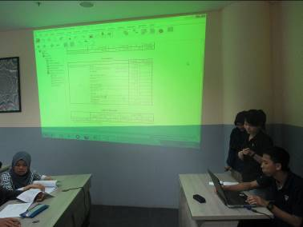
Figure 8. The activity of presenting the result of research data organization
- The activity of writing research report
In this activity, students made their research portfolio in the form of research report. The report contained all documents they used during their research. The making of research report was done beyond class schedule which was preceded by an explanation from lecturer in class about how to make and construct a good research report. At the end of this activity, each group submitted their completed research report. The report served as an assessment for students’ research skills.

- The activity of writing academic paper
The activity of writing academic paper was done in several stages as follow.
- Each group found published papers – as many as possible – from a journal or proceeding relevant to their research.
- Each group started to write academic paper following the guidance in the published paper they found earlier. The guidance contained title, authors’ name, institution, email, abstract, introduction, literature study, research methods, result and discussion, conclusion, and bibliography.
- The content of the academic paper came from their research design and data analysis from previous activities.
- Lecturer gave advice and guidance to each group about good writing, for example: how to expand ideas into paragraph, what a good paragraph is, how to do citation from others’ research report or how to take definition from a book, how to write in such a flow that is easily followed by the reader, how to write bibliography in APA style, and standard rule for writing a scientific article.
- Each group gave their finished draft of paper to the other to get suggestions from other groups and revised their draft based on those suggestions.
- The revised drafts were submitted to lecturer to get suggestions, and then each group did their second revision.

At the end of this activity, each group submitted their final draft. Finally, lecturer assessed the paper from each group prior to being disseminated in a google scholar–indexed national journal. The result of this assessment became the standard for judging students’ academic writing skills.

- The activity of disseminating research report
The final activity in this learning trajectory is the activity of disseminating research report. Dissemination here refers to an activity to communicate students’ research result in the form scientific paper to be published in a google scholar – indexed national journal. Each group must submit their final draft to a national journal through Open Journal System (OJS), which can be shown in Figure 9.
The draft of the scientific paper was matched with the journal template where they want to publish their articles. At the beginning, each group looked for the sites that suite their articles. After that, they read the author guideline section to find out the guidance to write articles in that journal. Most groups chose to download one of the published articles in the journal archives then followed the format. Lastly, each group matched their writing style to the guidance from the journal.
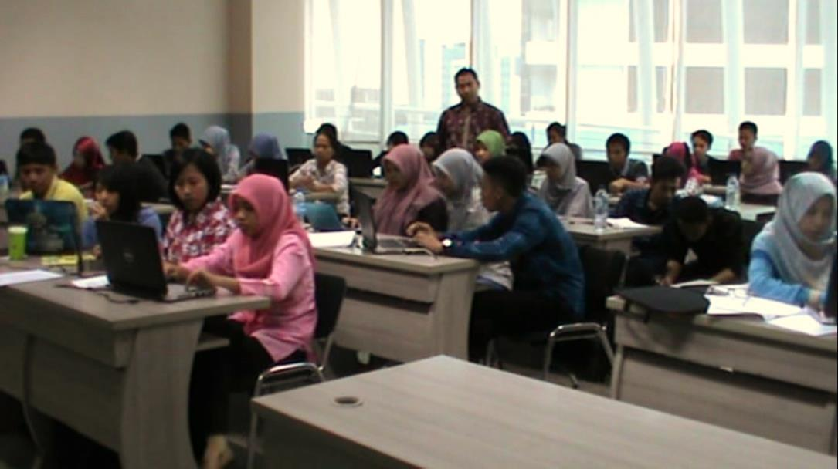
Figure 9. The activity of finding journal websites and submitting scientific articles

At the end of this activity, lecturer guided each group to submit their final drafts to a google scholar–indexed national journal through the Open Journal System. Each group should create an account on the website of the journal. As soon as the account was verified, they logged in to the website then followed the steps of online submission, started from writing personal identities until uploading the paper file along with its data. Lastly, each group received an email informing that their draft was already in the database of OJS to be processed further until being published, as can be seen in Figure 10.
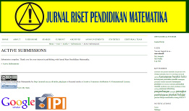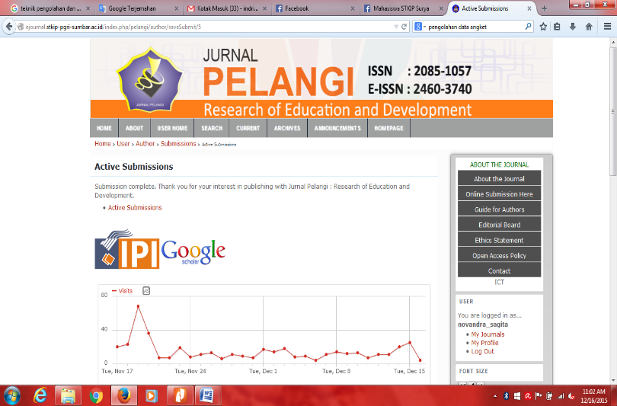
Figure 10. The display of journal website after completing online submission

Retrospective Analysis
On this stage, researcher did a retrospective analysis to all research reports to answer the research questions mentioned at the introduction section. Data analysis was conducted by comparing the observation result during the learning process as a pilot experiment with the preliminary designed HLT. Each of the two research questions will be answered by explaining the learning process of pilot experiment.
The stages being used as the guidance in this research are the stages in research-based learning which the learning activities have been modified. All of the stages were used as the guidance in designing learning trajectory of research in mathematics education course to enhance students’ research and academic writing skills. As a matter of fact, the learning process provided interesting explanation to answer the research question as follow.

To what extent do the learning trajectory on research in mathematics education by using research-based learning in assisting the students of mathematics education department to enhance their research and academic writing skills?

That research question will be answered by the activity of research-based learning (using research-based learning model). The enhancement of students’ research and academic writing skills due to the learning process will be explained based on the indicator of each skill.
- Formulating research question
After the research-based learning process came to an end, all students were given a project to do a research on mathematics education in group consists of 3 - 4 students. Each group decided the problems related to mathematics education that they want to solve through experimental research. Next, they were given evaluation questions related to everything relevant to previous research. All evaluation questions were constructed based on the indicators of research skills which have been formulated in the literature study section. The first indicator is represented by the first and second question in the evaluation.
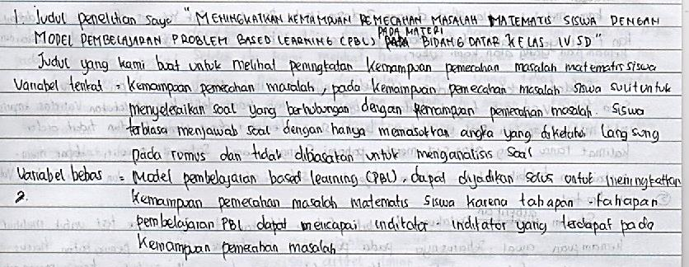
Figure 11. The example of student’s research title and the explanation
The title of my research is "Enhancing students' mathematical problem solving ability by using the model of Problem-Based Learning (PBL) in 2D dimension subject in the fourth grade”. The title that we made to see an increase in students' mathematical problem solving ability.
The dependent variable: problem-solving ability. In problem-solving ability, students are difficult to solve problems related to the understanding of problem solving. Students are accustomed to answering questions by adding the variable directly in the formula and are not accustomed to analyze the problem.
The independent variables: Problem-Based Learning (PBL) model can be used as a solution to improve students' mathematical problem-solving ability because the learning stages of PBL can achieve the indicators contained in problem-solving ability.
The first question is related to research title and relevant explanation to it. All students wrote their research titles, an example can be seen in Figure 11. An interesting point was that the students were able to explain each variable in their research and noticed the relationship between the treatment and the expected outcome. Overall, the average score for the students on this question is 3.87 which belong to the category of Good.
The next question shows that students were able to formulate their research questions so well which was relevant to the title that they have explained in the previous question. Besides, they were able to show the relevance between research question, purpose, and title, as can be seen in Figure 12. Indirectly, the explanation also described how data collection would be done to answer the research question. Overall, the average score for the students on this question is 4.13 which belong to the category of Very Good.
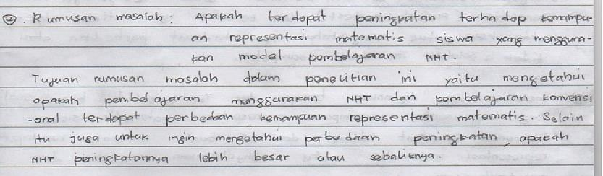
Figure 12. A student’s research question

- Finding necessary relevant information
Prior to doing research, each group found necessary relevant information to support their research. Researcher facilitated each group with a student worksheet as guidance. As a result of the evaluation at the end of learning process, each student was able to explain the activities they did to find relevant information for their research. Those activities were divided into two categories: by doing observation and by doing literature study.
Students were able to explain observation activity and why they did it. Besides, the group who chose literature study was also able to explain how the activity was done and why they did that. The answers given by the students shows that they were able to find relevant information to support their research very well. These finding information activities were different for each group since it depended on their research. However, each student understood why they had to do the activities either it was observation or literature study. Overall, students’ average score on this question is 3.69 which belong to the category of Good.

- Deciding on the appropriate research method to solve research problem
Each group had already figured out what and how research in mathematics education is. This knowledge came from the activity of analyzing published papers with different research methods. Throughout this activity, students were able to learn directly from other researchers’ experiment in doing research with certain research method. Students could read and discuss the research result in group and decide what research method they would use for their own research.
During the evaluation, most of the students were able to write down very well what method they would use for their research. Moreover, they were also able to explain the method, the procedure, and why they chose the method for their research. Overall, the average score for the students on this question is 3.70 which belong to the category of Good.

- Making a research design
After deciding research method to be used, each group designed their research. The research design here was more to the research procedure that they would do. Researcher distributed worksheet to help students to design and conducted a class discussion to allow each group to get suggestions from others. This discussion was really helpful for each group to perfect their research design.
At the evaluation, students’ were able to write down and explain their research design very well. They explained the construction of research instrument, validation, data collection, data analysis, until drawing a conclusion and making research report. This finding shows that the students were able to design a research based on their experience doing research in the learning process. Overall, the average score for the students on this question is 4.30 which belong to the category of Very Good.

- Constructing research instrument to collect data
The activity of constructing research instrument was started with filling in the worksheet of data collection and analysis. In this worksheet, each group decided what research instrument they would use to answer their research question. After that, each group made question cards in advance for test instrument, validated the test (expert-judgement and empirical validation), and then measure the reliability of the test. The purpose of these activities was to make sure they have good research instruments so that the result can be defended.
At the evaluation of the learning process, students were able to explain the procedure of constructing the research instruments very well. The procedures were more focused on the test instrument. This is because most students chose experimental method for their research with pretest and posttest as the instrument to collect data. Students’ answers shows that they were able to make the procedure to construct good research instrument, started from deriving questions from indicators of learning outcomes, validating and measuring reliability, as can be seen in Figure 13. Overall, the average score on this question is 3.34, which belong to the category of very good.
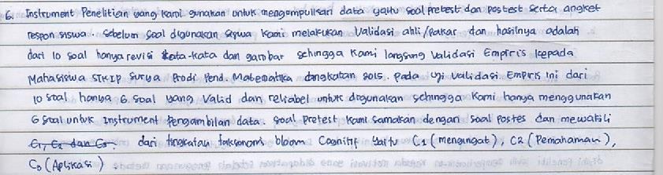
Figure 13. Several procedures of constructing research instrument
The research instruments that we use to collect the data are pretest, posttest, and questionnaire. Before the instruments use for student, we do expert validation and the result are ten items questions with the revision in words and pictures, so we direct empirical validation to the students. In empirical validation, ten questions became six questions that are valid and reliable to use. Thus, we only use six questions for the instrument of data collection. The problems of pretest and posttest are same and represent bloom taxonomy of cognitive levels, namely C1 (remember), C2 (comprehension), and C3 (application).

- Deciding on research data resources (sampling techniques)
Students created mind maps in group about everything they knew that related to research methodology, including how to decide on data resources. Through this activity, students discovered various sampling techniques and how to do it. Next, they applied their knowledge on deciding the appropriate techniques to their research simultaneously.
Students were able to write down and explain the sampling techniques that they used in the group research very well. From the explanation in Figure 14, it can be seen that they were able to decide which sampling techniques should be used based on the research questions. Overall, the average score on this question is 3.81 which belong to the category of Good.
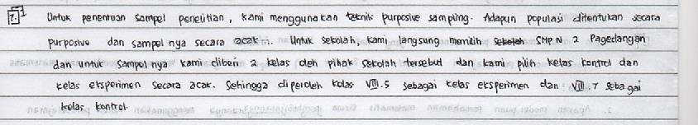
Figure 14. Sampling techniques used by the students in their research
For prescribe the sample of our research, we used purposive sampling technique. The population is determined by purposive and its sample is random. For the school, we immediately chose junior high school namely SMP N 2 Pagedangan and for the class we were given two classes by teacher. We select the control and experimental class at random, thus obtained VIII-5 as the experimental class and VIII-7 as a control class.

- Organizing and describing the collected research data
Students gathered a lot of data during data collection activity, such as videos, photographs, interview scripts, questionnaire, and pretest and posttest scores. Hence, they had to organize and describe the data using the worksheet of research data collection and analysis as guidance.
At the evaluation, students were able to explain how they did the activity of organizing and describing their research data very well. This can be seen from students explanation which one them used assessment rubrics to describe research data. Overall, the average score on this question is 3.01 which belong to the category of good. There was a significant difference from individual result on this indicator. This was because some of the students were not actively involved in the activity of organizing and describing research data from the previous group research.

- Analyzing research data, interpreting, and drawing conclusion.
The activity of analyzing research data, interpreting, and drawing conclusion was done during learning process and guided by lecturer. The data was analyzed with PSPP software with the procedure that has been explained in advance. This activity was conducted after all group finished collecting their research data.
As soon as the evaluation ended, students were able to explain the analysis of research data after all the data was complete. The analysis was focused on the data. Next, based on the analysis, students answered the research questions and drew a conclusion. Overall, the average score on this question is 3.16 which belong to the category of Good.
This result shows that through the research experience in this course, students were able to analyzed research data, interpret the data, and drew a conclusion from it. However, the activeness of each student in each group caused the individual score to be not really good. Only those you stood out in the group who obtained high scores on this indicator.

- Communicating the result of research in the form of published paper in a journal
The activity of disseminating research result in the form of published paper which was done during the learning process in class gave the students an experience f how to communicate their result in the form of articles. The making of these articles was done in group during the learning in class with several writing stages. After that, the drafts of the articles were submitted to be published in a google scholar-indexed journal through Open Journal System (OJS).
The result from evaluation shows that the students were satisfactorily able to explain the process of communicating their research result in the form of a scientific article published in google scholar-indexed journal. Most students were able to explain about the stages of making good scientific articles and the procedure of publishing the articles. However, most of them were still in the category of satisfactory. Overall, the average score on this question is 2.26 (Satisfactory).
In addition, the result of this study shows that the research based learning was able to enhance students’ skills in doing research, similar to the research finding by Widayati, et al. (2010), Waris (2009), Webb; Smith; Worsfold (2011), GIHE (2008), and University of Adelaide (2009). The difference of the result of this study to other studies was on the result of the research conducted by the subjects. These result focused more on the research on mathematics education and the dissemination stage was pushed until being published in a journal. In this study, 20% of the subjects were able to reach level 3, which means scaffolded research, and the other 80% were on level 4, which means student-initiated research, based on the framework of research skills by Willison & O’Regan (2007).
The level of students’ research skills was decided based on the result of data of students’ self-evaluation both in group and individually. This data was collected through self-assessment instrument of students’ research skills. The indicators of research skills were derived from every question on the assessment sheet (see Prahmana, 2015). The result shows that the highest average of individual score belong to group 9 with 3.64 (category of level 4) and the lowest average score belong to group 10 with 3.0 (category of level 3), meanwhile the average individual scores of other groups were in between 3 and 4 (category of level 3), with the overall average score 3.36 (the category of level 4). Lastly, the highest group score belong to group 3 and 4 with 4.0 (category of level 4), and the lowest score belong to group 8 with 3.0 (category of level 3), whereas the scores of other groups stays in between 3.0 and 4.0 (category of level 4), and the overall average of group score is 3.48 (category of level 4).
The result of lectures’ study which aimed to see students’ ability to conduct research was slightly different. This data was collected through final evaluation sheet which was constructed based on research skills indicators (see Prahmana, 2015). As a result, the highest average of individual score belongs to group 4 with 4.33 (category of level 5) and the lowest score belong to group 1 with 2.88 (category of level 3). Meanwhile, the average individual score of other groups stays in between 3.00 and 4.00 (category of level 3), except group 8 whose average individual score is 4.08 (category of level 5). If the average of all group scores was counted, it would be 3.50 (category of level 4). Lastly, the highest group score belong to group 3 and 4 with 4.0 (category of level 3) and the lowest score belong to group 8 with 3.0 (category of level 3). The scores of other groups stays in between 3.0 and 4.0 (category of level 4), with all the average of all group score is 3.48 (category of level 4).
In addition, the developed learning trajectory which was developed using research-based learning was also able to enhance students’ skills in writing academic paper. This statement was based on the result of evaluation on students’ academic writing skills. The rubric for this evaluation was constructed based on the indicators of academic writing skills, assessed by peer lecturers and the assessor team.
The assessment result from peer lecturer shows that the highest score belong to group 9 with 4.41 (category of Very Good) and the lowest score belong to group 6 with 2.65 (category of Satisfactory). Overall, the assessment result from peer lecturers is 10% in the category of Satisfactory, 40% in Good, and 50% in Very Good. This was slightly different to that of the assessor team, which shows that the highest score belongs to group 9 with 4.52 (Very Good), and the lowest score belong to group 4 with 3.06 (Good). Overall, the result from assessor team is: 70% in the category of Good and 30% in the category of Very Good

Conclusions
The use of research-based learning in designing learning trajectory of research in mathematics education plays a crucial role as a trigger to enhancing math department preservice teachers’ research and academic writing skills. This result was shown by the final product of this study, which is ten students’ research and ten submitted articles in a journal with ISSN and is indexed by google scholar through Open Journal System (OJS). The developed learning trajectory was the one that students must go through to enhance their skills in doing research and writing an academic paper, started from analyzing journals until communicating their research result in the form of scientific articles published in a journal with ISSN and is indexed by google scholar. This learning trajectory consists of 7 activities designed by the researcher to help the students enhance their research academic writing skills. This study produced a local instruction theory as a contribution to research in mathematics education to enhance preservice teachers’ skills in doing research and writing academic paper, which developed yet in Indonesia. This theory provides an explanation of the steps that preservice teachers’ must go through using research-based learning. The enhanced research skills were focused more on the trend in research in mathematics education, and the improved academic writing skills were focused more on the articles published in a journal.

References
Arcavi, A. (2000). Problem-driven research in mathematics education. The Journal of Mathematical Behavior, 19(2), 141-173.
Cryer, P. (2006). The Research Student’s Guide to Success, 3th Edition. Berkshire: Open University Press, McGraw-Hill Education.
Dowse, C., & Howie, S. (2013). Promoting academic research writing with South African masters’ students in the field of education. In T. Plomp & N. Nieveen (Eds.) Educational Design Research - Part B: Illustrative Cases (pp. 851-879). Enschede: SLO.
Gravemeijer, K. (2004). Local instructional theories as means of support for teacher in reform mathematics education. Mathematical Thinking and Learning, 6(2), 105-128.
Griffith Institute for Higher Education (GIHE). (2008). Research-Based Learning: Strategies for Successfully Linking Teaching and Research. Queensland: University of Griffith.
López, P., & Alsina, Á. (2016). Creencias de los futuros maestros sobre la aptitud matemática: consideraciones para promover procesos de cambio en la formación inicial. Bolema, Rio Claro (SP), 30(56), 892-905.
Majelis Profesor Riset Lembaga Ilmu Pengetahuan Indonesia. (2007). Kode Etika Peneliti. Jakarta: Lembaga Ilmu Pengetahuan Indonesia.
Miguel, A. (2016). Historiografia e terapia na cidade da linguagem de wittgenstein. Bolema, Rio Claro (SP), 30(55), 368-389.
Plomp, T. (2013). Educational design research: An introduction. In T. Plomp & N. Nieveen (Eds.) Educational Design Research - Part B: Illustrative Cases (pp. 10-51). Enschede: SLO.
Prahmana, R.C.I. (2015). Hubungan antara keterampilan meneliti dan pembuatan skripsi mahasiswa pendidikan matematika. Numeracy, 2(2), 70-78.
Prahmana, R.C.I. (2017). Design Research. Jakarta: Rajawali Pers.
Prahmana, R.C.I., & Kusumah, Y.S. (2016). The hypothetical learning trajectory on research in mathematics education using research-based learning. Pedagogika, 123(3), 42-54.
Prahmana, R.C.I., Kusumah, Y.S., & Darhim. (2016). Keterampilan mahasiswa dalam melakukan penelitian pendidikan matematika melalui pembelajaran berbasis riset. Beta, 9(1), 1-13.
Prahmana, R.C.I., Zulkardi, & Hartono, Y. (2012). Learning multiplication using Indonesian
traditional game in third grade. Journal on Mathematics Education, 3(2), 115-132.
Rios, D.F. (2016). Memórias de ex-alunos do colégio de aplicação da bahia: contribuições para a história da educação matemática. Bolema, Rio Claro (SP), 30(56), 1223-1243.
Santos, J.R.V., & Lins, R.C. (2016). Movimentos de teorizações em educação matemática theorization movements in mathematics education. Bolema, Rio Claro (SP), 30(55), 325-367.
Singhal, M. (2004). Academic writing and generation 1.5: Pedagogical goals and instructional issues in the college composition classroom. The Reading Matrix, 4(3), 1-13.
Siswono, T.Y.E. (2010). Penelitian Pendidikan Matematika. Surabaya: Unesa University Press.
Tim Penyusun KKNI Dikti. (2013). Kerangka Kualifikasi Nasional Indonesia dan Implikasinya pada Dunia Kerja dan Pendidikan Tinggi. Jakarta: DIKTI.
University of Adelaide. (2009). A Handbook for Research Skill Development and Assessment in the Curriculum. Adelaide: the Australian Learning and Teaching Council Ltd.
Waris, A. (2009). Model Pembelajaran Berbasis Riset (PBR) di Program Studi Fisika ITB. Berita Pembelajaran, 6(2), 1-3.
Webb, F., Smith, C., & Worsfold, K. (2011). Research Skills Toolkit. Queensland: Griffith Institute for Higher Education.
Widayati, D.T., Luknanto, D., Rahayuningsih, E., Sutapa, G., Harsono, Sancayaningsing, R.P., & Sajarwa. (2010). Pedoman Umum Pembelajaran Berbasis Riset. Yogyakarta: Universitas Gadjah Mada.
Willison, J., & O’Regan, K. (2007). Commonly known, commonly not known, totally unknown: A framework for students becoming researchers. The Higher Education Research and Development, 26(4), 393-409.

