Chairul Huda Atma Dirgatama. (2017). The Effectiveness Of Archieved E-Book Based Curriculum 2013 As An Effort To Improving Learning Outcomes In Vocational School. Journal of Education and Learning. Vol.11 (3) pp. 405-410.

The Effectiveness Of Archieved E-Book Based Curriculum 2013
As An Effort To Improving Learning Outcomes
In Vocational School

Chairul Huda Atma Dirgatama*
Magister of Economic Education, Sebelas Maret University

Siswandari**
Program of Teacher Training & Education, Sebelas Maret University

C. Dyah Sulistyaningrum Indrawati***
Program of Teacher Training & Education, Sebelas Maret University

Abstract
In digital era, the role of media as a helping tool in the process of teaching learning is very important. It is also the right choice in improving the quality of education. The purpose of this research is to find out whether archived e-book based curriculum 2013 which has been developed is effective to improve the learning outcomes in Vocational School. This was a research and development study. The data for the media developed used Sigil software with the help of Supreader software. The instrument was validated by experts. The instrument used in this study was a questionnaire and tests. Interviews and observations were analyzed with descriptive qualitative, whereas the questionnaire and test were analyzed by descriptive quantitative tests. This study used SPSS 20 and IBM software to calculate the data. Based on the analysis, the mean score of experimental group was 81.25 and the control group was 75.94 for their post-test. The t-test score for t-observed was 2.53 meanwhile the t-table was 2.00. The null hypothesis was rejected because t-observes was higher than t-table. It implied that the experimental group performed better than the control group. The conclusion was that learning media using archived e-book based curriculum 2013 was effective to improve learning outcomes. It was based on the t-test calculation in the significant error of 0.05. So there was a significant difference between the mean score of experimental and control group.

Keywords: Archived E-Book, Curriculum 2013, Learning Outcomes

* Chairul Huda Atma Dirgatama, Magister of Economic Education, Sebelas Maret University
E-mail: chairul.huda@student.uns.ac.id
**Siswandari, Program of Teacher Training & Education, Sebelas Maret University
E-mail: siswandari@staff.uns.ac.id
***C. Dyah Sulistyaningrum Indrawati, Program of Teacher Training & Education, Sebelas Maret University
E-mail: ciciliadyah@staff.uns.ac.id

Received July 1, 2017; Revised July 15, 2017; Accepted Agustus 18, 2017

Introduction
Technology advance in globalization era today is expected to enable Human Resource (HR) to be competitive in world realm. Therefore, human beings should have quality. To achieve the intended quality, education should be directed to the mastery and the establishment of competencies the human being needs in order to be competitive in the world realm thereby improving a nation’s quality.
Considering observation and interview the author has conducted in SMK Negeri 1 Surakarta on the learning process, the following data were obtained: 1) Teacher still uses lecturing and teacher-centered method in delivering the material, 2) learning media has not been used maximally yet, 3) learning still uses conventional textbooks, 4) e-book has not been used as a media in archiving learning in the school. In this case, the student learning activity has not been equipped with a media oriented to the students’ mastery of competency.
In preparing the Vocational Middle school graduates ready for the world realm, the learning activity in the curriculum of 2013 emphasizes on the process and active learning skill by applying scientific approach so that the role learning media becomes more important. E-book facilitates the students in learning independently so that the students can learn corresponding to their ability and can meet the competency the students should master (Liaw & Huang, 2014; Chen, 2013; Bradshaw, 2005). In education realm, learning media is an integral part of the learning method used Mune & Agee,2016; Bozkurt & Bozkaya, 2015; Tosun, 2014; Ezaleila, 2013). Media use can make the abstract more concrete thing and can make the uninteresting learning circumstance the interesting one (Akyuz & Yavuz, 2015; Gan, Menkhoff &Smith, 2015; All, Nunez, & Looy, 2015). Many learning media are created for independent learning today; however to find an actually good choice or solution of learning aid to make the learning process effective, attractive, interactive and joyful is still a problem needing the solution.
Existing e-book is expected to attract the students’ attention and interest in order to be motivated to learn. Thus, E-book can improve the students’ learning outcome in learning activity. For that reason, this research develops and studies the development of Archived E-Book Based Curriculum 2013 as the attempt of improving the learning outcome in SMK Negeri 1 Surakarta in 2016. The objective of research was to examine the effectiveness of Archived E-Book Based Curriculum 2013 developed to improve the learning outcome in SMK Negeri 1 Surakarta in 2016.This study was a Research and Development type. The development model used in this research was Hannafin and Peck’s development design. Hanafin and Peck’s model is one of product-oriented learning design models. Product-oriented model is a learning design model to produce a product, usually learning media (Tegeh, Jampel & Pudjawan, 2014:1). This learning design model consists of three stages: need analysis, design, and development & implementation. Techniques of collecting data used were interview, observation, questionnaire, documentation and learning outcome test.

Methods
This research was conducted at Juli-Desember, 2016 in SMK Negeri 1 Surakarta. This research was categorized research & development. One group pretest- posttest design. In this study, subjects were given a questionnaire about Archived E-Book Based Curriculum 2013before and after the learning processes. The subjects of this study were office administration students of class I who take Vocational School courses, as many as 32 students.
Data processing obtained using normality test and homogeneity test. The normality test serves to see if the experimental class and control class variances are normal or not. Normality test is done by liliefors test which basically uses baseline data. While the homogeneity test serves to determine the variance of the two homogeneous classes or not through the test bartlet. Furthermore, the t-test is calculated to determine whether there are differences in learning outcomes achieved between the control class and the experimental class after implementing the e-book learning media based on the curriculum of 2013.
There are instruments used to collect data on this research are:
- Observation
Observation is used to collect and record things that are important in teaching and learning activities and see the students in the process of testing the developed product. In this case the observation is done by direct observation so as to strengthen the information obtained as an effort to overcome the problems that arise in the learning.
- Interview
Interviews were used in the early stages of preliminary study to find out the initial conditions of the learning process at the location of the research sites. Interviews are very effective for researchers to use as additional data. In this case the interviews are responses, criticisms, suggestions, and inputs related to products developed before use.

- Questionnaire
Questionnaires are used at the time of evaluation before and after product trials of material and media experts. While questionnaires for learners are used to determine the response of learners and teachers to the media developed. In this case the questionnaire or questionnaire as an efficient data collection techniques if researchers know with certainty the variables to be measured and understand what is expected by the respondents.
- Test
The test is done on the learner after using the developed product that is learning media on learning process. In this case, the test results are used to determine the effectiveness of the media developed by the researcher.
- Documentation
This documentation is used to collect data from the research location, the name of the learners, the name of the teacher and some guidelines in the making of materials used in the learning media. The document is for evidence to support the quality of the data and evidence of the validity of the data obtained.

The data obtained in the research in the form of qualitative and quantitative data. Qualitative data is obtained from the analysis of needs and observations of the class at the time of implementation of e-book archives based on the curriculum 2013. While the quantitative data obtained from the product validation questionnaire, questionnaire test, questionnaires after the test used to measure the feasibility of the product, and tests given to participants Educate to know the effectiveness of the products that have been developed.

Result and Discussion
The development procedure consists of three stages: need analysis, design, and development & implementation.
- Need Analysis
The development of Archived E-Book Based Curriculum 2013 was started with need analysis. Need analysis is the initial step prior to the development of media; thereby the need should be identified in following up the development of media planned in the original design. In this case, the analysis was conducted to obtain data and supporting information in media development so that the media yielded will be consistent with the media users’ need later.
Considering the need analysis conducted, it can be concluded that teacher found difficulties in delivering some learning materials. The subject existing is archiving. The teacher, in this case, found difficulties as well in preparing a creative and innovative learning media that can trigger the students’ spirit and motivation to learn thereby improving the learning outcome of students in archiving subject later. This learning media development was supported with adequate infrastructures such as LCD, laptop, and smartphone that can be used easily by the students as the learning media users.

- Design
Media designing was conducted based on the result of an in-depth observation on the need analysis activity constituting the early step in preparing a learning media production. In this stage, the following stages were conducted:
- Setting out Basic Competency
- Selecting and collecting material
- Designing the material map
- Designing GBIM (Media Content Outline)
- Preparing storyboard
- Displaying the design

- Development and implementation stage
This development of e-book media started with preparing text, picture, and video necessary in learning material; the process of developing the Archived E-Book Based Curriculum 2013 was conducted by organizing the material in line with the syllabus of archiving subject using sigil as the main software. The organization of learning material using sigil software consisted of picture, writing and video so that the students can be interested in attending the learning and can facilitate the students to understand the existing learning material. Then, the Archived E-Book Based Curriculum 2013 media in the material to be delivered uses supreader assupporting software. In this stage, editing and revision on the Archived E-Book Based Curriculum 2013 media used in archiving learning process.

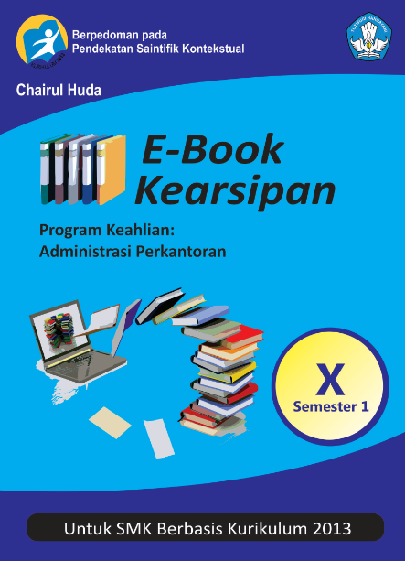
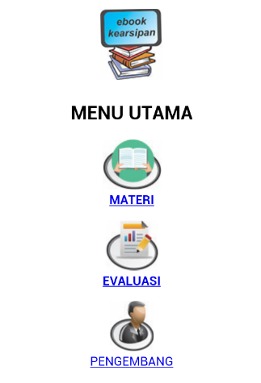

Figure 1. E-book Cover Figure 2. Main menu of E-book

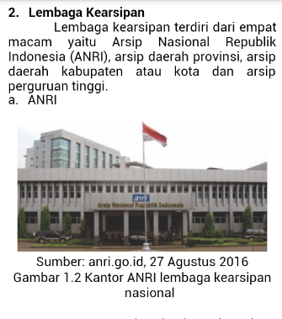
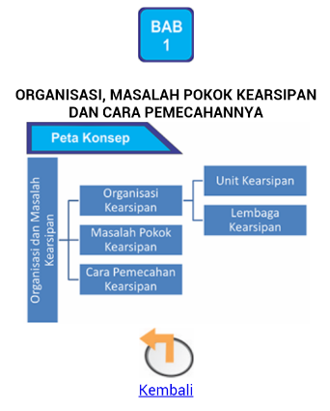

Figure 3. Concept Map Figure 4. Learning Material

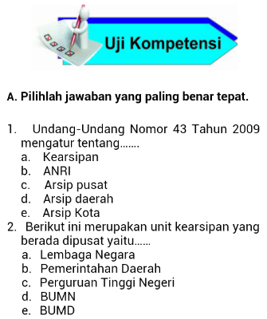
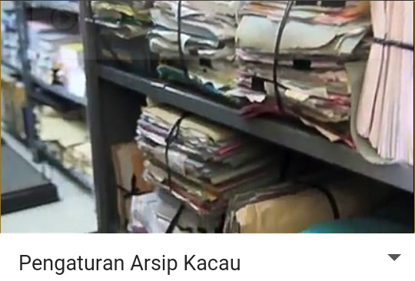

Figure 5. Video Figure 6. Competency Test

Considering the t-test (independent samples test) duringpretestbetween experiment and control class, the significance value of t-testis 0.160. This significance level is more than 0.05 meaning that H₀ is supported and t_{statistic} value is 1.421< t_{table} 2.00. It indicates that there is no significant difference of mean learning outcome score between the students in experiment and those in control class during pretest, and then the experiment class was treated using Archived E-Book Based Curriculum 2013 media.
The result of posttest assessment shows that the mean posttest score is 81.25 for the experiment class, and 75.94 for the control class. Considering such the result, the experiment class has higher learning outcome value than the control class does. The result of experiment class score before using Archived E-Book Based Curriculum 2013 media was 62.97 and having been treated using Archived E-Book Based Curriculum 2013 media this score increased to 81.25. The increase in the students’ learning outcome score in archiving subject before (pretest) and after (posttest) using Archived E-Book Based Curriculum 2013 media indicates that the Archived E-Book Based Curriculum 2013 media improves the students’ learning outcome in archiving subject effectively.
From the result of t-test (independent samples test) assessment (posttest) for experiment and control classes, it can be found that the significance level of t-test is 0.014. The significance value is less than 0.05 meaning that H₁ is supported and t_{statistic} is 2.531 > t_{table} 2.00. It indicates that there is a significant difference of mean learning outcome score between the students in experiment and those in control classes. The result shows that experiment class has better learning achievement than the control class does, meaning that the experiment class using obtains the mean posttest value higher than the control class not using Archived E-Book Based Curriculum 2013 media.
EPUB-based file in the Archived E-Book Based Curriculum 2013 media is usable and flexible because it can be installed into computer, pc, laptop, smartphone, and gadget thereby it is portable can be used anytime and anywhere. That is why the Archived E-Book Based Curriculum 2013 media is acceptable to its users. E-book is easy to use and the use is necessary particularly to write the assignment or to work on the project. It can indirectly improve its learning effectiveness (Roesnita & Zainab: 2005).
Effectiveness is an ability in selecting an appropriate objective or instrument to achieve the intended objective. Effectiveness, according to Handoko (2003: 7), is usually defined as the level of success achieved by certain way or attempt corresponding to the objective to be achieved. It is in line with Trianto (2010: 24) stating that learning effectiveness is the useful output of the teaching-learning activity implementation.

Conclusions
Based on this study, it can be concluded that the implementation of archived e-book based curriculum 2013 in Vocational High School is very effective for improving learning outcomes. The use of archived e-book based curriculum 2013 improves the students’ learning outcome as supported with statistical calculation and significance level of 0.014 < 0.05 in which there is a significant difference of mean score between experiment (81.25) and control classes (75.94). Considering the mean learning outcome score of posttest (after treatment), it could be concluded that the score of experiment class is better than that of control class.

Acknowledgement
The author thank to Magister of Economic Education and SMK N 1 Surakarta so that the study can be completed.

References
Akyuz, Serhat & Yavuz, Fatih. (2015). Digital Learning in EFL Classrooms. Procedia-Social and Behavioral Sciences, pp 766-769.
All, Anissa., Patricia Nunez Castellar, Elena., Van Looy, Jan. (2015). Assessing the effectiveness of digital game-based learning: Best practices.Journal Science Direct Computers & Education, pp 90-103.
Bozkurt & Bozkaya. (2015). Evaluation Criteria for Interactive E-Books for Open and Distance Learning. International Review of Research in Open and Distributed Learning. Vol.16, No. 5. pp. 1-25.
Bradshaw. (2005). Multimedia Textbooks and Student Learning. MERLOT Journal of Online Learning and Teaching, Vol 1, No.2, pp 1-9.
Chen, H. Y. (2013).Exploring The Reasons For Using Electric Books And Technologic Pedagogical And Content Knowledge Of Taiwanese Elementary Mathematics And Science Teachers. Journal TOJET: Educational Technology, 12(2), 131-141.
Ezaleila. (2013). Buku Elektronik: Ulasan Persuratan terhadap Kesedaran dan Penggunaannya. Jurnal Pengajian Media Malaysia, Vol 15, No.1, pp.. 113-117.
Gan, Benjamin., Menkhoff, Thomas., Smith, Ricard. (2015). Enhancing students’ learning process through interactive digital media: New opportunities for collaborative learning. Journal Science Direct Computers in Human Behavior 51 (2015) 652–663.
Handoko, Hani. (2003). Manajemen Sumber Daya Manusia. Bandung: Salemba Empat.
Liaw & Huang (2014). Investigating Learner Attitudes Toward E-Books as Learning Tools: Based on The Activity Theory Approach. Journal Interactive Learning Environments. ISSN: 1049-4820.
Mune & Agee. (2016). Are e-books for everyone? An evaluation of academic e-book platforms' accessibility features. Journal of Electronic Resources Librarianship. Vol. 28, No. 3. pp. 172-182.
Roesnita & Zainab A.N. (2005). The Pattern of E-Book Use Amongst Undergraduates In Malaysia: A Case of to Know is to Use. Malaysian Journal of Library & Information Science. VoL 10, No. 2, pp. 1-23.
Tegeh, Jamel & Pudjawan. (2014). Model Penelitian Pengembangan. Yogyakarta: Graha Ilmu.
Tosun, Nilgün. (2014). A Study On Reading Printed Books Or E-Books: Reasons For Student-Teachers Preferences. Journal TOJET: Educational Technology, Vol 13, No. 1, pp. 21-28.
Trianto. (2010). Mendesain Model-Model Pembelajaran Inovatif Progresif. Jakarta: Kencana Media Pranada Group.

