The Correlatıon Between Generıc Scıence Skıll and Bıology Learnıng Results of Publıc Junıor Hıgh Schools In Ambon Usıng Scıentıfıc Approach

Prelly M.J. Tuapattinaya, Dominggus Rumahlatur*
Biology Education Study Program, Faculty of Teacher Training and Education Science, Pattimura University

Article Info |  | ABSTRACT
Article history:  Received Jun 12, 201x  Revised Aug 20, 201x  Accepted Aug 26, 201x |  | The improvement of the quality of education is influenced by the students’ learning success, as measured by the students’ generic skill combined with an innovative approach to trigger their thinking skills. One of them is a scientific approach which implements the students' knowledge of the natural surroundings. The purpose of this research was to determine the correlation between generic science skills and students’ Biology learning results on plant movement material in Junior High Schools in Ambon using scientificapproach. This is a correlational research using the instruments of the rubric of generic science skill and cognitive tests. The design of this reserch is the analysis of the effect of generic science skill variables (X₁) and the school origin (X₂) toward the students’ learning results (Y) with the design of one group pretest-posttest. The data ontained were descriptively analyzed and through covariate analysis and correlation analysis. The results of this research showed that learning by using scientific approach had the average score of 0.740 with high category (Junior High School 6 Ambon), while learning using conventional approach had an average score of 0.219 with low category (Junior high school 9 Ambon). In addition, the biology learning result score of the students in some junior high schools in Ambon on the material ofplant movement systems taught by using scientific approach experienced an increase, inwhich the students’ biology learning results after taught by uisng scientific approach achieved 85.68-100.00% with very good category compared to that taught by using the conventional approach, which was 39.51-89.04% with fair until very good catagory. The results of the correlation analysis showed that there is a strong correlation (r = 0.6) between generic science skills and biology learning results on the conceptof plant movement of Junior High School students in Ambon.
Keywords:

Learning results

Generic science skills
Scientific approach
Junior High Schools in Ambon
Copyright © 201x Institute of Advanced Engineering and Science.
All rights reserved.
Corresponding Author:
Dominggus Rumahlatu,
Biology Education Study Program, Faculty of Teacher Training and Education Science
Pattimura University,
Jl. Ir. M. Putuhena, Campus Poka-Ambon 97233, Indonesia.
Email: dominggus_amq@yahoo.co.id

INTRODUCTION
The quality of education is one of the main problems in developing countries (Kremer et al., 2013; Schweisfurth, 2011). The education system in Indonesia, especially in the field of science at the level of junior high schools (SMP) carried out by Trend in International Mathematic and Science Study (TIMSS) in 2015 that showed Indonesia ranked 45 out of 48 countries (TIMSS, 2015). It shows that science education in Indonesia is very low. Taber (2017) revealed that the science learning has a very strategic role in improving the quality of human resources, thus it needs to be improved. One strategy that must be done is by implementing innovative learning approach and able to increase students’ motivation (Schweisfurth, 2011; Tapilouw and Juanda, 2009).
Learning approach which is considered to be optimal in improving science education is a scientific approach. Scientific approach is a learning process that is designed to make learners actively construct concepts, laws or principles through the stages of observing (identifying or finding problems), formulating problems, proposing or formulating hypotheses, collecting data with a variety of techniques, analyzing data, drawing conclusions and communicating the concepts and principles found (Irfan et al., 2017; Park and Chen, 2012). Another thing that determines the success in improving science education is the students’ basic ability to undergo the learning process. This basic ability is known as generic skills. Baharom and Palaniandy (2013) state that generic science skills are skills that can be used to study a variety of concepts and solve problems in science.
To date, generic science skills are only applied in the fields of physics and chemistry, so it is considered to be necessary to begin applying it in the field of biology. Generic skills is included as the ability which is obtained from science learning results based on empirical experience or case study and science knowledge acquired during the learning process (Nghia, 2017; Osman, 2011). The empirical experience and generic science skills possessed by junior high students are mostly related to Biology learning material, such as on the material of plant movement system. Based on preliminary observations in Junior high school 4, Junior high school 6, and Junior high school 9 Ambon in the learning process, particularly biology, the material of plant movement is considered to be appropriate to be used in the implementation of scientific approach. This is because all the three schools have an environment that has many overgrown plants, thus it can be used as a medium of learning material related to plant movement.
In addition to learning media, what made the students' knowledge of plant movement was still not maximal were due to several factors, such as teachers had not used the appropriate learning approach, teachers more often used lecturing methods as thier teaching methods, the lack of opportunities for students to express the concept that they learnt personally, and the memorization system without understanding the concept taught by the teachers. This condition caused the knowledge of class VIII students was still passive to the material of plant movement (Hong et al., 2015; Osman 2011).
In relation to these problems, the appropriate solutions were needed to improve the science learning results, especially the material of plant movement, through the application of scientific approaches toward students’ generic skills and their learning results. The purpose of this research was to know the correlation between generic science skill and biology learning results of junior high school students in Ambon on the material of plant movement using scientific approach.

RESEARCH METHOD
This research was conducted in June 2016 in Junior high school 4, Junior high school 6, and Junior high school 9 Ambon. This is a correlational research to investigate the correlation between generic science skills and Biology learning results on the material of plant movement of the Junior high school students in Ambon using scientificapproach. The instruments used in this research were the rubric of generic science skill and cognitive test. The design used in this research was analysis of the effect of generic science skill variable (X₁₎ and the school origin (X₂) toward students’ learning results (Y) using one group pretest-posttest design. The research subjects were the students of class VIII (VIII-A) of Junior high school 4, Junior high school 6, and Junior high school 9 Ambon as many as 31 students. The learning material taught was the material of plant movement. The data obtained were then descriptively analyzed.
- Generic science skills
The students’ generic science skills were assessed using 2 instruments, as follows:
1) KGS Rubric (Creswell, 1994; Susanti et al., 2010)
$$\text{KGS Rubric Score =}\frac{\text{Score PL+MK+IF}}{\text{Minimal Score}}\text{×100\%}$$

Table 1. Criteria of KGS rubric
Interval Class | Final score (alphabet) | Classification
81% - 100%  61% - 80%  41% - 60%  21% - 40%  ≤20% | A  B  C  D  E | Very good  Good  Fair  Poor  Very poor

2) KGS test (Creswell 1994; Susanti et al., 2010)
$$\text{N-gain = }\frac{\text{PostTest Score}-\text{PreTest Score}}{\text{Max Score}-\text{PreTest Score}}$$

Table 2.Criteria of KGS test
Criteria | Predicate
Ng ≥ 0.7 | High
0.3 ≤ Ng ≥ 0.7 | Medium
Ng <0.3 | Low

- Learning results (Creswell, 1994; Susanti et al., 2010)

$$\text{"Percentage of Student Answers"}\text{= }\frac{\text{Score gained}}{\text{Max Score}}\text{×100\%}$$

Table 3.Criteria of learning results
Interval Class | Final score (alphabet) | Classification
81% - 100%  61% - 80%  41% - 60%  21% - 40%  ≤20% | A  B  C  D  E | Very good  Good  fair  Poor  Very poor

To investigate the correlation between scientific approach toward generic science skill and learning results of the students of Junior high school 9, Junior high school 4, and Junior high school 6Ambon, Analysis of Covariate (Ancova) and correlation test Product Moment using SPSS 16,0 were used.If the significance >0.05, the hypothesis H₀ was accepted and H₁ was rejected, and if the significance <0.05, the hypothesis H₁ was acceptedand the H₀ was rejected. The data of students’ concept gaining stage 3 were analyzed by calculating the N-Gain in which the difference in N-gain score between the experimental group and the control group was analyzed by using independent t-test.

RESULTS AND ANALYSIS
Scientific Approach to Improve Generic Science Skills of junior high school students in Ambon
The scientific approach used in the Biology learning material of plant movement is known to improve the generic science skills of the students of Junior high school 4, Junior high school 6, and Junior high school 9 Ambon. The students’ generic science skills were measured using 2 instruments as follows.

Generic Science Skill Rubric
The generic science skill rubric used in this reseach aimed at measuring the students’ basic skill. The generic science skill rubric was structured in a special format with the assessment aspects developed from generic science skill indicators. The students’ score increase on the generic science skill rubric using scientific approach can be seen in Table 4.
Rubric score (Table 4) shows indirect observation indicator using scientific approach has the highest average, which was 100% with very good category compared to that of the conventional learning approach, which was 69,35% with good category. Indirect observation indicator in this research was to observe a video of endonomic plant movement and to observe video of esionom plant movement covering taksis movement and nasti movement on plants. The students in this process made an indirect observation of the object by using learning videos, because the observed objects could not be derectly observed using the human senses (Buckley and Quellmalz, 2013; Gobaw and Atagana, 2011; Kremer et al., 2013). The rubric score of direct or indirect observation for scientific approach obtained the highest score of all the three schools that became the samples of this research, namely Junior high school 9, Junior high school 6, and Junior high school 4 Ambon. The highest rubric score for the indicator of the concept construction (CC) and logic inference (LI) was achieved by the students of Junior high school 6 Ambon, followed by the students of Junior high school 9 and 4 Ambon. This is presumably because the learning atmosphere factor in Junior high school 6 Ambon is better than the other schools. Based on the observation of annual achievement, Junior high school 6 Ambon is superior in the field of Biology (Siwalima, 2015).

Table 4. Recapitulation of rubric score comparation of generic science skills using the conventional approach and the scientific approach
Coverage score of generic science skill | School Origin | Percentage (%)
 |  | Conventional |  |  |  | Scientific
 |  | Endonom movement | Esionom movement | Average | Category | Endonom movement | Esionom movement | Average | Category
Direct observation (DO) | Junior High School 9 | - | 39.51 | 39.51 | Poor | - | 100 | 100 | Very good
 | Junior High School 4 | - | 40.78 | 40.78 | Poor | - | 100 | 100 | Very good
 | Junior High School 6 | - | 52.3 | 52.3 | Fair | - | 100 | 100 | Very good
Indirect Observation  (IO) | Junior High School 9 | 63.7 | - | 69.35 | Fair | 100 | - | 100 | Very good
 |  | - | 75 |  |  | - | 100
 | Junior High School 4 | 65.79 | - | 68.12 | Fair | 100 | - | 100 | Very good
 |  | - | 70.45 |  |  | - | 100
 | Junior High School 6 | 80.02 | - | 79.71 | Fair | 100 | - | 100 | Very good
 |  | - | 79.4 |  |  | - | 100
Concept building  (CB) | Junior High School 9 | 82.79 | 83.87 | 83.33 | Very good | 84.94 | 93,81 | 89.375 | Very good
 | Junior High School 4 | 81.80 | 83,50 | 82.65 | Very good | 8 1.99 | 92.34 | 87.165 | Very good
 | Junior High School 6 | 89.73 | 88.35 | 89.04 | Very good | 93.01 | 95.83 | 94.42 | Very good
logic Inference  (LI) | Junior High School 9 | 39.51 | 54.83 | 47,17 | Fair | 83.87 | 87.50 | 85.685 | Very good
 | Junior High School 4 | 40.66 | 60.20 | 50.43 | Fair | 79.03 | 85.89 | 82.46 | Very good
 | Junior High School 6 | 55.00 | 63.20 | 59.10 | Fair | 87.90 | 90.73 | 89.315 | Very good

While the indicators of direct observation by a scientific approach have the average of 100% with very good category, compared to the average of direct observation using the conventional approach which was 39.51% with poor category. The indicator of direct observation in this research was to observe esionom movement including the tropism movements in plants through the observation outside the classroom. Students made direct observations of the object by using their senses. This indicator guided the students to be able to use their sensory organs as much as possible to have direct observation (Buckley and Quellmalz, 2013;Tapilouw and Juanda, 2009). The improvement of learning results occured because students were directly involved in learning activities aimed at araising the students’ curiosity (Baharom and Palaniandy, 2013).
The average of the indicator of concept building using scientific approach reached 89.37% with very good catagory compared to the average of concept building using conventional approach, which was 83.33%. The indicator of concept building in this research was to ask concepts that had not been understood when the students were making a video observation, observation outside the classroom, and practicum, as well as answering every question on the students’ work sheet. On this indicator, the students had to built the concepts related to the material of the practicum and had to be brave to ask related concepts that had not been understood (Buckley and Quellmalz, 2013; Gobaw and Atagana, 2011; Kinchin, 2011). The achievement results on this indicator was very good because students bravely asked concepts that had not been understood, so that their understanding increased. Students were also able to answer the questions in the students’ worksheet well, so that the average score of the students’ concept building was catagorized as very good. The results of this research were in line with the research by Wallert and Provost (2014), revealing that the indicator for concept building for science material increased after the students were taught by using appropriate learning approaches.
The score of the indicator of logical inference using scientific approach 85.68% catagorized as very good, the average of logical inference using conventional approach was 47.17% with fair catagory. The application of the indicator of logical inference in this research was to make conclusions based on the results of observations conducted via video, observations outside the classroom and lab. The students were asked to make conclusions related to the results of their lab work that had been done, and then the students presented it in front of the class (Buckley and Quellmalz, 2013; Osman, 2011).

Generic Science Skill Tests
The generic science skill test used in this research aimed at measuring the students’ basic skills based on knowledge. The score of generic skill science test was measured based on pre-test scores and post test scores. The score results of the generic science skill test of the junior high school 9 students in Ambon using the scientific and conventional approach can be seen in Table 5.

Table 5. Recapitulation of the comparison of the scores of generic science skill test using conventional approach and scientific approach
School | Learning | Average | Category
Junior High School 9 Ambon | Conventional | 0.219 | Low
 | Scientific | 0.551 | Medium
Junior High School 4 Ambon | Conventional | 0.244 | Low
 | Scientific | 0.304 | Medium
Junior High School 6 Ambon | Conventional | 0.35 0 | Low
 | Scientific | 0.740 | High

Table 5 shows that learning by using scientific approach has the highest average score reaching 0.740 with high category obtained by students of Junior High School 6 Ambon, while learning using conventional approach has the lowest average, reaching 0.219 with low category obtained by students Junior High School 9 Ambon.

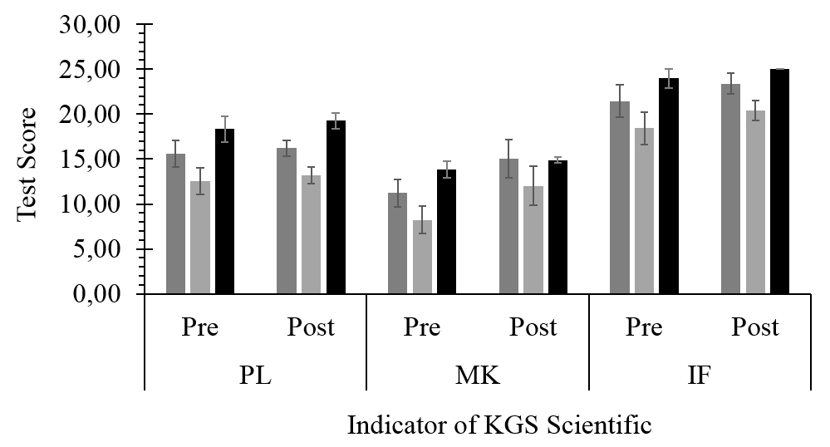
Figure 1. Histogram of the comparison of the average scores of direct observation indicators (PL), concept building (MK), and logic inference (IL) on students' generic skills (KGS) Scientific through pre-test and post-test at Junior High School 9 Ambon ();Junior High School 4 Ambon (), and Junior High school 4 Ambon ()

The increase of low category is seen from the logic inference indicator. While the increase of medium category is seen from the indicators of direct observation and concept building. This research is supported by the research by Wallert and Provost (2014), describing that each indicator of generic science skills increased, but with different categories, namely low and medium. The increase with low catagory was on the indicator of indirect observation and awareness indicator. While the approach with medium category was on the indicators of symbolic language, logic inference, causal law, modeling, and concept building. The high average test score of generic science skill was seen based on problem solving skill, learning skills and personal attributes including commitment, honesty, enthusiastic, trustworthy and having a healthy mind (Coles and McGrath, 2013). The increase of generic skills in direct observation was because of KGS (generic science skill). The increase score of the understanding of endonom movement and esionom movement in plants is thought to be very important because direct observation stimulates visual memory in recalling an occurence (Connell et al., 2016; Kinchin, 2011).
KGS method was successful in improving the indicators of concept building in understanding the concepts of endonom and esionom movements in plants. The mature and organized concepts, particularly in the exact sciences such as biology, are a crucial stage because it can affect the development of neurons and a representation of a condition in the field (Dasgupta et al., 2016). The students’; ability in logic inference also increased after the students were taught by using KGS learning. It is thought that the endonom and esionom movements in plants improve students' learning performance based on empirical experience (Zangori and Forbes, 2016).

Scientific Approach to Enhance Students’ biology learning results in Junor high school in Ambon
Scientific approach in biology learning is expected to increase the score of students’ learning results. However, it should be understood that there is a covariate factor in the assessment of learning results, namely the KGS, so that the factor of the assessment location is not the sole factor affecting students’ learning results. The results of this research show that scientific approach could improve the biology learning results of the students of Junoir high school 4, 6, and 9 in Ambon on the learning material plant movements measured by using tests before the learning process (pre-test) and after the learning process (post-test) which can be seen in Figure 2 below:

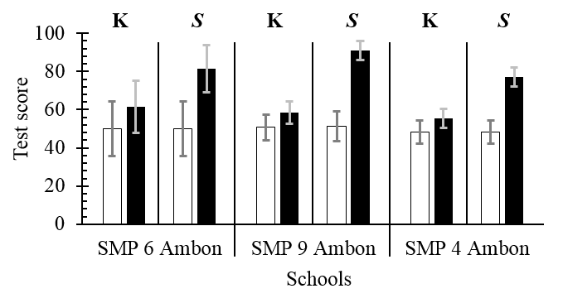
Figure 2. Recapitulation of biology learning results of junoir high school (SMP) students through a pre-test () And post-test ();control approach (K) and Scientific approach (S)

The results of this research on figure 2 above show that there is an increase in the score of the students’ biology learning results in Junior high school 9 Ambon on the material of pllant movements after the students had been taught by using scientificapproach. The students’ biology learning results measured by using tests before the learning process (pre-test) reached 60.08% with fair catagory and the score of the pre-test using the conventional approach was 67.83% with fair catagory. The increase of the students’ learning results occured after the learning process measured from the results of post-test. The students’ biology learning results measured after the learning process (post-test) using a scientific approach obtained 90.67% with very good vatagory, compared to the students’ biology learning results measured after the learning process (post-test) using the conventional approach ontaining 74.54 with good catagory.
The average of the students’ biology learning results using scientific approach is classified as high catagory compared to the students’ biology learning results using conventional approach. Hassard and Dias (2013) state that the difference in students’ learning results seen from the increase between the pre-test and post-test showing the initial ability of students to solve problems and to reconstruct ideas experience a change. The score of the post-test using conventional approach tends to be low because the students did not understand about the material of plant movements and because of the students’ tendency in making mistakes in working on test items. Thus, scientific approach is needed to improve students’ cognitive learning results compared to the previous learning (Irfan et al., 2017). Through a scientific approach, students feel chalanged in the learning process which results on the increase of Biology learning results. This is because the scientific approach engage the students to directly infer pthe existing problems in the form of curiosity and reading (Machluf and Yarden, 2013).

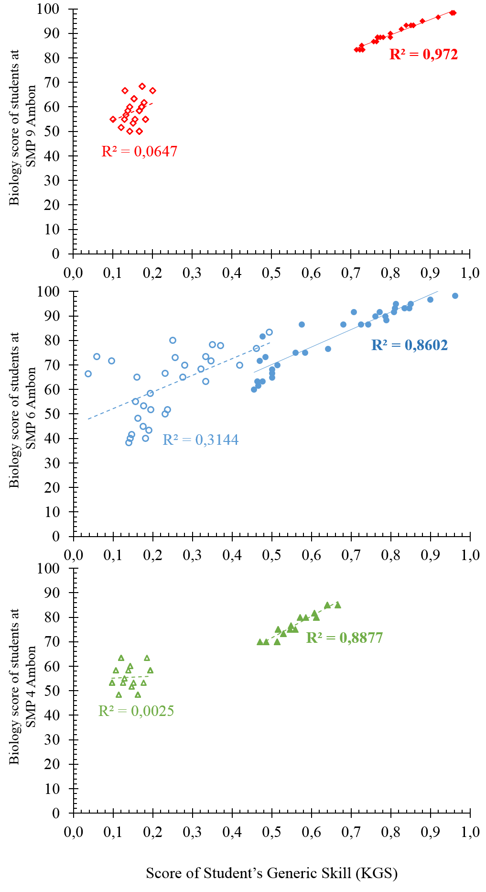

Figure 3. Multicorrelational correlation of the biology score of junior high school students with students’ generic skills using conventional approach (thin) and scientific approach (thick).

Scientific approach in the material of plant movement included the learning results seen from the cognitive aspect, namely through the activities of knowing, understanding, applying, analyzing, evaluating, and creating. Thus, it can be said that learning activity has a correlation with learning results. This is in line with the opinions of Suldo et al. (2014), that students’ activity is one of the factors affecting the students’ learning results, the higher the student's activity during the learning process, the higher the learning results will be achieved.

The correlation between Generic Science skill and Biology learning results of Junior High School Students in Ambon
The correlation analysis between scientific approach and generic science skills and students’ learning results used multicorrelational analysis. The results of the correlation analysis of Product Moment showed that there is a strong correlation between Generic science Skills and biology learning results of the concept of plant movement system of the students of junior high school 4, 6, and 9 Ambon, especially using a scientific approach. It can be seen from the value of R ^{2>} 0.8 for each junior high school in Ambon (Figure 3). This correlation occurs because the students who have good science generic skills must have good biology learning results. This is in line with the research by Lartson (2013), that improving student learning results can also improve students’ generic science skills.
Student success can be measured from the students’ basic skills in undergoing the learning process. The measurement of students’ generic science skills can be used to know that students have made a difference in the learning process. It means that the students have experienced a learning process that changes their understanding. It can be clearly seen from the learning score of every school which are given scientist approach. The correlation value (R²⁾ of Conventional KGS which is lower than Scientific KGS shows that differences in learning methods provides a change (Figure 3). Every learning process will always have real results and can be measured, that is the students’ learning results. Rosario et al. (2013) reveals that learning results are the students’ abilities after they receive a learning experience.
The implementation of learning by using a scientific approach can be used as an alternative to solve learning problems such as low generic science skills and low biology learning results of the students of junior high school 9 Ambon. Scientific learning, in addition to providing a solution to the teacher in teaching, is also able to increase generic science skills (Edward, 2011). This is because the scientific learning is student-centered learning, as the learning process that the students experience, such as observing, questioning, gathering information, reasoning, and communicating, and combined with the indicators of generic science skills including the indicators of direct observation, in concept building and logical inference.

CONCLUSION
The correlation between scientific approach and generic science skill and biology learning results of the concept of plant movement system of the students of Junior High School 4 (R² = 0.88), Junior High School 6 (R² = 0.86), and Junior High School 9 Ambon (R² = 0.97) is relatively strong (r> 0.6). The value of the learning using scientific approach has the highest average reaching 0.740 with high category (Junior High School 6 Ambon), while the learning by using conventional approach has the lowest average reaching 0.219 with low category (Junor High School 9 Ambon). In addition, the score of the students’ biology learning results in some junior high schools in Ambon on the material of plant movement system after taught by using scientificapproach experience an increase, in which the students’ biology learning results assessed after the learning by using scientific approach achieved 85.68 to 100.00% with very good category compared with the conventional approach from 39.51 to 89.04% with fair until very good category.

ACKNOWLEDGEMENTS
The authors thank the Dean of the Faculty of Teacher Training and Education Science, Pattimura University by the Research Grants for Lecturers fiscal year 2016.

REFERENCES
Baharom, S., and Palaniandy, B. (2013). Problem-Based Learning: A Process for the Acquisition of Learning and Generic Skills. The 4th International Research Symposium on Problem-Based Learning (RSPBL), 47-55.
Buckley, B.C., and Quellmalz, E.S. (2013). Supporting and assessing complex biology learning with computer-based simulations and representations. Multiple representations in biological education (pp. 247-267). Dordrecht: Springer.
Connell, G.L., Donovan, D.A. and Chambers, T.G. (2016). Increasing the use of student-centered pedagogies from moderate to high improves student learning and attitudes about biology. Life Sciences Education, 15(1), ar3.
Coles, A., and McGrath, K. (2013). Teaching in Post-compulsory Education: Policy, Practice and Values. Routledge.
Creswell, J.W. (1994). Research Design: Qualitatif and Quantitatif Approaches. California: Sage Publications, Inc.
Dasgupta, A.P., Anderson, T.R. and Pelaez, N.J. (2016). Development of the neuron assessment for measuring biology students’ use of experimental design concepts and representations. CBE-Life Sciences Education, 15(2), p.ar10.
Edward, K. 2011. Looking intro early childhood teacher support of childern’s scientific learning. Australasian Journal of Early Childhood, 36(2), 28-35.
Gobaw, G.F. and Atagana, H.I. (2016). The Relationship Between Students'biology Laboratory Skill Performance And Their Course Achievement. Problems of Education in the 21st Century, 72.
Hassard, J. and Dias, M. (2013). The art of teaching science: Inquiry and innovation in middle school and high school. Routledge.
Hong, J.C., Hwang, M.Y., Liu, M.C., Ho, H.Y. and Chen, Y.L. (2014). Using a “prediction–observation–explanation” inquiry model to enhance student interest and intention to continue science learning predicted by their Internet cognitive failure. Computers & Education, 72, 110-120.
Irfan, M., Sugiharto, S. and Hidayah, T. (2017). The Implementation Of Scientific Approach To The Pjok Learning At The Target Secondary Schools Of The 2013 Curriculum In North Sumatra. The Journal of Educational Development, 5(1), 12-19.
Kremer, M., Brannen, C. and Glennerster, R. (2013). The challenge of education and learning in the developing world. Science, 340(6130), 297-300.
Kinchin, I.M. (2011). Visualising knowledge structures in biology: Discipline, curriculum and student understanding. Journal of Biological Education, 45(4), 183-189.
Lartson, C.A. (2013). Effects of design-based science instruction on science problem-solving competency among different groups of high-school traditional chemistry students (Doctoral dissertation, University of Colorado).
Machluf, Y. and Yarden, A. (2013). Integrating bioinformatics into senior high school: design principles and implications. Briefings in bioinformatics, 14(5), 648-660.
Nghia, T.L.H. (2017). Developing generic skills for students via extra-curricular activities in Vietnamese universities: Practices and influential factors. Journal of Teaching and Learning for Graduate Employability, 8(1), 22-39.
Osman, K. (2011). The inculcation of generic skills through service learning experience among science student teachers. Procedia - Social and Behavioral Sciences, 18(2011), 148–153.
Park, S and Chen, Y-C. (2012). Mapping out the integration of the components of pedagogical content knowledge (PCK): Examples from high school biology classrooms. Journal of Research in Science Teaching, 49(7), 922-941.
Rosário, P., Núñez, J.C., Ferrando, P.J., Paiva, M.O., Lourenço, A., Cerezo, R. and Valle, A. (2013). The relationship between approaches to teaching and approaches to studying: A two-level structural equation model for biology achievement in high school. Metacognition and learning, 8(1), 47-77.
Schweisfurth, M. (2011). Learner-centred education in developing country contexts: From solution to problem?. International Journal of Educational Development, 31(5), 425-432.
[Siwalima] Siwalima. (2015). Jadikan Nira Kelapa sebagai Bioetanol, SMPN 6 Ambon Raih Juara III LPIR Nasional [Making Nira Kelapa as bioethanol, Junior high school 6 Ambon Won III LPIR National]. http://www.siwalimanews.com/post/smpn_6 ambon_raih_juara_iii_lpir_nasional (accessed on February 17, 2017).
Suldo, S.M., Savage, J.A. and Mercer, S.H. (2014). Increasing middle school students’ life satisfaction: Efficacy of a positive psychology group intervention. Journal of happiness studies, 15(1), 19-42.
Susanti, R., Rustaman, N.Y., Redjeki, S. (2010). Profile Material Difficulty Level of Plant Physiology According to Prospective Biology Teachers. In: Procedding of the 4th International Seminar on Science Education, B9-1 – B9-6. Science Education Program School of Postgraduate Studies, Indonesia University of Education, Bandung, West Java. ISBN 978-979-99232-3-3.
Taber, K.S. (2017). The Nature of Student Conceptions in Science. In Science Education (pp. 119-131). SensePublishers.
Tapilouw, F.S. and Juanda, E.A. (2009). How interactive multi media (imm) affected students’cognition in learning biology at the middle and higher education level?. In: Procedding International Conference on Rural Information and Communication Technology, 209-215.
Trends in international mathematics and science study (TIMSS). 2015. TIMSS 2011 International Results in Science. Online at https://nces.ed.gov/timss/timss15.as. accessed on January 24, 2017.
Wallert, M.A., and Provost, J.J. (2014). Integrating standard operating procedures and industry notebook standards to evaluate students in laboratory courses. Biochemistry and Molecular Biology Education, 42(1), 41-49.
Zangori, L. and Forbes, C.T. (2016). Development of an Empirically Based Learning Performances Framework for Third‐Grade Students’ Model‐Based Explanations About Plant Processes. Science Education, 100(6), 961-982.

