Modification of *CSE-UCLA* Model Using *Weighted Product* in Optimizing Digital Library of Learning Support

**Dewa Gede Hendra Divayana**

Department of Information Technology Education, Universitas Pendidikan Ganesha

|  |  |  |
| --- | --- | --- |
| **Article Info** |  | **ABSTRACT** |
| ***Article history:***  Received Feb 12, 201x  Revised Mar 20, 201x  Accepted Mar 26, 201x |  | The purpose of this research was to know the implementation of the design model evaluation of *CSE-UCLA* modified by the *weighted product* method into an application evaluation and conduct field trials against simulation application in order to obtain a reliable application used in evaluating digital library services as a complementary learning process at a computer College in Bali. The method that was used in this research was R&D, with a model design of the Borg and the Gall consists of 10 stages of development. However, specialized on research this year implemented making the application and field trials as a form of implementation of the draft models that have been produced the previous year. The subject of the research involved in the simulation field trials as much as 2 education experts and 2 informatics experts. Technical analysis in this research was descriptive statistics. The results obtained in this research in the form of applications that have been tested and ready to use for the test on the more respondent and wider coverage. |
| ***Keywords:***  Evaluation Application  *CSE-UCLA*  *Weighted Product*  Digital Library |
| *Copyright © 201x Institute of Advanced Engineering and Science.  All rights reserved.* |
| ***Corresponding Author:***  Dewa Gede Hendra Divayana,  Departement of Information Technology Education,  Universitas Pendidikan Ganesha,  Jl. Udayana No. 11 Singaraja, Bali, Indonesia.  Email: [hendra.divayana@undiksha.ac.id](mailto:hendra.divayana@undiksha.ac.id) | | |

1. **INTRODUCTION**

The current study process is inseparable from the development of information technology. This happens because the learning strategies, learning model or supporting facilities learning process based on information technology is widely applied in schools or colleges in various forms such as: e-learning, digital libraries, e-teaching, and more. These statements have the same perception with the results of research that has been conducted by Divayana, Suyasa and Sugihartini [1] stating that the development of the world of education can greatly facilitated through a variety of learning models utilizing information technology, such as: e-teaching, computer based instruction, and e-learning.

However, advances in information technology remains won't be able to replace completely the role of educators in making the learners as intelligent beings and behave well through wisdom arising from the experience shared by educators. Information technology can facilitate the needs probably just supporting, such as for example digital learning materials, digital library, and other needs in the learning process, but the experiences of educators in addressing the problems-problems/difficulties found in the learning process that concerns the realm of attitude or motivation of learning are certainly very difficult resolved through the help of information technology.

It is well known with that until the current developments and advances in information technology can only be used to help support the learning process and can not replace completely the duties and functions of the educators in the learning process. One form of the development of information technology is used as a complementary learning process is digital library. Through the digital library of all parties (ranging from educators to with learners) can obtain information about the source/learning materials quickly and easily accessible regardless of where they are located.

Almost in some colleges, especially in the field of computer college both public and private in the Bali already has a digital library as a container to support the learning process. However, to date not yet known definitively the effectiveness/optimal of digital library implementation, which was held at several colleges.

To be able to find out the effectiveness of the evaluation activities need to be done, because in essence the evaluation aims to obtain a recommendation or input against a program that has been implemented for the revision/perfectly program to the next. This is in accordance with statement of Marwanto and Djatmiko [2] States that “An evaluation activities need to be carried out in order to obtain a very input about what remains to be done to the programs that have been carried out and that should be corrected, so that the results of the evaluation can be used as a considerations for drafting the next program”.

Simply, evaluation can be interpreted as determining a value against an object is observed. It is similar to the statements expressed by Muchoyar, *et al*. [3], stating that “the evaluation can be defined simply as the determination of the value of something”. Basically the definition of evaluation in accordance with the statement of several research results from some researchers, among others: Divayana, Adiarta and Abadi [4]-[7], Arnyana, *et al*. [8], Jampel, *et al.* [9], Suandi, Putrayasa and Divayana [10], Divayana and Sanjaya [11], Divayana, *et al.* [12]-[15], Divayana, Ardana and Ariawan [16], Divayana [17]-[20], and Ardana, Ariawan and Divayana [21], which states that the evaluation is an activity undertaken by the evaluators in collecting and analyzing the data collected through the measurement process with a valid measurement tool, so produce the right recommendations to assist in decision making.

Evaluation activity should be prepared an evaluation tool to know the success rate of an object being evaluated. This situation was accordance with the statement of Widarwati, Budiastuti and Karomah [22] stating that “the creation of a tool evaluation is an activity that must be done, because the evaluation tools can be used to know the success rate”.

In order for the evaluation tool can be used to measure precisely against the object being evaluated, then it needs a suitable evaluation models to evaluate objects that are evaluated. There are several models of evaluation that can be used to evaluate learning support facilities, such as common and known by its evaluators including education, i.e. the *CIPP* model, model-oriented goals, and stake model. From some of these models, the most suitable for evaluating digital libraries as one of the supporting facilities of learning were the *CSE-UCLA* model. This statement was reinforced from the results of research conducted by Divayana [23], which essentially states that the selection of *CSE-UCLA* model was used in evaluating the quality of digital libraries based on expert systems applied at Universitas Teknologi Indonesia was very suitable, because the *CSE-UCLA* model was very appropriate to be used in evaluating the service program, where the digital library included as one of the services program or program support the learning process.

Another advantage owned model *CSE-UCLA*, so it is appropriate to evaluate a digital library is to have a program component implementation that is able to evaluate the procedure of introducing / promoting the existence of a particular program/service/object/policy. However, behind the advantages possessed by the *CSE-UCLA* model, there are also disadvantages i.e. hasn’t been able to coherent shows in the evaluation results of the highest category down to the lowest on each evaluation component, so that will be visible aspects of the evaluation section which needs to be done. This was confirmed from the research results that have been published by Divayana [17], which just shows the percentage level of quality digital library-based expert system which was held at Universitas Teknologi Indonesia of 69.76% and hasn't been able to show the rank in coherent the evaluation results of the highest category down to lowest for each evaluation components.

From some of these problems, so it was appropriate to modify the *CSE-UCLA* evaluation model using a method called *weighted product*. Using this method was capable of ranking the evaluation results on each evaluation components from the highest category down to the lowest category based on the weighting of each evaluation aspects given by the decision maker.

The result of modification to *CSE-UCLA* model using *weighted product* method is a desktop application capable of displaying evaluation results with accurate calculations as recommendations that can be used by the Head of Library in universities in making decisions/policies in order to optimize digital library services.

Based on the problems and general solutions offered to solve the problem, it can be clarified problem formulation in this research is: “How form and application of *CSE-UCLA* evaluation model modified with *weighted product* method?”. Based on the formulation of these problems, generally the main purpose of this research is to know the application form of *CSE-UCLA* evaluation model which has been modified using *weighted product* method and the simulation of its application in evaluating the digital library service in computer colleges in Bali.

This research is a second year research based on the result of research which has been implemented by Divayana, Adiarta, and Abadi before in 2017. In the first year research has been produced the design of *CSE-UCLA* evaluation model modified by *weighted product* method [4]. However, the limitations found in the first year are limited to the design of the design and limited trials of the design which involves only two educational experts and 2 informatics experts. This research is also based on the obstacles found from self-directed research conducted by Divayana [17], where the results show that the evaluation application of digital library is still static, so that it will have difficulties if new evaluation aspect is needed.

1. **RESEARCH METHOD**

The research was carried out using R & D research (Development and Development) research method, with Borg and Gall model design which has 10 stages, including [24]: 1) research and field data collection, 2) planning research, 3) design development, 4) initial test , 5) revision of initial test results, 6) field trials, 7) field trial revisions, 8) trial usage, 9) final product revisions, and 10) dissemination and final product implementation.

In the first year implemented five stages, including: 1) research and field data collection, 2) planning research, 3) design development, 4) initial test, and 5) revision of initial test results. Meanwhile, in the second year implemented the application to realize the model design that has been produced in previous years to be ready field tested. Research subjects involved for field trials in this second year as much as 2 education experts, 2 informatics experts, and 10 evaluators. Selection of research subjects using purposive sampling technique. The location of this research was carried out in several existing computer colleges in Bali Province. Instruments used in collecting data in the form of questionnaires, interview guides, and documentation. The analysis technique that was used in this research was descriptive statistic.

1. **RESULTS AND ANALYSIS**

This research has obtained the result of application based on *CSE-UCLA* evaluation model that has been modified with *weighted product* and for field test result in this paper only explained with simulation of field trials conducted by 4 respondents. As a general view of the application based on *CSE-UCLA* evaluation model that has been modified, can be seen in Figure 1-3.

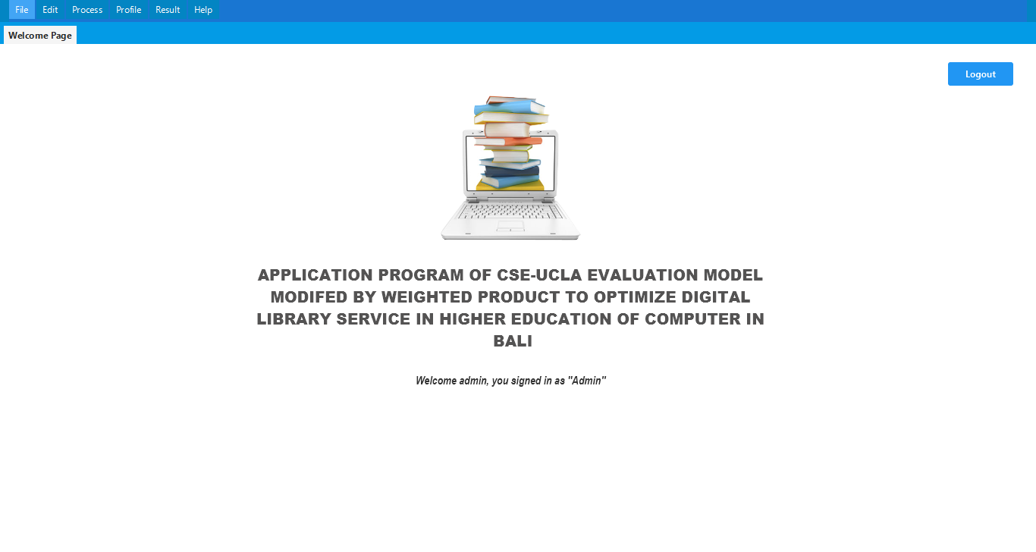

Figure 1. Display of main menu

The display of main menu shown in Figure 1 is used as navigation to the page/other forms. The display of main menu has four pointers located on the menu bar. The display of main menu is also decorated with the design of the image according to the evaluation theme of digital library services.

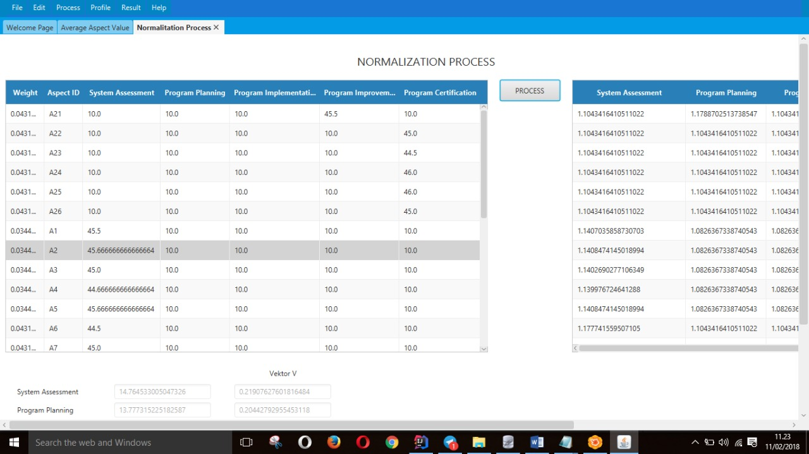

Figure 2. Display of *weighted product* calculation form

The display of *weighted product* calculation form shown in figure 2 is used to facilitate the calculation process by *weighted product* method. In this form is available textbox that is used to input the weight value of the decision maker and input the average value of each aspect automatically. In this form is also available button to perform the calculation process automatically, so it can display the value of vector S as the value of normalization process and Vektos V as the basis of ranking value.

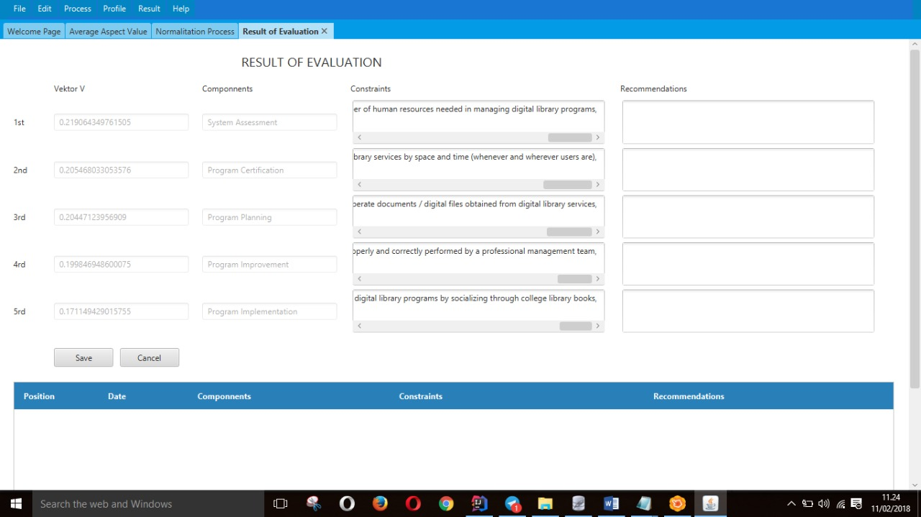

Figure 3. Display of evaluation results form

The display of evaluation results form shown in figure 3 above is used to facilitate the display of evaluation results. The form consists of texbox used to display the vector-V value and evaluation components, while the text area is used to display evaluation and recommendation constraints.

The simulation of field trials conducted by 4 respondents ie 2 education experts and 2 informatics experts can be explained as follows: If known results of field questionnaire filling questionnaire on the application of *CSE-UCLA* evaluation model modified by the *weighted product* method, which conducted by 4 respondents can be shown in table 1 below.

Table 1. Results of Field Test Questionnaire on Implementation of Evaluation Application Based on *CSE-UCLA* Model that Modified by *Weighted Product* Method

| Evaluation Components | Code of Evaluation Aspects | Item- | Respondents | | | | Σ | Average of Evaluation Aspects |
| --- | --- | --- | --- | --- | --- | --- | --- | --- |
| Education Experts | | Informatics Experts | |
| E1 | E2 | E3 | E4 |
|  | A1 | 1 | 5 | 5 | 4 | 5 | 19 | 18.00 |
|  | 2 | 5 | 4 | 4 | 4 | 17 |
|  | A2 | 3 | 4 | 5 | 5 | 4 | 18 | 18.67 |
|  | 4 | 5 | 5 | 4 | 5 | 19 |
|  | 5 | 5 | 5 | 4 | 5 | 19 |
|  | A3 | 6 | 4 | 4 | 5 | 4 | 17 | 17.67 |
|  | 7 | 5 | 4 | 4 | 5 | 18 |
|  | 8 | 5 | 4 | 4 | 5 | 18 |
| *System* | A4 | 9 | 4 | 5 | 4 | 5 | 18 | 18.00 |
| *Assessment* | 10 | 4 | 5 | 5 | 4 | 18 |
|  | 11 | 4 | 5 | 5 | 4 | 18 |
|  | A5 | 12 | 5 | 4 | 5 | 5 | 19 | 18.33 |
|  | 13 | 5 | 5 | 4 | 5 | 19 |
|  | 14 | 4 | 4 | 5 | 4 | 17 |
|  | A6 | 15 | 4 | 5 | 4 | 4 | 17 | 16.50 |
|  | 16 | 4 | 4 | 4 | 4 | 16 |
|  | A7 | 17 | 5 | 5 | 4 | 5 | 19 | 18.50 |
|  | 18 | 5 | 4 | 4 | 5 | 18 |
|  | A8 | 19 | 5 | 5 | 5 | 4 | 19 | 18.00 |
|  | 20 | 5 | 4 | 4 | 4 | 17 |
|  | A9 | 21 | 4 | 4 | 3 | 4 | 15 | 14.00 |
|  | 22 | 3 | 4 | 3 | 3 | 13 |
|  | A10 | 23 | 5 | 5 | 4 | 3 | 17 | 16.00 |
|  | 24 | 4 | 5 | 3 | 3 | 15 |
| *Program* | A11 | 25 | 5 | 5 | 5 | 4 | 19 | 18.00 |
| *Planning* | 26 | 4 | 5 | 4 | 4 | 17 |
|  | A12 | 27 | 4 | 3 | 3 | 3 | 13 | 15.00 |
|  | 28 | 4 | 3 | 3 | 4 | 14 |
|  | 29 | 5 | 4 | 4 | 5 | 18 |
|  | A13 | 30 | 3 | 4 | 3 | 3 | 13 | 15.33 |
|  | 31 | 5 | 5 | 5 | 4 | 19 |
|  | 32 | 4 | 3 | 3 | 4 | 14 |
|  | 33 | 4 | 5 | 4 | 5 | 18 |
|  | 34 | 4 | 3 | 3 | 3 | 13 |
|  | 35 | 4 | 4 | 4 | 4 | 16 |
|  | 36 | 3 | 4 | 3 | 3 | 13 |
|  | 37 | 5 | 4 | 4 | 4 | 17 |
|  | 38 | 4 | 4 | 3 | 4 | 15 |
|  | A14 | 39 | 4 | 4 | 4 | 4 | 16 | 15.00 |
|  | 40 | 4 | 4 | 3 | 3 | 14 |
| *Program* | A15 | 41 | 5 | 5 | 4 | 4 | 18 | 18.00 |
| *Implementation* | 42 | 4 | 5 | 4 | 5 | 18 |
|  | A16 | 43 | 3 | 4 | 3 | 3 | 13 | 12.50 |
|  | 44 | 3 | 3 | 3 | 3 | 12 |
|  | A17 | 45 | 4 | 4 | 4 | 4 | 16 | 17.00 |
|  | 46 | 4 | 5 | 4 | 4 | 17 |
|  | 47 | 5 | 5 | 4 | 4 | 18 |
|  | 48 | 4 | 5 | 5 | 4 | 18 |
|  | 49 | 4 | 4 | 4 | 4 | 16 |
|  | A18 | 50 | 5 | 5 | 4 | 4 | 18 | 17.50 |
|  | 51 | 5 | 4 | 4 | 4 | 17 |
| *Program* | A19 | 52 | 5 | 4 | 4 | 4 | 17 | 16.50 |
| *Improvement* | 53 | 4 | 4 | 4 | 4 | 16 |
|  | A20 | 54 | 5 | 5 | 4 | 5 | 19 | 18.40 |
|  | 55 | 4 | 4 | 4 | 3 | 15 |
|  | 56 | 5 | 5 | 4 | 5 | 19 |
|  | 57 | 5 | 5 | 5 | 5 | 20 |
|  | 58 | 5 | 5 | 5 | 4 | 19 |
|  | A21 | 59 | 4 | 4 | 3 | 3 | 14 | 16.50 |
|  | 60 | 5 | 5 | 5 | 4 | 19 |
| *Program Certification* | A22 | 61 | 4 | 3 | 3 | 3 | 13 | 15.33 |
| 62 | 4 | 4 | 4 | 4 | 16 |
| 63 | 5 | 4 | 4 | 4 | 17 |
| A23 | 64 | 4 | 4 | 4 | 4 | 16 | 18.00 |
| 65 | 5 | 5 | 5 | 5 | 20 |
| A24 | 66 | 5 | 5 | 4 | 4 | 18 | 18.50 |
| 67 | 5 | 5 | 4 | 5 | 19 |
| A25 | 68 | 5 | 5 | 5 | 5 | 20 | 20.00 |
| 69 | 5 | 5 | 5 | 5 | 20 |
| A26 | 70 | 5 | 5 | 4 | 5 | 19 | 18.50 |
| 71 | 5 | 5 | 4 | 4 | 18 |

To obtain the ranking result on every evaluation components from the highest down to the lowest category, we use the *weighted product* method, with the following calculation phases.

1. Determining the weight of decision makers

The weight of the decision maker is given for each evaluation aspects. To obtain weighted total value of 1, then the first process is weight improvement. The weight for each evaluation aspects and improvement can be seen in table 2 below.

Table 2. Weight of Each Evaluation Aspect of *CSE-UCLA* Model to Evaluate on Digital Library at Computer College in Bali

| Code of Aspects | Weight From Decision Makers | Results of Weight Improvement |
| --- | --- | --- |
| A1 | 5 | 0.042 |
| A2 | 5 | 0.042 |
| A3 | 5 | 0.042 |
| A4 | 5 | 0.042 |
| A5 | 5 | 0.042 |
| A6 | 4 | 0.034 |
| A7 | 4 | 0.034 |
| A8 | 5 | 0.042 |
| A9 | 4 | 0.034 |
| A10 | 4 | 0.034 |
| A11 | 5 | 0.042 |
| A12 | 4 | 0.034 |
| A13 | 4 | 0.034 |
| A14 | 5 | 0.042 |
| A15 | 5 | 0.042 |
| A16 | 4 | 0.034 |
| A17 | 4 | 0.034 |
| A18 | 4 | 0.034 |
| A19 | 4 | 0.034 |
| A20 | 4 | 0.034 |
| A21 | 5 | 0.042 |
| A22 | 5 | 0.042 |
| A23 | 5 | 0.042 |
| A24 | 5 | 0.042 |
| A25 | 5 | 0.042 |
| A26 | 5 | 0.042 |
| Total | 119 | 1 |

Notes:

To obtain the results of weight improvement can be done by dividing the value of each weight of the decision maker with the total weight of decision makers. For example: the result of weight fixes for aspects with code A1 ie: 5/119 = 0.042, and so do the calculations using the same steps for other aspects in determining the weight improvement.

2. The normalization process

The normalization process is done to obtain the preference value for each evaluation components. The formula was used in this normalization process was as follows [25].



(1)

with i = 1,2, ....., m, and ∑wj must be worth = 1.

Where:

S : alternative preference value

w : weight criteria

n : number of criteria

wj is a rank that is either positive or negative. If it is positive to attribute a profit and a negative value to the cost attribute. Based on the data shown in table 1 above, it can be recapitulated become data for normalization process into table 3 and then can be calculated the normalization process.

Table 3. Data for Normalization Process

| Evaluation Components  Code of Evaluation Aspects | *System Assessment* | *Program Planning* | *Program Implementation* | *Program Improvement* | *Program Certification* |
| --- | --- | --- | --- | --- | --- |
| A1 | 18.00 | 4.00 | 4.00 | 4.00 | 4.00 |
| A2 | 18.67 | 4.00 | 4.00 | 4.00 | 4.00 |
| A3 | 17.67 | 4.00 | 4.00 | 4.00 | 4.00 |
| A4 | 18.00 | 4.00 | 4.00 | 4.00 | 4.00 |
| A5 | 18.33 | 4.00 | 4.00 | 4.00 | 4.00 |
| A6 | 16.50 | 4.00 | 4.00 | 4.00 | 4.00 |
| A7 | 18.50 | 4.00 | 4.00 | 4.00 | 4.00 |
| A8 | 4.00 | 18.00 | 4.00 | 4.00 | 4.00 |
| A9 | 4.00 | 14.00 | 4.00 | 4.00 | 4.00 |
| A10 | 4.00 | 16.00 | 4.00 | 4.00 | 4.00 |
| A11 | 4.00 | 18.00 | 4.00 | 4.00 | 4.00 |
| A12 | 4.00 | 15.00 | 4.00 | 4.00 | 4.00 |
| A13 | 4.00 | 15.33 | 4.00 | 4.00 | 4.00 |
| A14 | 4.00 | 4.00 | 15.00 | 4.00 | 4.00 |
| A15 | 4.00 | 4.00 | 18.00 | 4.00 | 4.00 |
| A16 | 4.00 | 4.00 | 12.50 | 4.00 | 4.00 |
| A17 | 4.00 | 4.00 | 4.00 | 17.00 | 4.00 |
| A18 | 4.00 | 4.00 | 4.00 | 17.50 | 4.00 |
| A19 | 4.00 | 4.00 | 4.00 | 16.50 | 4.00 |
| A20 | 4.00 | 4.00 | 4.00 | 18.40 | 4.00 |
| A21 | 4.00 | 4.00 | 4.00 | 16.50 | 4.00 |
| A22 | 4.00 | 4.00 | 4.00 | 4.00 | 15.33 |
| A23 | 4.00 | 4.00 | 4.00 | 4.00 | 18.00 |
| A24 | 4.00 | 4.00 | 4.00 | 4.00 | 18.50 |
| A25 | 4.00 | 4.00 | 4.00 | 4.00 | 20.00 |
| A26 | 4.00 | 4.00 | 4.00 | 4.00 | 18.50 |

Notes:

All values of 4.00 were obtained from the average number of respondents who did not provide an answer to the evaluation aspect, while the other values were derived from the average evaluation aspects shown earlier in Table 1.

Based on table 2 and table 3 above, it can be done calculation of the normalization process as follows.

S1 = (18.000.042) * (18.670.042) * (17.670.042) * (18.000.042) * (18.330.042) * (16.500.034) * (18.500.034) * (4.000.042) * (4.000.034) * (4.000.034) * (4.000.042) * (4.000.034) * (4.000.034) * (4.000.042) * (4.000.042) * (4.000.034) * (4.000.034) * (4.000.034) * (4.000.034) * (4.000.034) * (4.000.042) * (4.000.042) * (4.000.042) * (4.000.042) * (4.000.042) * (4.000.042) = 6.107

S2 = (4.000.042) * (4.000.042) * (4.000.042) * (4.000.042) * (4.000.042) * (4.000.034) * (4.000.034) * (18.000.042) * (14.000.034) * (16.000.034) * (18.000.042) * (15.000.034) * (15.330.034) * (4.000.042) * (4.000.042) * (4.000.034)* (4.000.034) * (4.000.034) * (4.000.034) * (4.000.034)* (4.000.042) * (4.000.042) * (4.000.042) * (4.000.042) * (4.000.042) * (4.000.042) = 5.466

S3 = (4.000.042) * (4.000.042) * (4.000.042) * (4.000.042) * (4.000.042) * (4.000.034) * (4.000.034) * (4.000.042) * (4.000.034) * (4.000.034) * (4.000.042) * (4.000.034) * (4.000.034) * (15.000.042) * (18.000.042) * (12.500.034) * (4.000.034) * (4.000.034) * (4.000.034) * (4.000.034) * (4.000.042) * (4.000.042) * (4.000.042) * (4.000.042) * (4.000.042) * (4.000.042) = 4.708

S4 = (4.000.042) * (4.000.042) * (4.000.042) * (4.000.042) * (4.000.042) * (4.000.034) * (4.000.034) * (4.000.042) * (4.000.034) * (4.000.034) * (4.000.042) * (4.000.034) * (4.000.034) * (4.000.042) * (4.000.042) * (4.000.034) * (17.000.034) * (17.500.034) * (16.500.034) * (18.400.034) * (16.500.042) * (4.000.042) * (4.000.042) * (4.000.042)* (4.000.042) * (4.000.042) = 5.211

S5 = (4.000.042) * (4.000.042) * (4.000.042) * (4.000.042) * (4.000.042) * (4.000.034) * (4.000.034) * (4.000.042) * (4.000.034) * (4.000.034) * (4.000.042) * (4.000.034) * (4.000.034) * (4.000.042) * (4.000.042) * (4.000.034) * (4.000.034) * (4.000.034) * (4.000.034) * (4.000.034) * (4.000.042) * (15.330.042) * (18.000.042) * (18.500.042) * (20.000.042) * (18.500.042) = 5.516

3. The ranking process of evaluation components

To obtain the ranking of evaluation components from the highest down to the lowest category can be calculated using the following formula [25].

$V_{i}=\frac{\prod_{j=1}^{n}{{X_{ij}}^{wj}}}{\prod_{j=1}^{n}{{{(X}_{j})}^{wj}}}$ (2)

Where :

V : Relative preference value for ranking

X : Criteria value

w : Weight criteria

Based on the formula, the following calculation can be done to obtain the ranking result from each evaluation components.

$$V_{1}=\frac{S_{1}}{S_{1}+S_{2}+S_{3}+S_{4}+S_{5}}$$

$$V_{1}=\frac{6.107}{6.107+5.466+4.708+5.211+5.516}=0.226$$

$$V_{2}=\frac{S_{2}}{S_{1}+S_{2}+S_{3}+S_{4}+S_{5}}$$

$$V_{2}=\frac{5.466}{6.107+5.466+4.708+5.211+5.516}=0.202$$

$$V_{3}=\frac{S_{3}}{S_{1}+S_{2}+S_{3}+S_{4}+S_{5}}$$

$$V_{3}=\frac{4.708}{6.107+5.466+4.708+5.211+5.516}=0.174$$

$$V_{4}=\frac{S_{4}}{S_{1}+S_{2}+S_{3}+S_{4}+S_{5}}$$

$$V_{4}=\frac{5.211}{6,107+5,466+4,708+5,211+5,516}=0.193$$

$$V_{5}=\frac{S_{5}}{S_{1}+S_{2}+S_{3}+S_{4}+S_{5}}$$

$$V_{5}=\frac{5.516}{6.107+5.466+4.708+5.211+5.516}=0.204$$

From the results of the vector-V value above, it can be determined the ranking of evaluation components that belongs to the highest category down to the lowest, which can be seen in the following table 4.

Table 4. The Ranking of Each Component

|  |  |  |
| --- | --- | --- |
| **Components** | **Vector-V Values** | **Rank** |
| *System Assessment* | 0.226 | I |
| *Program Planning* | 0.202 | III |
| *Program Implementation* | 0.174 | V |
| *Program Improvement* | 0.193 | IV |
| *Program Certification* | 0.204 | II |

The *CSE-UCLA* model modified with the *weighted product* method is manifested through a desktop application program with glance views shown above. The complete features of this evaluation aplication based on *CSE-UCLA* modified with *weighted product* include: 1) login form, 2) main menu form, 3) user input data form, 4) interest rating input form, 5) form of weight making from decision maker, 6) form of questionnaire filling, 7) average aspect calculation form, 8) normalization calculation form, 9) ranking and recommendation form, and 10) evaluation result form.

The login form contains the username and password that serves as the opening access for users and admins. If the username and password are correct, then the user can access the sub menu “user input data", sub menu “questionnaire filling”, sub menu “decision”, and sub menu “exit”. While the admin can access sub menu “interest rating input”, sub menu “data input of weight from decision makers”, sub menu “average value of each aspect”, sub menu “normalization”, sub menus “rank and recommendation”, and sub menu “exit”.

The main menu form serves as a pointer to other forms. In the main menu form the evaluation aplication based on *CSE-UCLA* modified with *weighted product* consists of 4 pointers on the menu bar: the “file” pointer, the “process” pointer, the “about” pointer, and the “help” pointer. On the “file” pointer there is “user” menu, “admin” menu, and “exit” menu. On the “process” pointer there is a menu of “aspect average calculation”, “normalization” menu, menu “rank and recommendations”. In particular, in the “user” menu there are several sub menus, including: sub menu “user data input”, sub menu “questionnaire filling”, and sub menu “decision”.

On the “admin” menu there are several sub menus, among others: sub menu “interest rating input”, and sub menu “data input of weight from decision makers”. The sub menu “user data input” is used as a link to the user input data form. The sub-menu of “questionnaire filling” is used to enter the respondent's assessment data on each evaluation aspects. The “decision” sub menu used to view the results of evaluation decision. The “interest rating input” sub menu is used to include an interest rating score.

The “data input of weight from decision makers” sub menu is used to input weighted data provided by the decision maker against each evaluation aspects. The “exit” sub menu is used to close the application. The “aspect average calculation” menu is used as a link to the average value calculation process form for each evaluation aspects. The “normalization” menu is used as a link to the normalization form. The “rank and recommendations” menu used to rank calculations incorporates the constraints found in each aspect and recommendation as a problems solving. The pointer “about” is used as a pointer to the creator's identity information form and the specification of this application. Pointer “help” used by the user as a pointer to the manual information form the use of this application.

Form of user data input comes with features that can store user identity. Interest rating input form is equipped with features that can store interest rating score data, such as: excellent = 5, good = 4, moderate= 3, less = 2, and poor or don't choose any answer = 1. Form of weight making from decision maker is equipped with features that can store weighted data provided by the decision maker against each evaluation aspects. The questionnaire filling form comes with features that can store the results of the respondent's assessment of each evaluation aspects. The form of aspect average calculation is equipped with features that can determine and store the calculation data of average score given by the respondent to each evaluation aspects. Normalization calculation form is equipped with features that can calculate and store data result of normalization process that yield of vector-S value. Rank and recommendation forms are equipped with features that can determine the ranking results, insert constraints and put recommendations. Form evaluation results are equipped with features that can display the evaluation results.

Based on the result of field test simulation which has been done by 4 respondents, obtained the evaluation result in sequence from the highest category down to the lowest in each evaluation components that is started from system assessment components, program certification components, program planning components, program improvement components, and program implementation components.

From the ranking results, it can be seen that the evaluation component that gets the highest category was the component of the system assessment, so that all aspects of the components, need to be maintained it was effectiveness. In addition, the evaluation component that received the lowest category was the implementation program, so that all aspects of the component need to be re-analyzed and given recommendations for improvement. The aspect of most program implementation components that need to be recommended to be improved when viewed from the simulation results of field trials were the aspect with the A16 code because the average evaluation aspect were 12.50. Code A16 were the aspects of software socialization required in digital libraries for librarians, with items that need to be optimized, among others: 1) the availability of information that must be clearly provided by the manager/developer team to the library operational officer about the software needed in carrying out the digital library program through the provision of a library manual, and 2) the availability of information that must be clearly provided by the management team/developer to the library operational officer about the software needed to run the digital library program through the workshop.

The results of this research have been able to answer the obstacles found in research conducted by Divayana [17], where the obstacle is not yet able to show accurately the aspects of evaluation that have not been optimal implementation and also the application features that have not been able to add new aspects dynamically. However, through the implementation of this research, these constraints have been answered by obtaining a sequence ranging from the highest down to the lowest category on each evaluation components, so it can be seen that aspects are not yet optimal through the lowest categorized evaluation component. Besides that, in this research result of evaluation application which have been equipped with dynamic feature to be able to add new evaluation aspect.

The results of this research also have been able to answer the first year research obstacles that have been done by Divayana, Adiarta and Abadi [4] that is constraint in the case of the research results is still limited to the design of evaluation model and limitations of the evaluation model design trial. However, with the results of this study it is clear that it has been able to answer these constraints by implementing the model design produced in the first year of research into a *CSE-UCLA* model evaluation application modified with *weighted product*. In addition, field trials have also been conducted on the application.

Besides the existence of several advantages that have been shown in this research, there are also obstacles that become the findings in this research that is still not stable and optimally the evaluation model of *CSE-UCLA* model modified with *Weighted Product* can run because only limited field trial on this research, so need to look for further solutions so that applications can be more stable and ready to be applied thoroughly to evaluate digital library at all college computer in Bali.

1. **CONCLUSION**

Modification of the *CSE-UCLA* model used in evaluating the optimization of digital library services at computer colleges in Bali is manifested through a *CSE-UCLA* model-based evaluation application that inserts a *weighted product* method in the ranking process, resulting in more accurate evaluation results by defining and valid aspects of evaluation that do need special and focus for the revision / improvement, so that the implementation of digital library can run more optimal. This *CSE-UCLA* model evaluation application that modified with *weighted product* method has provided some comprehensive features and is able to facilitate the needs of its users especially in terms of ease in obtaining accurate evaluation results. The solution to overcome the obstacles encountered in this study is to test a usage that involves more respondents on a wider scale to test the reliability of these evaluation applications, so that these applications can become more reliable and tested.

**ACKNOWLEDGEMENTS**

The author would like thanks to Director General of Higher Education on the Republic of Indonesia, who provided funding in this research. The author also thanks to all those who have helped carry out this research, so that it can be finished on time.

**REFERENCES**

1. D. G. H. Divayana, P. W. A. Suyasa and N. Sugihartini, “Pengembangan media pembelajaran berbasis web untuk matakuliah kurikulum dan pengajaran di jurusan pendidikan teknik informatika universitas pendidikan ganesha,” *Jurnal Nasional Pendidikan Teknik Informatika*, vol. 5, no. 3, pp. 149–157, 2016.
2. A. Marwanto and R. D. Djatmiko, “Evaluasi pelaksanaan praktik oxy-acetylene welding di jurusan pendidikan teknik mesin ft uny,” *Jurnal Pendidikan Teknologi dan Kejuruan*, vol. 22. no. 2, pp. 127–135, 2014.
3. I. Muchoyar, Basrowi, B. S. W., Sudiyanto, A. C. Nugroho, Soeprapto and I. Cahyati, “Evaluasi prestasi belajar mahasiswa fakultas teknik universitas negeri yogyakarta,” *Jurnal Pendidikan Teknologi dan Kejuruan*, vol. 21, no. 4, 325–334, 2013.
4. D. G. H. Divayana, A. Adiarta and I. B. G. S. Abadi, “Conceptual and physical design of evaluation program for optimizing digital library services at computer college in Bali based on CSE-UCLA model modification with weighted product,” *Journal of Theoretical and Applied Information Technology*, vol. 95, no. 16, 3767–3782, 2017.
5. D. G. H. Divayana, A. Adiarta and I. B. G. S. Abadi, “Initial draft of CSE-UCLA evaluation model based on weighted product in order to optimize digital library services in computer college in Bali,” *IOP Conference Series: Materials Science and Engineering*, vol. 296, pp. 13–18, 2018.
6. D. G. H. Divayana, A. Adiarta and I. B. G. S. Abadi, “Uji coba rancangan model CSE-UCLA yang dimodifikasi dengan metode weighted product dan validasi instrumen evaluasi layanan perpustakaan digital pada perguruan tinggi komputer di Bali,” *Prosiding Seminar Nasional Pendidikan Teknik Informatika*, vol. 8, pp. 28–34, 2017.
7. D. G. H. Divayana, A. Adiarta and I. B. G. S. Abadi, “Development of CSE-UCLA evaluation model modified by using weighted product in order to optimize digital library services in higher education of computer in Bali,” *Jurnal Pendidikan Vokasi*, vol. 7, no. 3, 288–303, 2017.
8. I. B. P. Arnyana, I. W. Sadia, I. K. Suma and Dewa Gede Hendra Divayana, “Determination of effectiveness of evaluation results on school culture and character of junior high school students using character assessment instruments with the local wisdom of Bali based on mobile phone,” *Journal of Theoretical and Applied Information Technology*, vol. 95, no. 20, 5348–5359, 2017.
9. I. N. Jampel, I. W. Lasmawan, I. M. Ardana, I. P. W. Ariawan, I. M. Sugiarta and D.G.H. Divayana, “Evaluation of learning programs and computer certification at course institute in bali using CSE-UCLA based on saw simulation model,” *Journal of Theoretical and Applied Information Technology*, vol. 95, no. 24, 6934–6949, 2017.
10. I. N. Suandi, I. B. Putrayasa and D. G. H. Divayana, “Compiling a dictionary of loan words in balinese: the evaluation result of effectiveness testing in the field aided by mobile technology,” *Journal of Theoretical and Applied Information Technology*, vol. 95, no. 14, 3186–3195, 2017.
11. D. G. H. Divayana and D. B. Sanjaya, “Mobile phone-based CIPP evaluation model in evaluating the use of blended learning at school in Bali,” *International Journal of Interactive Mobile Technologies*, vol. 11, no. 4, 149–159, 2017.
12. D. G. H. Divayana, A. A. I. N. Marhaeni, N. Dantes, I. B. P. Arnyana and W. Rahayu, “Evaluation of Blended Learning Process of Expert System Course Program by Using CSE-UCLA Model Based on Mobile Technology,” *Journal of Theoretical and Applied Information Technology*, vol. 95, no. 13, 3075–3086, 2017.
13. D. G. H. Divayana, B. I. Sappaile, I. G. N. Pujawan, I. K. Dibia, L. Artaningsih, I. M. Sundayana and G. A. D. Sugiharni, “An evaluation of instructional process of expert system course program by using mobile technology-based CSE-UCLA model,” *International Journal of Interactive Mobile Technologies*, vol. 11, no. 6, 18–31, 2017.
14. D. G. H. Divayana, D. B. Sanjaya, A. A. I. N. Marhaeni and I. G. Sudirtha, “CIPP evaluation model based on mobile phone in evaluating the use of blended learning platforms at vocational schools in Bali,” *Journal of Theoretical and Applied Information Technology*, vol. 95, no. 9, 1983–1995, 2017.
15. D. G. H. Divayana, A. A. G. Agung, B. I. Sappaile, W. Simatupang, Y. Sastrawijaya, I. M. Sundayana and G. A. D. Sugiharni, “Utilization of open source technology in determining of validity and reliability of evaluation model instruments based on aneka values in order to evaluate the quality of computer learning,” *Journal of Theoretical and Applied Information Technology*, vol. 95, no. 20, 5517–5534, 2017.
16. D. G. H. Divayana, I. M. Ardana and I. P. W.Ariawan, “Measurement of effectiveness of a lecturer in transferring algebra knowledge through of multimedia facilities by using certainty factor-formative-summative model,” *Journal of Theoretical and Applied Information Technology*, vol. 95, no. 9, 1963–1973, 2017.
17. D. G. H. Divayana, “Utilization of CSE-UCLA model in evaluating of digital library program based on expert system at universitas teknologi indonesia: a model for evaluating of information technology-based education services,” *Journal of Theoretical and Applied Information Technology*, vol. 95, no. 15, 3585–3596, 2017.
18. D. G. H. Divayana, “Evaluasi Pemanfaatan E-Learning Menggunakan Model CSE-UCLA,” *Jurnal Cakrawala Pendidikan*, vol. 36, no. 2, 280–289, 2017.
19. D. G. H. Divayana, “Evaluasi pelaksanaan blended learning di smk ti udayana menggunakan model cse-ucla. *Jurnal Pendidikan Vokasi*, vol. 7, no. 1, 64–77, 2017.
20. D. G. H. Divayana and G. A. D.Sugiharni, “Evaluasi program sertifikasi komputer pada universitas teknologi indonesia menggunakan model CSE-UCLA,” *Jurnal Pendidikan Indonesia*, vol. 5, no. 2, 865–872, 2016.
21. I.M. Ardana, I.P.W., Ariawan, D.G.H Divayana, “*Measuring the effectiveness of BLCS model (bruner, local culture, scaffolding) in mathematics teaching by using expert system-based CSE-UCLA,” International Journal of Education and Management Engineering,* vol. **7**, no. 4, 1–12, 2017.
22. S. Widarwati, E. Budiastuti and P. Karomah, “Implementasi alat evaluasi menggambar busana di smk swasta kelompok pariwisata kabupaten sleman,” *Jurnal Pendidikan Teknologi dan Kejuruan*, vol. 22, no. 2, 208–214, 2014.
23. D. G. H. Divayana. *Evaluasi Program Perpustakaan Digital Berbasis Sistem Pakar Pada Universitas Teknologi Indonesia*. Jakarta: Universitas Negeri Jakarta, 2016.
24. W. R. Borg and M. D. Gall. *Educational Research: An Introduction, Fifth Edition*. New York: Longman, 2008.
25. A. Ahmadi and D. T. Wiyanti, “Implementasi weighted product (wp) dalam penentuan penerima bantuan langsung masyarakat pnpm mandiri perdesaan,” *Proceedings Seminar Nasional Aplikasi Teknologi Informasi (SNATI)*, pp. 19–22, 2014.

**BIOGRAPHIES OF AUTHOR**

|  |  |
| --- | --- |
| D:\Undiksha\Foto Divayana.bmp | **Dewa Gede Hendra Divayana** obtained his S.Kom in informatics engineering from STMIK Asia Malang, at Malang in 2008. He obtained his M.Kom in informatics engineering from STMIK Eresha, at Jakarta in 2010. He obtained his Dr. in Measurement and Evaluation in Education at Universitas Negeri Jakarta, at Jakarta in 2016. Since 2014, his research interest areas are evaluation in Education, informatics engineering education, decision support system, and expert system. Dr. Dewa Gede Hendra Divayana has been written several international journal and international conference articles in the area of digital library, decision support system, expert system, evaluation, and informatics engineering education. |