Critical thinking skills and concepts mastery on the topic of temperature and heat: inquiry-discovery

Jamaludin¹, John Rafafy Batlolona², Wartono³
^{1,2}Department of Physics Education, Faculty of Teacher Training and Education, Pattimura University, Ambon, Indonesia
³Department of Physics Education, Faculty of Science and Technology, Universitas Kanjuruhan Malang, Malang, Indonesia

Article Info |  | ABSTRACT
Article history:  Received Jun 12, 201x  Revised Aug 20, 201x  Accepted Aug 26, 201x |  | This study aimed to determine the effect of the inquiry-discovery learning model on critical thinking skills and mastery of students' physics concepts on the topic of temperature and heat. This quasi-experimental research used Posttest Only Control Group Design in which there are two groups in this design, each of which was selected randomly. The sample in this study was 34 students for the experimental class and 34 students for the control class. The results showed that there was a difference between inquiry-discovery learning and conventional learning in improving students' critical thinking skills and mastery of physics concepts. Based on the research analysis results, it can be concluded that inquiry-discovery learning affects critical thinking skills and students' mastery of physics concepts. Future research is expected to explore variables that can sharpen students' physics skills through inquiry-discovery learning.
Keywords:
Critical Thinking Skills Concept Mastery
Inquiry-Discovery

This is an open access article under the CC BY-SA license.

Corresponding Author:
Jamaludin,
Department of Physics Education,
Faculty of Teacher Training and Education,
Pattimura University, Ambon, Indonesia
Jl. Ir. M. Putuhena, Campus Poka, Ambon, Maluku, Indonesia 97233
Email: jamaludianfisika@gmail.com

- INTRODUCTION
Teaching physics to students is expected to acquire new concepts that can foster a scientific attitude and become a capable scientists [1]. In recent years, student achievement in physics has been meager at the college and secondary levels. This can be seen from the very bad physics final exam [2]. In addition, the motivation to study physics is shallow. When the teacher says "physics," it becomes a fear for students [3]. Physics is a study to find answers to the questions 'why' and 'how' natural phenomena in everyday life occur (Tel et al., 2020). Studies from Singapore provide information that elementary school students in grade 4 have introduced thermal concepts, while junior and senior high school students explore broader thermal concepts (Fernandez, 2017). In addition, the results of a study in England for 70 students who consider physics as something difficult [6], mainly because learning is oriented towards understanding physics, representation, and conceptual understanding [7]. Therefore, physics enthusiasts have become the least preferred subject in schools. Most students are reported to have veered away from learning physics [8]. Physics is a subject that crosses various disciplines with its application in various fields for economic development [9]. Unfortunately, the results of the study explain that students have difficulty understanding physics. It causes poor achievement that the results of studying physics in Nigeria are 42.36 and 50% of high school students to have difficulty understanding the concepts of force, motion, and energy so that students become bored. [10].

21st-century learning is oriented towards collaboration in a prediction that can empower the ability to think, find and solve problems through the help of several supporting sources [11]. Critical thinking skills are closely related to students' deep understanding of the content of learning materials. In addition, critical thinking skills have penetrated into various aspects of human life and scientific disciplines such as science, history, literature, psychology, and everyday life [12]. The results of a study in Indonesia, namely in Ambon City, explained that students' thinking skills in science learning were still low at 53.41[13]. One of the keys to someone skilled in solving problems is requiring critical skills based on competency. If a person does not have good competence, he will have difficulty in solving problems. Therefore, it takes a lot of practice and study so that academic competence can increase [14].
Furthermore, students are also required to do the same thing to achieve the aspired target. Therefore, modern and innovative learning models are needed that can sharpen critical thinking skills and mastery of concepts [15]. One of the recommended learning models to develop students' critical thinking skills and mastery of concepts is inquiry discovery. Most of the learning physics researchers have not developed much in this model. Most of them are researched separately, even in cultural psychology and environmental studies [16]. There has been no comprehensive amalgamation between these two models. There is only one between discovery-inquiry [17], not Inquiry-discovery. Inquiry discovery is a series of learning activities that emphasize critical and analytical thinking processes to seek and find answers to a problem in question [18].
The phases in inquiry learning are starting from observation, asking questions, making a hypothesis, collecting related data, and formulating conclusions based on the data obtained [19]. The results of previous studies show that inquiry learning can improve critical thinking skills and mastery of concepts [20]. The results of other studies also state that inquiry can improve physics learning achievement in terms of students' critical thinking skills [21]. Discovery is a mental process by which an individual can assimilate concepts and principles [22]. In discovery learning, students can solve their problems with help from several sources to generate new concepts and principles with discovery and then solve problems [23]. In principle, it is a way to involve students in the mental process of exchanging information through discussion and independent learning [24].
The learning system conducted by the teacher is not only oriented in one direction but various directions, namely friends as a source of learning, so that the team is allowed to search and find their own using a problem-solving approach [25]. With inquiry-discovery (ID) learning, students can be directly involved and use critical thinking skills to search, find and solve their problems. Therefore, in mastering the physics concepts that have been formed in students, it will bring up critical and even creative thinking in the form of new meaningful perspectives, ideas, and concept. Along with that, students are led to become independent learners [26]. In critical thinking and mastering the physics concept, students need a stimulus in the form of analogies and phenomena around them as the basis for suppositions before taking them to the next stage related to physics material. Adding analogies to learning materials can help students improve their logical thinking and conceptual understanding [27]. The results of previous studies stated that learning by using illustrations in the form of videos, pictures, and even stories can improve critical thinking skills and help students learn physics more effectively [28]. Based on the existing explanation, the purpose of this study was to determine the effect of the inquiry-discovery learning model on students’ critical thinking skills and mastery of physics concepts on the topic of temperature and heat.

- RESEARCH METHOD
This study used a quasi-experimental research design. The research design used Posttest Only Control Group Design. There were two groups in this design, each of which was selected randomly. This research was conducted in the experimental and the control group. Each group was selected and placed randomly. The experimental group learning process uses the ID model, and the control group learning process uses conventional learning (K). The experimental class was named Joseph Black, and the control class was named Lord Kelvin
Table 1. One-way ANOVA design
X Y |  | Learning Model (X)
X Y |  | ID  (X1) | K  (X2)
Class | Joseph Black (Y1) | X1Y1 | -
 | Lord Kelvin (Y2) | - | X2Y2
Note
X1Y1 | : | The group of students who were given learning with the ID learning model, in Joseph Black's class.
X2Y2 | : | The groups of students who were given learning with a conventional learning model with a conventional learning model in Lord Kelvin's class .
The research design used was Posttest Only Control Group Design with the following pattern.

Table 2. posttest only control group design
Class | Treatment | Postest
Joseph Black | X | T1
Lord Kelvin | - | T2
Note
(X) | : | Treatment for Joseph Black's class in using the ID model
(-X) | : | The treatment for Lord Kelvin's group using the lessons learned in school
T2 | : | Posttest to measure the score of critical thinking skills and mastery of concepts

The population used in this study were all 10th-grade students consisting of 5 classes at one high school in Malang City. This study used a simple random sampling technique from a population to be used as Lord Kelvin (LK) class using conventional learning and Joseph Black (JB) class using ID learning. The samples have the same average value and passed normality and homogeneity tests. Lord Kelvin's class and Joseph Black's class consisted of the same number, 34 students. In this study, the instruments used were treatment instruments and measurement instruments. The measurement instrument used in this study was a test instrument for students' conceptual understanding based on indicators C1-C6 and a test of students' critical thinking skills.
The data collection technique begins with the pre-implementation stage, the implementation stage, and the final stage. The data analysis technique begins with the prerequisite analysis test, namely the normality test and homogeneity test. The research hypothesis test used One Way Anova with the assistance of SPSS 16.0 for windows at a sig level of 0.05.

- RESULTS AND DISCUSSION
Data on critical thinking skills of experimental class and control class students are presented in Figure 1.

Figure 1. Comparison of the average value of critical thinking skills and concept understanding
The analysis results shown in Figure 1 above explain a difference in the average value of critical thinking skills between students taught by the ID learning model in the JB class and the conventional learning model in the LK class. The average value of students' critical thinking skills using the ID learning model is higher than the conventional learning model. In addition, data on concept understanding of experimental class and control class students presented show a difference in the average value of concept understanding between students taught by the ID learning model in the JB class and the conventional learning model in the LK class. Concept understanding data using the ID learning model is higher than the conventional learning model.
Before testing the hypothesis, the normality and homogeneity test as analyst prerequisite test was conducted. The normality test of critical thinking skills for the JB group and the LK group was normally distributed. Meanwhile, the normality test results for concept understanding of the JB and the LK group were normally distributed. The homogeneity test of critical thinking skills shows that the two groups of data have homogeneous variances. Both groups came from a homogeneous population. The homogeneity test of concept mastery shows that the two groups of data have homogeneous variances. Both groups came from a homogeneous population. The results of the research hypothesis test are presented in Table 3 below.

Table 3. Critical thinking ability hypothesis test results
 | Learning Models and CTS
Sig_{count} | 0,014
Sig_{table} | 0,05

The results of ANOVA analysis of critical thinking skills show Sig_{count} < Sig_{table} (0.014 < 0.05), so it can be concluded that H₀ is rejected and H₁ is accepted, this shows that there is a difference between ID learning with animation and conventional learning in improving critical thinking skills student.

Table 4. Concept mastery hypothesis test results
 | Learning Models and CU
Sig_{count} | 0,013
Sig_{table} | 0,05

The results of the ANOVA analysis on concept mastery show Sig_{count} < Sig_{table} (0.013 < 0.05). It can be concluded that H₀ is rejected and H₁ is accepted. This shows that there is a difference between ID learning with animation and conventional learning in improving students' concept understanding.
The results of data analysis state that ID learning can improve students' critical thinking skills. There was a difference between ID learning and conventional learning in improving students' critical thinking skills. The ID learning model is a model that can be developed by teachers in learning as a tool to achieve learning objectives. Through this model, students can develop self-confidence and the courage to participate in the learning process.
ID learning can improve students' critical thinking skills because the learning involves students directly. There are several stages of inquiry-discovery learning that greatly affect students' critical thinking skills. In the simulation stage, students try to find problems according to the instructions given by the teacher. At this stage, students formulate the problems found in the form of problem formulations. Thus, it dramatically affects critical thinking skills, especially on the indicators of formulating problems shown in Figure 2.

Figure 2. Indicator of formulating problem

The results of the one-way ANOVA test show that there are differences between the students’ concept mastery using the ID learning model and conventional learning. The results of data analysis show that there is a difference between ID learning compared to conventional learning in improving students' concept understanding.
The use of the ID model in the learning process can train students to carry out various kinds of activities, namely observing, investigating, experimenting, comparing findings with one another, asking questions and seeking answers to their own questions. Therefore, students will get complete facts about the object being observed [29]. The ID learning model is more effective for improving concept understanding, because students will indirectly be able to create new concepts, and create new ideas after mastering concepts independently in the learning process. This research is supported by research, which states that the ID learning model can improve concept understanding [30].
The following shows the state of gas particles when heat is given, as shown in Figure 3. The results of the virtual experiment show that the more heat is given, the faster the particles move, and the air temperature in the tube or vessel gets hotter. Then, the surface of the tube cover will be lifted into the air, and the gas in the tube will move out (Source: https://phet.colorado.edu/sims/html/gas-properties/latest/gas-properties_en.html). Figure 4 shows that when the vessel is heated to a specific temperature, heat transfer occurs from one particle to another, so the heat will spread throughout the material of the vessel (Sumber: https://www.youtube.com/watch?v=MUC098hvqH4).
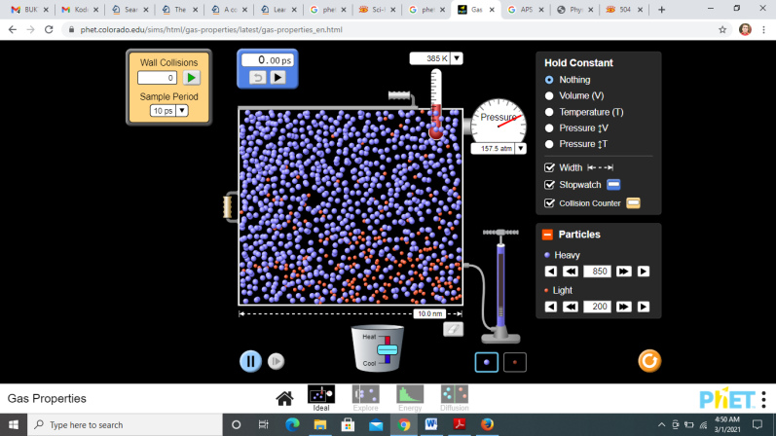

.

Figure 3. The state of the particles in a gas when given heat

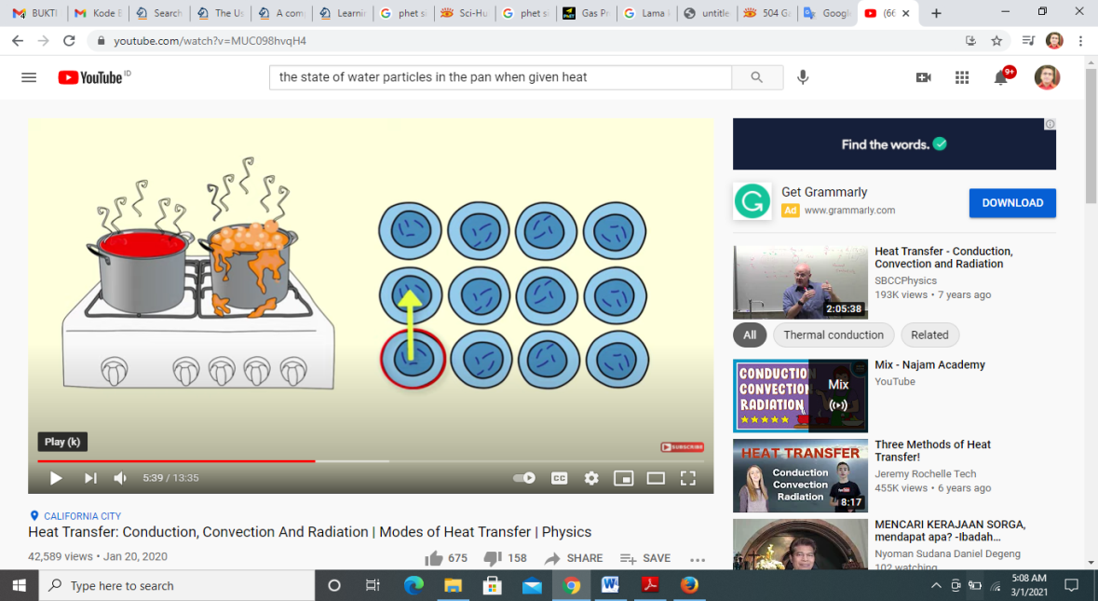

Figure 4. Transfer of energy from one particle to another

Several stages of ID learning significantly affect students' understanding of concepts. At the verification stage, students prove the data obtained from experiments with the formulated hypothesis. At the Generalisation stage, students formulate conclusions from the data that the teacher has corrected. Both of these stages emphasize understanding the concept. The results of this study are in line with previous research that pointed out the concept mastery of the junior high school students has increased, and students also gave a positive response to the learning model used, namely Inquiry-Discovery. [31].

- CONCLUSION
Based on the research and the results of hypothesis testing that have been carried out, it can be concluded that inquiry-discovery learning can improve students' critical thinking skills and conceptual understanding, so that they can be used as a teacher's reference to develop students' critical thinking skills and conceptual understanding. For researchers who will conduct similar research, the results of this study can be used as a reference to develop further research and explore more about Inquiry-Discovery learning with other variables in sharpening students' physics competence.

REFERENCES
[1] C. M. Steenkamp, I. Rootman-le Grange, and K. K. Müller-Nedebock, “Analysing assessments in introductory physics using semantic gravity: refocussing on core concepts and context-dependence,” Teach. High. Educ., vol. 0, no. 0, pp. 1–16, 2019, doi: 10.1080/13562517.2019.1692335.
[2] D. Kwarikunda, U. Schiefele, J. Ssenyonga, and C. M. Muwonge, “The Relationship between Motivation for, and Interest in, Learning Physics among Lower Secondary School Students in Uganda,” African J. Res. Math. Sci. Technol. Educ., vol. 24, no. 3, pp. 435–446, 2020, doi: 10.1080/18117295.2020.1841961.
[3] O. Goldstein, “A project-based learning approach to teaching physics for pre-service elementary school teacher education students,” Cogent Educ., vol. 3, no. 1, pp. 1–12, 2016, doi: 10.1080/2331186X.2016.1200833.
[4] T. T, M. Vincze, and I. M. J, “Vortices capturing matter : a classroom demonstration,” 2020.
[5] F. B. Fernandez, “Action research in the physics classroom: the impact of authentic, inquiry based learning or instruction on the learning of thermal physics,” Asia-Pacific Sci. Educ., vol. 3, no. 1, 2017, doi: 10.1186/s41029-017-0014-z.
[6] J. Dewitt, J. Moote, and J. Dewitt, “15 / 16-Year-Old Students ’ Reasons for Choosing and Not Choosing Physics at a Level,” 2018.
[7] O. S. H, “A content analysis of cognitive representations in a ninth-grade science textbook ’ s chemistry of matter unit : Evidence from Saudi Arabia A content analysis of cognitive representations in a ninth-grade science textbook ’ s chemistry of matter unit : Ev,” Cogent Educ., vol. 7, no. 1, 2020, doi: 10.1080/2331186X.2020.1808283.
[8] J. Kang, “Role of Interest and Self-Concept in Predicting Science Aspirations : Gender Study,” 2019.
[9] U. S. Inyang and M. M. Josiah, “Students ’ Gender and Perceived Difficulty of Concepts in Secondary School Physics in Jos Metropolis , Nigeria,” vol. 6, no. 5, pp. 1–5, 2016, doi: 10.9790/7388-0605060105.
[10] M. I. Simeon, M. A. Samsudin, and N. Yakob, “Effect of design thinking approach on students’ achievement in some selected physics concepts in the context of STEM learning,” Int. J. Technol. Des. Educ., no. 0123456789, 2020, doi: 10.1007/s10798-020-09601-1.
[11] C. Schoor, S. Narciss, and K. Hermann, “Regulation During Cooperative and Collaborative Learning : A Theory-Based Review of Terms and Concepts,” vol. 50, no. 2, pp. 97–119, 2015, doi: 10.1080/00461520.2015.1038540.
[12] D. T. Tiruneh, M. De Cock, and J. Elen, “Designing Learning Environments for Critical Thinking: Examining Effective Instructional Approaches,” Int. J. Sci. Math. Educ., vol. 16, no. 6, pp. 1065–1089, 2018, doi: 10.1007/s10763-017-9829-z.
[13] S. N. Kane, A. Mishra, and A. K. Dutta, “Preface: International Conference on Recent Trends in Physics (ICRTP 2016),” J. Phys. Conf. Ser., vol. 755, no. 1, 2016, doi: 10.1088/1742-6596/755/1/011001.
[14] S. Shanta and J. G. Wells, “T/E design based learning: assessing student critical thinking and problem solving abilities,” Int. J. Technol. Des. Educ., no. 0123456789, 2020, doi: 10.1007/s10798-020-09608-8.
[15] D. Whiley, B. Witt, R. M. Colvin, R. Sapiains Arrue, and J. Kotir, “Enhancing critical thinking skills in first year environmental management students: a tale of curriculum design, application and reflection,” J. Geogr. High. Educ., vol. 41, no. 2, pp. 166–181, 2017, doi: 10.1080/03098265.2017.1290590.
[16] A. Steele, L. Hives, and J. Scott, “Stories of learning : Inquiry-based pathways of discovery through environmental education Stories of learning : Inquiry-based pathways of discovery through environmental education,” Cogent Educ., 2016, doi: 10.1080/2331186X.2016.1202546.
[17] I. Meijerman, G. Storm, E. Moret, and A. Koster, “Development and student evaluation of an inquiry-based elective course on drug discovery and preclinical drug development,” Curr. Pharm. Teach. Learn., vol. 5, no. 1, pp. 14–22, 2013, doi: 10.1016/j.cptl.2012.09.009.
[18] W. Wartono, M. N. Hudha, and J. R. Batlolona, “How are the physics critical thinking skills of the students taught by using inquiry-discovery through empirical and theorethical overview?,” Eurasia J. Math. Sci. Technol. Educ., vol. 14, no. 2, 2018, doi: 10.12973/ejmste/80632.
[19] T. Cooper et al., “Assessing Student Openness to Inquiry-Based Learning in Precalculus Assessing Student Openness to Inquiry-Based Learning in Precalculus,” vol. 1970, no. September, 2016, doi: 10.1080/10511970.2016.1183155.
[20] M. Duran, “The effect of the inquiry-based learning approach on student ’ s critical -thinking,” vol. 12, no. 12, pp. 2887–2908, 2016, doi: 10.12973/eurasia.2016.02311a.
[21] L. Preston, K. Harvie, and H. Wallace, “Inquiry-based learning in teacher education: A primary humanities example,” Aust. J. Teach. Educ., vol. 40, no. 12, pp. 72–85, 2015, doi: 10.14221/ajte.2015v40n12.6.
[22] D. Druckman and N. Ebner, “Discovery Learning in Management Education: Design and Case Analysis,” J. Manag. Educ., vol. 42, no. 3, pp. 347–374, 2018, doi: 10.1177/1052562917720710.
[23] K. Ames, “Distance Education and ‘Discovery Learning’ in First-year Journalism: A Case in Subject Improvement,” Asia Pacific Media Educ., vol. 26, no. 2, pp. 214–225, 2016, doi: 10.1177/1326365X16669196.
[24] B. Dalgarno, G. Kennedy, and S. Bennett, “The impact of students’ exploration strategies on discovery learning using computer-based simulations,” EMI. Educ. Media Int., vol. 51, no. 4, pp. 310–329, 2014, doi: 10.1080/09523987.2014.977009.
[25] W. Zwaal, “Assessment for problem-based learning,” Res. Hosp. Manag., vol. 9, no. 2, pp. 77–82, 2019, doi: 10.1080/22243534.2019.1689696.
[26] Nurjanah, B. Latif, R. Yuliardi, and M. Tamur, “Computer-assisted learning using the Cabri 3D for improving spatial ability and self- regulated learning,” Heliyon, vol. 6, no. 11, p. e05536, 2020, doi: 10.1016/j.heliyon.2020.e05536.
[27] A. P. Correia, N. Koehler, A. Thompson, and G. Phye, “The application of PhET simulation to teach gas behavior on the submicroscopic level: secondary school students’ perceptions,” Res. Sci. Technol. Educ., vol. 37, no. 2, pp. 193–217, 2019, doi: 10.1080/02635143.2018.1487834.
[28] K. Perkins, “Transforming STEM Learning at Scale: PhET Interactive Simulations,” Child. Educ., vol. 96, no. 4, pp. 42–49, 2020, doi: 10.1080/00094056.2020.1796451.
[29] P. H. Wu, C. Y. Kuo, H. K. Wu, T. H. Jen, and Y. S. Hsu, “Learning benefits of secondary school students’ inquiry-related curiosity: A cross-grade comparison of the relationships among learning experiences, curiosity, engagement, and inquiry abilities,” Sci. Educ., vol. 102, no. 5, pp. 917–950, 2018, doi: 10.1002/sce.21456.
[30] D. Cairns and S. Areepattamannil, “Exploring the Relations of Inquiry-Based Teaching to Science Achievement and Dispositions in 54 Countries,” Res. Sci. Educ., vol. 49, no. 1, 2019, doi: 10.1007/s11165-017-9639-x.
[31] E. E. Peters-Burton, S. A. Merz, E. M. Ramirez, and M. Saroughi, “The Effect of Cognitive Apprenticeship-Based Professional Development on Teacher Self-Efficacy of Science Teaching, Motivation, Knowledge Calibration, and Perceptions of Inquiry-Based Teaching,” J. Sci. Teacher Educ., vol. 26, no. 6, pp. 525–548, 2015, doi: 10.1007/s10972-015-9436-1.

